Annex-I




Monthly Review

on


Price Indices

October 2025

(Base Year 2015-16)
Government of Pakistan
Ministry of Planning, Development & Special Initiatives
Pakistan Bureau of Statistics
Islamabad

PRICE STATISTICS TEAM

S# | Name | Designation
- 1 | Dr. Naeem Uz Zafar (S.I) | Chief Statistician
 | Dr. Bahrawar Jan | Deputy Director General
 | Mr. Naseer Ahmad | Director
- 2 | Dr. Ahtasham Gul | Chief Statistical Officer
- 3 | Mr. Kashif Ali | Statistical Officer
- 6 | Miss. Umaira Zareen | Statistical Officer
 | Mr. Abdul Qadir | Statistical Officer
 | Mrs. Safia Akram | Statistical Officer
 | Mrs. Faiza Razzaq | Statistical Officer
 | Mr. Umer Farooq | Statistical Officer
11. | Mr. Ansar Mahmood | Statistical Assistant
12. | Mrs. Madiha Gulfraz | Statistical Assistant
13.  14. | Mrs. Humail Fatima  Mr. Muhammad Asif | Statistical Assistant  Statistical Assistant

IT & SOFTWARE TEAM

1. | Mr. Muhammad Sarwar Gondal (S.I) | Member (Support Services)
2.  3.  4. | Mr. Muhammad Ehtesham  Mrs. Sobia Munawar  Mr. Arsalan Bashir | Director (DP)  Director (DP)  Chief System Analyst
5. | Mr. Muhammad Kibria | Data Processing Officer
6. | Mr. Irfan Bajwa | Data Processing Officer

Inflation in Brief
- CPI inflation General, increased by 6.2% on year-on-year basis in October 2025 as compared to 5.6% of the previous month and 7.2% in October 2024. On month-on-month basis, it increased by 1.8% in October 2025 as compared to an increase of 2.0% in the previous month and an increase of 1.2% in October 2024.

- CPI inflation Urban, increased by 6.0% on year-on-year basis in October 2025 as compared to 5.5% of the previous month and 9.3% in October 2024. On month-on-month basis, it remained stable at 1.5% both in October 2025 and the previous month compared to an increase of 1.1% in October 2024.

- CPI inflation Rural, increased by 6.6% on year-on-year basis in October 2025 as compared to an increase of 5.8% in the previous month and 4.2% in October 2024. On month-on-month basis, it increased by 2.3% in October 2025 as compared to an increase of 2.8% in the previous month and an increase of 1.5% in October 2024.

- SPI inflation on YoY basis increased by 4.8% in October 2025 as compared to an increase of 4.5% a month earlier and an increase of 9.7% in October 2024. On MoM basis, it increased by 0.9% in October 2025 as compared to 2.0% in a month earlier and an increase of 0.6% in October 2024.

- WPI inflation on YoY basis increased by 1.1% in October 2025 as compared to an increase of 0.6% in the previous month and an increase of 3.9% in October 2024. On month-on-month basis, it remained stable at 0.5% both in October 2025 and the previous month as compared to no change in October 2024.

- Figures 1 and 2 show graphically the yearly data of Table 1.a for Urban and Rural CPI while Table 1.1 shows “Period Average” and “YoY” percentage changes in indices.

Table 1.a General Inflation (%) (Base 2015-16)
PERIOD | CPI |  |  |  |  |  |  |  |  |  |  |  |  |  | SPI** |  | WPI
PERIOD | General |  |  |  |  |  | Food |  |  |  | Non-Food
PERIOD | National |  | Urban |  | Rural |  | Urban |  | Rural |  | Urban |  | Rural
PERIOD | YoY | MoM | YoY | MoM | YoY | MoM | YoY | MoM | YoY | MoM | YoY | MoM | YoY | MoM | YoY | MoM | YoY | MoM
Jan-24 | 28.3 | 1.8 | 30.2 | 1.8 | 25.7 | 1.9 | 27.4 | 2.8 | 25.1 | 2.3 | 32.3 | 1.1 | 26.3 | 1.4 | 36.2 | 2.0 | 27.0 | 1.5
Feb-24 | 23.1 | 0.0 | 24.9 | 0.2 | 20.5 | -0.3 | 20.2 | -1.5 | 19.0 | -1.1 | 28.2 | 1.5 | 22.1 | 0.6 | 30.4 | -0.8 | 18.7 | 1.1
Mar-24 | 20.7 | 1.7 | 21.9 | 1.4 | 19.0 | 2.1 | 16.6 | 2.4 | 17.1 | 2.8 | 25.8 | 0.7 | 21.0 | 1.4 | 25.9 | 2.1 | 14.8 | 1.3
Apr-24 | 17.3 | -0.4 | 19.4 | -0.1 | 14.5 | -0.9 | 11.3 | -1.3 | 9.5 | -2.6 | 25.6 | 0.8 | 20.0 | 0.8 | 21.6 | -0.7 | 13.9 | -0.7
May-24 | 11.8 | -3.2 | 14.3 | -2.8 | 8.2 | -3.9 | 2.2 | -6.3 | -0.1 | -7.4 | 23.6 | -0.4 | 17.2 | -0.4 | 15.3 | -4.0 | 9.9 | -2.5
June-24 | 12.6 | 0.5 | 14.9 | 0.6 | 9.3 | 0.3 | 2.6 | 0.4 | 1.3 | -0.2 | 24.3 | 0.7 | 17.9 | 0.8 | 16.6 | 1.3 | 10.6 | 0.4
July-24 | 11.1 | 2.1 | 13.2 | 2.0 | 8.1 | 2.2 | 3.4 | 4.5 | 1.3 | 3.6 | 20.7 | 0.5 | 15.5 | 0.9 | 15.7 | 2.0 | 10.4 | 2.3
Aug-24 | 9.6 | 0.4 | 11.7 | 0.3 | 6.7 | 0.6 | 4.1 | 1.3 | 1.9 | 1.3 | 17.4 | -0.4 | 11.9 | -0.2 | 10.8 | -0.3 | 6.3 | 0.3
Sep-24 | 6.9 | -0.5 | 9.3 | -0.5 | 3.6 | -0.5 | 1.7 | -0.8 | -0.9 | -1.0 | 15.0 | -0.3 | 8.4 | -0.1 | 9.2 | 0.2 | 1.9 | -1.1
Oct-24 | 7.2 | 1.2 | 9.3 | 1.1 | 4.2 | 1.5 | 2.7 | 1.6 | 0.6 | 2.2 | 14.2 | 0.7 | 8.0 | 0.8 | 9.7 | 0.6 | 3.9 | 0.0
Nov-24 | 4.9 | 0.5 | 5.2 | 0.5 | 4.3 | 0.5 | 1.7 | -0.2 | -0.2 | 0.2 | 7.8 | 1.0 | 9.1 | 0.8 | 7.3 | 1.0 | 2.3 | -0.1
Dec-24 | 4.1 | 0.1 | 4.4 | -0.1 | 3.6 | 0.3 | 2.5 | 0.1 | -0.2 | 0.1 | 5.7 | -0.2 | 7.6 | 0.5 | 4.2 | 0.8 | 1.9 | -0.4
Jan-25 | 2.4 | 0.2 | 2.7 | 0.2 | 1.9 | 0.2 | -0.6 | -0.3 | -2.9 | -0.4 | 5.0 | 0.5 | 7.0 | 0.9 | 0.7 | -1.4 | 0.6 | 0.2
Feb-25 | 1.5 | -0.8 | 1.8 | -0.7 | 1.1 | -1.1 | -0.9 | -1.8 | -4.3 | -2.5 | 3.6 | 0.1 | 6.6 | 0.3 | -0.2 | -1.6 | -0.7 | -0.2
Mar-25 | 0.7 | 0.9 | 1.2 | 0.8 | 0.0 | 1.1 | -1.7 | 1.6 | -5.4 | 1.6 | 3.1 | 0.2 | 5.6 | 0.5 | -2.3 | -0.1 | -1.6 | 0.3
Apr-25 | 0.3 | -0.8 | 0.5 | -0.7 | -0.1 | -1.0 | -1.9 | -1.6 | -4.6 | -1.8 | 2.2 | -0.1 | 4.4 | -0.4 | -3.6 | -2.1 | -2.2 | -1.3
May-25 | 3.5 | -0.2 | 3.5 | 0.1 | 3.4 | -0.5 | 5.3 | 0.6 | 2.1 | -1.0 | 2.4 | -0.3 | 4.6 | -0.1 | -0.6 | -1.0 | 0.4 | 0.0
June-25 | 3.2 | 0.2 | 3.0 | 0.1 | 3.6 | 0.5 | 4.2 | -0.6 | 2.4 | 0.1 | 2.2 | 0.5 | 4.7 | 0.8 | -1.9 | 0.0 | 0.6 | 0.6
July-25 | 4.1 | 2.9 | 4.4 | 3.4 | 3.5 | 2.2 | 2.2 | 2.4 | 1.5 | 2.7 | 5.9 | 4.1 | 5.4 | 1.6 | -0.9 | 3.1 | -0.5 | 1.2
Aug-25 | 3.0 | -0.6 | 3.4 | -0.7 | 2.4 | -0.5 | -0.5 | -1.3 | -0.5 | -0.7 | 5.9 | -0.4 | 5.2 | -0.4 | 2.6 | 3.2 | -1.0 | -0.2
Sep-25 | 5.6 | 2.0 | 5.5 | 1.5 | 5.8 | 2.8 | 4.4 | 4.0 | 6.0 | 5.5 | 6.2 | 0.0 | 5.6 | 0.3 | 4.5 | 2.0 | 0.6 | 0.5
Oct-25 | 6.2 | 1.8 | 6.0 | 1.5 | 6.6 | 2.3 | 4.5 | 1.7 | 6.8 | 3.0 | 7.0 | 1.4 | 6.4 | 1.5 | 4.8 | 0.9 | 1.1 | 0.5
** SPI for quintile 1. Digits 0.0* are due to rounding off.

Core inflation (NFNE)
- Measured by non-food non-energy Urban increased by 7.5% on (YoY) basis in October 2025 as compared to 7.0% of the previous month and 8.6% in October 2024. On (MoM) basis, it increased by 1.1% in October 2025 as compared to 0.3% in previous month and an increase of 0.6% in the corresponding month of last year i.e. October 2024.

- Measured by non-food non-energy Rural increased by 8.4% on (YoY) basis in October 2025 compared to 7.8% in previous month and an increase of 11.7% in October 2024. On (MoM) basis, it increased by 1.3% in October 2025 as compared to 0.6% in the previous month and an increase of 0.7% in corresponding month of last year i.e. October 2024.

Core inflation (Trimmed)
- Measured by 20% weighted trimmed mean Urban increased by 6.0% on (YoY) basis in October 2025 as compared to 5.7% of the previous month and 6.4% in October 2024. On (MoM) basis, it increased by 0.9% in October 2025 as compared to 0.3% of the previous month and an increase of 0.7% in corresponding month of last year i.e. October 2024.

- Measured by 20% weighted trimmed mean Rural increased by 6.8% on (YoY) basis in October 2025 as compared to an increase of 6.5% of the previous month and 7.2% in October 2024. On (MoM) basis, it increased by 1.4% in October 2025 as compared to an increase of 0.7% in the previous month and an increase of 1.0% in corresponding month of last year i.e. October 2024.

Table 1.b Core Inflation (%) (Base 2015-16)
Period | NFNE |  |  |  | Trimmed
Period | Urban |  | Rural |  | Urban |  | Rural
Period | YoY | MoM | YoY | MoM | YoY | MoM | YoY | MoM
Oct-24 | 8.6 | 0.6 | 11.7 | 0.7 | 6.4 | 0.7 | 7.2 | 1.0
Nov-24 | 8.9 | 1.2 | 10.9 | 0.7 | 7.5 | 0.6 | 7.8 | 0.5
Dec-24 | 8.1 | 0.2 | 10.7 | 0.6 | 6.2 | 0.1 | 6.5 | 0.6
Jan-25 | 7.8 | 0.8 | 10.4 | 0.9 | 5.4 | 0.6 | 5.4 | 0.7
Feb-25 | 7.8 | 0.3 | 10.4 | 0.4 | 4.6 | 0.1 | 5.2 | 0.1
Mar-25 | 8.2 | 0.5 | 10.2 | 0.7 | 4.8 | 0.3 | 4.8 | 0.4
Apr-25 | 7.4 | 1.3 | 9.0 | 0.9 | 3.8 | 0.3 | 3.3 | -0.1
May-25 | 7.3 | 0.4 | 8.8 | 0.4 | 4.9 | 0.1 | 4.7 | -0.2
June-25 | 6.9 | 0.2 | 8.6 | 0.7 | 4.7 | 0.3 | 5.2 | 0.5
July-25 | 7.0 | 0.8 | 8.1 | 0.7 | 5.1 | 1.0 | 4.9 | 0.7
Aug-25 | 6.9 | 0.3 | 7.8 | 0.2 | 4.2 | 0.0 | 3.6 | 0.3
Sep-25 | 7.0 | 0.3 | 7.8 | 0.6 | 5.7 | 0.3 | 6.5 | 0.7
Oct-25 | 7.5 | 1.1 | 8.4 | 1.3 | 6.0 | 0.9 | 6.8 | 1.4

Table 1.1 Period Average and Y-o-Y % Change
INDEX | Average July - October  % Changes |  |  | October over October  % Changes
INDEX | 2025-2026 | 2024-2025 | 2023-2024 | 2025-2026 | 2024-2025 | 2023-2024
CPI (National) | 4.73 | 8.68 | 28.45 | 6.24 | 7.17 | 26.79
CPI (Urban) | 4.83 | 10.84 | 26.59 | 6.00 | 9.28 | 25.48
CPI (Rural) | 4.59 | 5.65 | 31.15 | 6.59 | 4.23 | 28.67
SPI | 2.76 | 11.31 | 30.85 | 4.79 | 9.70 | 34.17
WPI | 0.05 | 5.54 | 24.61 | 1.10 | 3.89 | 24.62

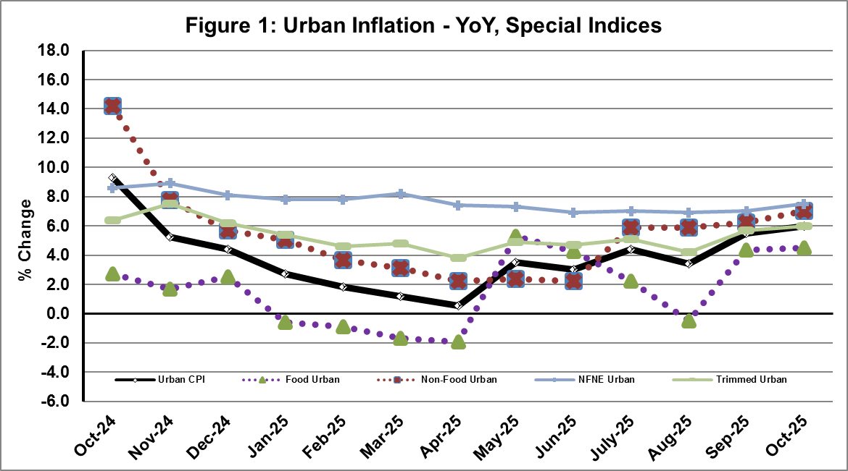
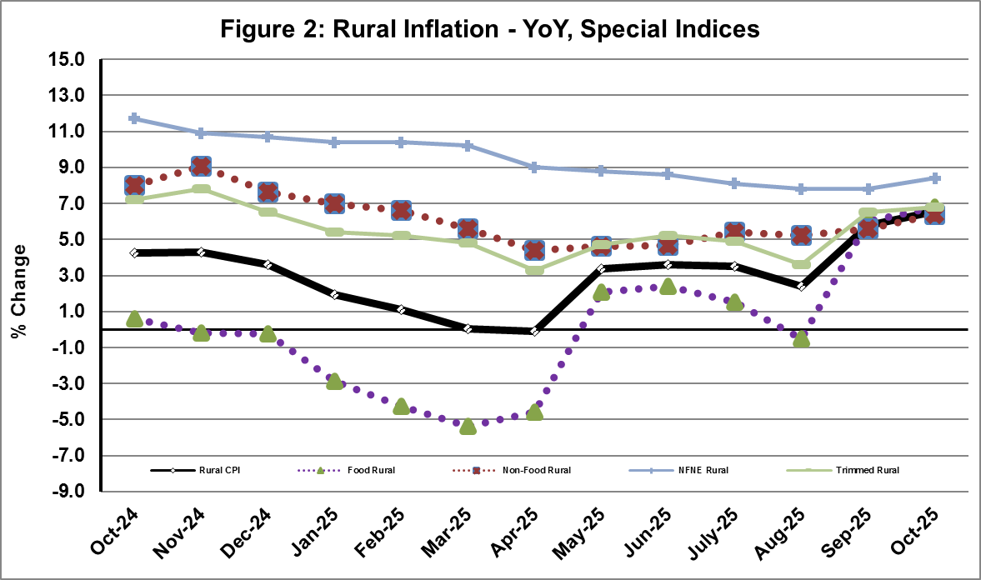

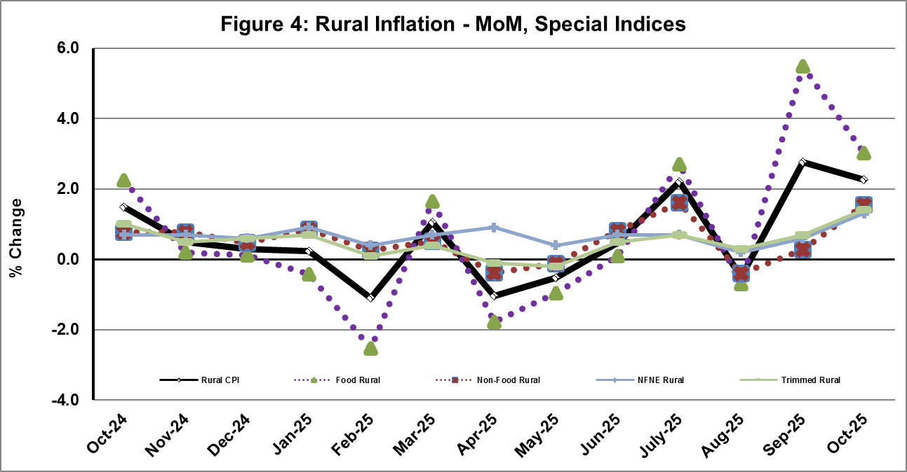
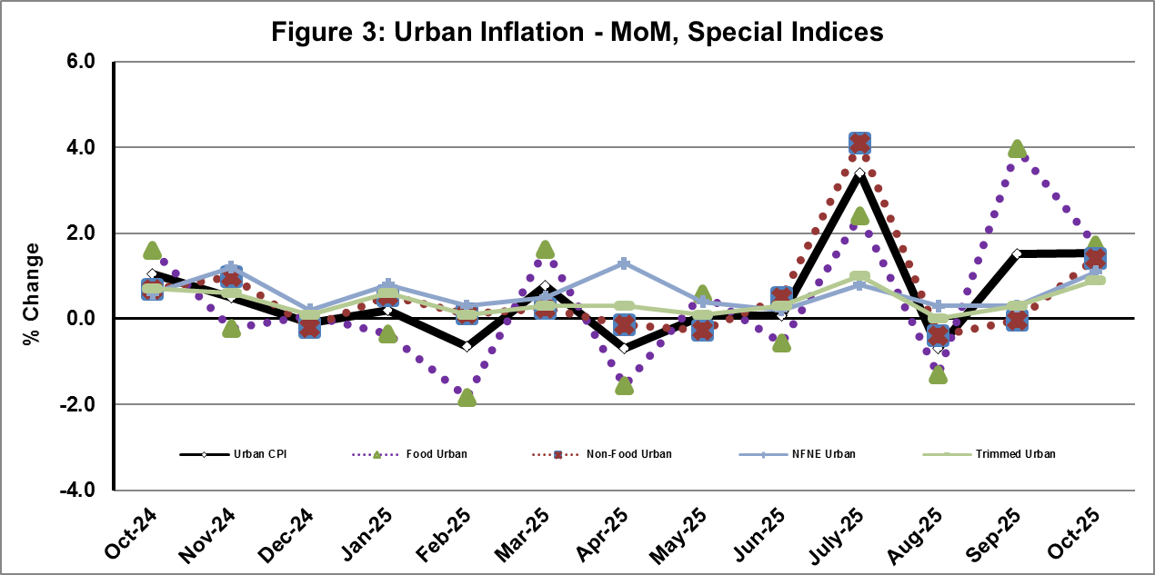

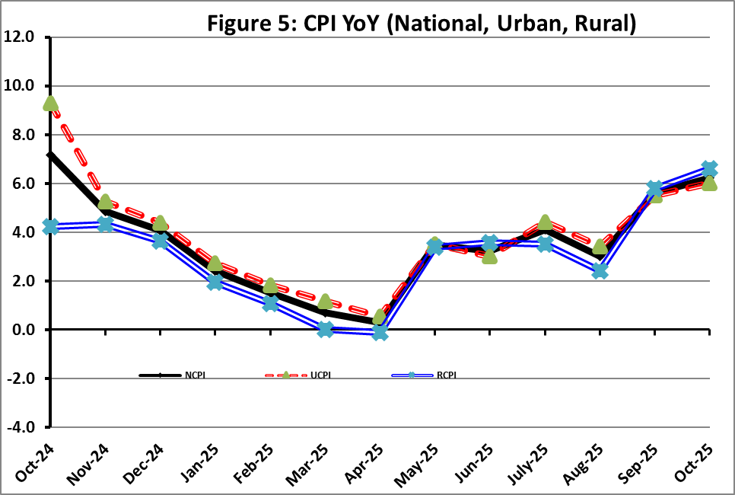

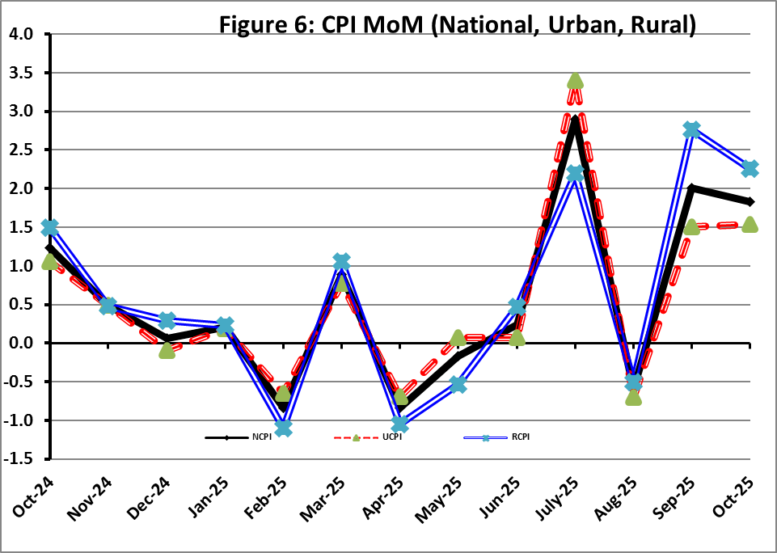
I. National Consumer Price Index (NCPI)

The National Consumer Price Index for October 2025 is increased by 1.83% over September 2025 and increased by 6.24% over corresponding month of the last year i.e. October 2024.

Table 1: Consumer Price Index (National) by Group of Commodities and Services (Base 2015-16)
No | Group | Group  Weight  (%) | Indices |  |  | % Change  Oct 2025  Over |  | Impact  (In % points)  Oct 2025 Over
No | Group | Group  Weight  (%) | Oct 25 | Sep 25 | Oct 24 | Sep 25 | Oct 24 | Sep 25 | Oct 24
No | General | 100.00 | 280.66 | 275.60 | 264.17 | 1.83 | 6.24 | 1.83 | 6.24
1. | Food & Non-alcoholic Bev. | 34.58 | 298.58 | 290.74 | 282.86 | 2.69 | 5.56 | 0.98 | 2.06
 | Non-perishable Food Items | 29.60 | 295.88 | 293.59 | 278.38 | 0.78 | 6.29 | 0.25 | 1.96
 | Perishable Food Items | 4.99 | 314.61 | 273.83 | 309.47 | 14.89 | 1.66 | 0.74 | 0.10
2. | Alcoholic Bev. & Tobacco | 1.02 | 398.10 | 398.28 | 385.40 | -0.04 | 3.30 | 0.00 | 0.05
3. | Clothing & Footwear | 8.60 | 266.67 | 265.79 | 246.76 | 0.33 | 8.07 | 0.03 | 0.65
4. | Housing, Water, Electricity, Gas & Fuels | 23.63 | 249.46 | 244.12 | 239.31 | 2.19 | 4.24 | 0.46 | 0.91
5. | Furnishing & Household Equipment Maintenance | 4.10 | 281.86 | 280.52 | 271.05 | 0.48 | 3.99 | 0.02 | 0.17
6. | Health | 2.79 | 281.37 | 279.49 | 256.51 | 0.67 | 9.69 | 0.02 | 0.26
7. | Transport | 5.91 | 319.76 | 317.05 | 299.63 | 0.85 | 6.72 | 0.06 | 0.45
8. | Communication | 2.21 | 135.62 | 135.38 | 134.85 | 0.18 | 0.58 | 0.00 | 0.01
9. | Recreation & Culture | 1.59 | 264.36 | 266.50 | 274.54 | -0.80 | -3.71 | -0.01 | -0.06
10. | Education | 3.79 | 223.61 | 223.43 | 202.16 | 0.08 | 10.61 | 0.00 | 0.31
11. | Restaurants & Hotels | 6.92 | 293.73 | 292.46 | 276.86 | 0.44 | 6.09 | 0.03 | 0.44
12. | Miscellaneous | 4.87 | 352.83 | 339.02 | 298.54 | 4.08 | 18.19 | 0.24 | 1.00

II. Urban Consumer Price Index (UCPI)

The Urban Consumer Price Index for October 2025 is increased by 1.54% over September 2025 and increased by 6.00% over corresponding month of the last year i.e. October 2024.

Table 2: Consumer Price Index (Urban) by Group of Commodities and Services (Base 2015-16)
No | Group | Group  Weight  (%) | Indices |  |  | % Change  Oct 2025  Over |  | Impact  (In % points)  Oct 2025 Over
No | Group | Group  Weight  (%) | Oct 25 | Sep 25 | Oct 24 | Sep 25 | Oct 24 | Sep 25 | Oct 24
 | General | 100.00 | 276.28 | 272.09 | 260.64 | 1.54 | 6.00 | 1.54 | 6.00
1. | Food & Non-alcoholic Bev. | 30.42 | 293.61 | 287.74 | 281.39 | 2.04 | 4.34 | 0.66 | 1.43
 | Non-perishable Food Items | 25.97 | 291.64 | 291.08 | 277.68 | 0.19 | 5.03 | 0.05 | 1.39
 | Perishable Food Items | 4.46 | 305.11 | 268.30 | 303.03 | 13.72 | 0.69 | 0.60 | 0.04
2. | Alcoholic Bev. & Tobacco | 0.85 | 420.73 | 420.57 | 408.28 | 0.04 | 3.05 | 0.00 | 0.04
3. | Clothing & Footwear | 8.01 | 256.50 | 255.85 | 237.24 | 0.25 | 8.12 | 0.02 | 0.59
4. | Housing, Water, Electricity, Gas & Fuels | 27.03 | 259.29 | 254.08 | 245.75 | 2.05 | 5.51 | 0.52 | 1.40
5. | Furnishing & Household Equip. & Maintenance | 4.09 | 272.01 | 270.65 | 261.24 | 0.50 | 4.12 | 0.02 | 0.17
6. | Health | 2.31 | 282.04 | 280.61 | 260.72 | 0.51 | 8.18 | 0.01 | 0.19
7. | Transport | 6.14 | 314.95 | 311.84 | 294.62 | 1.00 | 6.90 | 0.07 | 0.48
8. | Communication | 2.35 | 138.97 | 138.78 | 138.37 | 0.14 | 0.43 | 0.00 | 0.01
9. | Recreation & Culture | 1.73 | 248.77 | 250.70 | 259.72 | -0.77 | -4.22 | -0.01 | -0.07
10. | Education | 4.88 | 216.38 | 216.28 | 195.98 | 0.05 | 10.41 | 0.00 | 0.38
11. | Restaurants & Hotels | 7.41 | 288.06 | 286.84 | 272.98 | 0.43 | 5.52 | 0.03 | 0.43
12. | Miscellaneous | 4.77 | 341.17 | 328.68 | 289.03 | 3.80 | 18.04 | 0.22 | 0.95
Main contributors to month-on-month and year-on-year percentage changes are given below and detail is given in Annexure-A.
- MONTH-ON-MONTH Top few commodities which varied from previous month i.e. September, 2025 are given below:
FOOD
Increased: Tomatoes (58.64%), Onions (18.71%), Fresh Vegetables (12.22%), Wheat (10.51%), Wheat Flour (5.49%), Eggs (4.22%), Fish (3.83%), Wheat Products (2.61%), Fresh Fruits (2.44%), Butter (2.21%), Vegetable Ghee (1.91%) and Cooking Oil (1.02%).
Decreased: Chicken (21.52%), Potatoes (2.36%), Beans (1.93%), Besan (1.81%), Pulse Gram (1.74%), Gram Whole (0.78%), Pulse Masoor (0.32%), Pulse Moong (0.20%), Beverages (0.08%) and Honey (0.05%).
NON-FOOD:
Increased: Electricity Charges (8.78%), Postal Services (6.10%), Transport Services (2.93%), House Rent (1.46%), Dental Services (1.19%) and Tailoring (1.14%).
Decreased: Text books (2.00%) and Construcion input items (0.03%).

YEAR-ON-YEAR: Top few commodities, which varied from corresponding month of previous year i.e. October 2024, are given below:
FOOD
Increased: Tomatoes (126.96%), Sugar (34.83%), Butter (29.63%), Wheat (22.56%), Honey (17.78%), Wheat Flour (15.69%), Vegetable Ghee (12.50%) and Pulse Moong (11.89%).
Decreased: Onions (33.82%), Chicken (29.08%), Pulse Gram (27.28%), Besan (22.27%), Pulse Mash (21.80%), Tea (17.75%), Gram Whole (17.49%), Potatoes (17.12%), Pulse Masoor (5.41%), Beans (4.88%), Fresh Vegetables (2.13%) and Wheat Products (2.11%).
NON-FOOD:
Increased: Gas Charges (22.91%), Electrical Appliances For Personal (13.59%), Footwear (12.67%), Newspapers (11.93%), Woolen Readymade Garments (11.66%), Transport Services (10.82%), Solid Fuel (10.63%) and Education (10.41%).
Decreased: Electricity Charges (15.59%), Text Books (10.61%) and Liquified Hydrocarbons (1.72%).
III. Rural Consumer Price Index (RCPI)

The Rural Consumer Price Index for October 2025 is increased by 2.26% over September 2025 and increased by 6.59% over corresponding month of the last year i.e October 2024.

Table 3: Consumer Price Index (Rural) by Group of Commodities and Services (Base 2015-16)
No | Group | Group  Weight  (%) | Indices |  |  | % Change  Oct 2025  Over |  | Impact  (In % points)  Oct 2025 Over
No | Group | Group  Weight  (%) | Oct 25 | Sep 25 | Oct 24 | Sep 25 | Oct 24 | Sep 25 | Oct 24
 | General | 100.00 | 287.26 | 280.91 | 269.51 | 2.26 | 6.59 | 2.26 | 6.59
1. | Food & Non-alcoholic Bev. | 40.87 | 304.16 | 294.12 | 284.51 | 3.41 | 6.91 | 1.46 | 2.98
 | Non-perishable Food Items | 35.08 | 300.62 | 296.40 | 279.16 | 1.42 | 7.69 | 0.53 | 2.79
 | Perishable Food Items | 5.79 | 325.65 | 280.25 | 316.95 | 16.20 | 2.74 | 0.94 | 0.19
2. | Alcoholic Bev. & Tobacco | 1.28 | 375.29 | 375.81 | 362.33 | -0.14 | 3.58 | 0.00 | 0.06
3. | Clothing & Footwear | 9.48 | 279.63 | 278.46 | 258.89 | 0.42 | 8.01 | 0.04 | 0.73
4. | Housing, Water, Electricity, Gas & Fuels | 18.49 | 227.75 | 222.12 | 225.10 | 2.53 | 1.18 | 0.37 | 0.18
5. | Furnishing & Household Equip. & Maintenance | 4.10 | 296.68 | 295.37 | 285.81 | 0.44 | 3.80 | 0.02 | 0.17
6. | Health | 3.51 | 280.71 | 278.38 | 252.33 | 0.84 | 11.25 | 0.03 | 0.37
7. | Transport | 5.56 | 327.77 | 325.74 | 307.99 | 0.62 | 6.42 | 0.04 | 0.41
8. | Communication | 1.99 | 129.66 | 129.33 | 128.57 | 0.26 | 0.85 | 0.00 | 0.01
9. | Recreation & Culture | 1.38 | 293.93 | 296.47 | 302.66 | -0.86 | -2.88 | -0.01 | -0.04
10. | Education | 2.13 | 248.57 | 248.13 | 223.51 | 0.18 | 11.21 | 0.00 | 0.20
11. | Restaurants & Hotels | 6.19 | 303.98 | 302.60 | 283.88 | 0.46 | 7.08 | 0.03 | 0.46
12. | Miscellaneous | 5.02 | 369.58 | 353.86 | 312.20 | 4.44 | 18.38 | 0.28 | 1.07
Main contributors to Month-on-Month and Year-on-Year percentage changes are given below and detail is given in Annexure-B.
- MONTH-ON-MONTH Top few commodities which varied from previous month i.e. September, 2025 are given below:

FOOD
Increased: Tomatoes (47.87%), Fresh Vegetables (19.50%), Onions (18.21%), Wheat (9.24%), Wheat Flour (8.27%), Eggs (5.83%), Potatoes (2.93%), Wheat Products (2.82%), Mustard Oil (2.64%), Milk Powder (2.18%), Vegetable Ghee (2.02%) and Rice (1.80%).
Decreased: Chicken (21.42%), Pulse Gram (2.37%), Pulse Moong (2.00%), Gram Whole (1.85%), Honey (1.04%), Tea (0.70%), Pulse Mash (0.23%) and Fresh Fruits (0.06%).

Non-Food

Increased: Electricity Charges (8.78%), House Rent (1.83%), Medical Tests (1.67%), Readymade Garments (1.48%) and Household Textiles (1.37%).

Decreased: Text Books (3.44%), Postal Services (1.43%) and Liquified Hydrocarbons (0.94%).

Year-On-Year: Top few commodities which varied from corresponding month of previous year i.e. October, 2024 are given below:
Food
Increased: Tomatoes (149.35%), Sugar (36.93%), Wheat (26.62%), Wheat Flour (23.48%), Honey (18.31%), Vegetable Ghee (12.17%), Dry Fruits (11.76%), Meat (11.58%), Cooking Oil (10.13%) and Pulse Moong (9.87%).
Decreased: Onions (38.43%), Chicken (25.92%), Pulse Gram (24.66%), Pulse Mash (20.63%), Tea (18.80%), Besan (17.01%), Potatoes (12.18%), Gram Whole (11.76%), Condiments and Spices (3.43%), Pulse Masoor (3.26%) and Beans (2.06%).

Non-Food
Increased: Dental Services (18.74%), Woolen Readymade Garments (16.81%), Newspapers (16.67%), Readymade Garments (14.72%), Doctor Clinic Fee (14.58%), Drugs & Medicines (11.68%) and Education (11.21%).
Decreased: Electricity Charges (15.59%), Text Books (15.30%) and Liquified Hydrocarbons (2.62%).
IV. Sensitive Price Indicator

Quintile-wise percentage changes YoY and MoM are given below in Table 4. The series from
October 2024 to October 2025 is also graphed below in Figure 7.

Table 4: Sensitive Price Indicator (Base 2015-16)
Quintiles | Indices |  |  | % Change Oct 2025  Over
Quintiles | Oct 25 | Sep 25 | Oct 24 | Sep 25 | Oct 24
1 | 327.93 | 325.00 | 312.95 | 0.90 | 4.79
2 | 325.58 | 323.52 | 310.49 | 0.64 | 4.86
3 | 348.15 | 346.52 | 330.25 | 0.47 | 5.42
4 | 335.10 | 333.88 | 318.03 | 0.37 | 5.37
5 | 331.64 | 331.33 | 319.83 | 0.09 | 3.69
Combined | 333.67 | 332.83 | 319.21 | 0.25 | 4.53

Table 4.1: Weekly Percentage Change of SPI During October 2025
Quintiles | % Change over Previous week
Quintiles | 02-10-2025 | 09-10-2025 | 16-10-2025 | 23-10-2025 | 30-10-2025
Quintile 1 | 0.82 | 0.14 | 1.07 | 0.27 | 0.28
Combined | 0.56 | 0.17 | 0.49 | 0.22 | 0.12

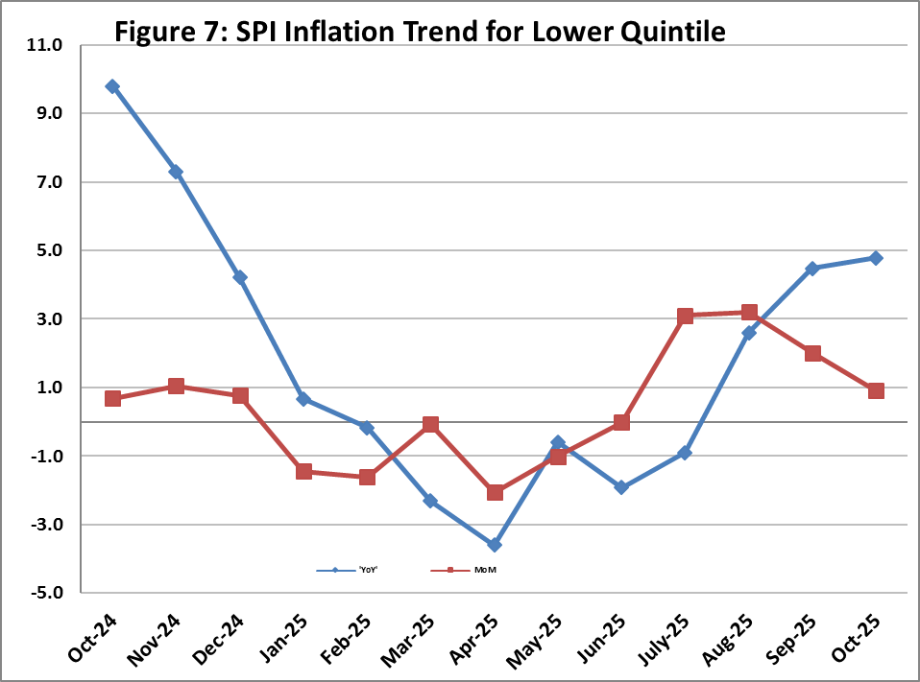

V. Wholesale Price Index
The Wholesale Price Index for October 2025 increased by 0.51% over September 2025 and increased by 1.10% over the corresponding month of the last year i.e. October, 2024. YoY and MoM movements from October, 2024 to October, 2025 are also graphed below in Figure 8.

Table 5: Wholesale Price Index by Group of Commodities (Base 2015-16)
No | Group | Group  Weight  (%) | Indices |  |  | % Change  Oct 2025  Over |  | Impact  (In % points)  Oct 2025 Over
No | Group | Group  Weight  (%) | Oct 25 | Sep 25 | Oct 24 | Sep 25 | Oct 24 | Sep 25 | Oct 24
 | General | 100.00 | 316.96 | 315.34 | 313.50 | 0.51 | 1.10 | 0.51 | 1.10
1 | Agriculture Forestry & Fishery | 25.77 | 284.94 | 283.50 | 291.04 | 0.51 | -2.10 | 0.12 | -0.50
2 | Ores/Minerals, Elec., Gas & Water | 12.01 | 356.22 | 349.10 | 366.68 | 2.04 | -2.85 | 0.27 | -0.40
3 | Food, Beverages, Tobacco, Textiles & Leather Products | 31.11 | 292.89 | 290.38 | 272.86 | 0.86 | 7.34 | 0.25 | 1.99
 | i. Food Products, Beverages & Tobacco | 20.07 | 314.00 | 310.15 | 286.87 | 1.24 | 9.46 | 0.25 | 1.74
 | ii. Textiles & Apparels | 10.33 | 259.70 | 259.63 | 251.41 | 0.03 | 3.30 | 0.00 | 0.27
 | iii. Leather Products | 0.71 | 179.03 | 179.03 | 188.92 | 0.00 | -5.24 | 0.00 | -0.02
4 | Other Transportable Goods | 22.40 | 336.35 | 338.00 | 337.73 | -0.49 | -0.41 | -0.12 | -0.10
5 | Metal Product, Machinery & Equipment | 8.72 | 393.66 | 393.89 | 389.45 | -0.06 | 1.08 | -0.01 | 0.12

Main contributors to month-on-month and year-on-year percentage changes are given below and detail is given in Annexure-C.

- MONTH-ON-MONTH: Top few commodities which varied from previous month are given below:
Increased: Vegetables (22.56%), Wheat (12.63%), Wheat Flour (8.67%), Woven Fabrics (8.33%), Maize (6.59%), Electrical Energy (5.75%), Eggs (4.46%), Oil Cakes (3.94%), Kerosene Oil (2.78%), Stimulant & Spice Crops (2.66%) and Dried Fruits & Nuts (2.57%).
Decreased: Poultry (20.99%), Dry Fruits (8.13%), Millet / Bajra (6.57%), Fresh Fruits (5.98%), Synthetic Carpets (4.36%), Furnace Oil (4.35%), Fibre Crops (2.47%), Other Cereal Flour (2.33%), Glass Sheets (2.12%), Sugar Crops (2.08%) and Cement (1.89%).

YEAR-ON-YEAR: Top few commodities which varied from previous year are given below:
Increased: Other Food Products (52.77%), Sugar Refined (35.56%), Sugar Confectionary (30.98%), Wheat (24.81%), Sorghum / Jowar (24.56%), Dyeing Material (22.99%), Pesticides (20.61%), Millet / Bajra (19.61%), Wheat Flour (16.34%) and Maize (16.17%).
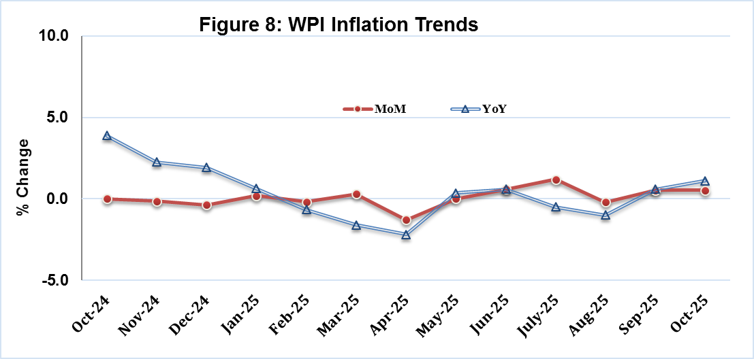
Decreased: Stimulant & Spice Crops (36.73%), Poultry (32.00%), Other Cereal Flour (24.60%), Furnace Oil (20.29%), Pulses (15.95%), Electrical Energy (15.03%), Fibre Crops (14.64%), Other Leather N.E.C (14.24%), Edible Roots / Potatoes (11.03%) and Cement (6.59%).
Annexure A: CPI (Urban) Index Numbers by Commodity Groups & Commodities (2015-16=100)
Item and Specification |  | Weight | Index Numbers  Oct 25 Sep 25 Oct 24 |  |  | % Change in Oct 2025 over  Sep 2025 Oct 2024
 | General | 100.0000 | 276.28 | 272.09 | 260.64 |  | + | 1.54 |  | + | 6.00
 | Food and non-alcoholic Beverages | 30.4215 | 293.61 | 287.74 | 281.39 |  | + | 2.04 |  | + | 4.34
01 | Wheat | 0.6120 | 287.88 | 260.50 | 234.88 |  | + | 10.51 |  | + | 22.56
02 | Wheat flour | 3.0075 | 275.00 | 260.69 | 237.71 |  | + | 5.49 |  | + | 15.69
03 | Wheat products | 0.0936 | 287.70 | 280.38 | 293.91 |  | + | 2.61 |  | - | 2.11
04 | Besan | 0.0830 | 249.47 | 254.06 | 320.94 |  | - | 1.81 |  | - | 22.27
05 | Rice | 1.1804 | 330.87 | 330.09 | 314.76 |  | + | 0.24 |  | + | 5.12
06 | Bakery and confectionary | 0.4770 | 270.83 | 270.74 | 262.99 |  | + | 0.03 |  | + | 2.98
07 | Nimco | 0.1224 | 302.11 | 301.17 | 292.50 |  | + | 0.31 |  | + | 3.29
08 | Meat | 2.0411 | 350.61 | 348.63 | 321.62 |  | + | 0.57 |  | + | 9.01
09 | Chicken | 1.3631 | 229.92 | 292.98 | 324.19 |  | - | 21.52 |  | - | 29.08
10 | Fish | 0.3855 | 219.45 | 211.35 | 207.73 |  | + | 3.83 |  | + | 5.64
11 | Milk fresh | 7.1070 | 268.25 | 266.65 | 259.55 |  | + | 0.60 |  | + | 3.35
12 | Milk products | 0.6407 | 269.24 | 268.56 | 264.32 |  | + | 0.25 |  | + | 1.86
13 | Milk powder | 0.3106 | 320.03 | 317.55 | 302.42 |  | + | 0.78 |  | + | 5.82
14 | Eggs | 0.5083 | 376.76 | 361.49 | 348.81 |  | + | 4.22 |  | + | 8.01
15 | Butter | 0.0932 | 487.80 | 477.26 | 376.31 |  | + | 2.21 |  | + | 29.63
16 | Mustard oil | 0.0120 | 312.24 | 310.45 | 288.85 |  | + | 0.58 |  | + | 8.10
17 | Cooking oil | 1.1016 | 328.02 | 324.71 | 299.20 |  | + | 1.02 |  | + | 9.63
18 | Vegetable ghee | 1.0324 | 350.45 | 343.87 | 311.51 |  | + | 1.91 |  | + | 12.50
19 | Dry fruits | 0.3299 | 299.77 | 298.95 | 287.80 |  | + | 0.27 |  | + | 4.16
20 | Fresh fruits | 1.4363 | 225.89 | 220.51 | 203.14 |  | + | 2.44 |  | + | 11.20
21 | Pulse masoor | 0.1624 | 199.70 | 200.35 | 211.12 |  | - | 0.32 |  | - | 5.41
22 | Pulse moong | 0.1697 | 237.40 | 237.88 | 212.18 |  | - | 0.20 |  | + | 11.89
23 | Pulse mash | 0.1152 | 185.86 | 185.78 | 237.68 |  | + | 0.04 |  | - | 21.80
24 | Pulse gram | 0.1660 | 247.29 | 251.67 | 340.04 |  | - | 1.74 |  | - | 27.28
25 | Gram whole | 0.0912 | 267.59 | 269.69 | 324.31 |  | - | 0.78 |  | - | 17.49
26 | Beans | 0.0408 | 357.07 | 364.08 | 375.40 |  | - | 1.93 |  | - | 4.88
27 | Potatoes | 0.4496 | 334.57 | 342.66 | 403.68 |  | - | 2.36 |  | - | 17.12
28 | Onions | 0.5928 | 245.17 | 206.52 | 370.44 |  | + | 18.71 |  | - | 33.82
29 | Tomatoes | 0.3459 | 643.69 | 405.76 | 283.61 |  | + | 58.64 |  | + | 126.96
30 | Fresh vegetables | 1.5306 | 311.02 | 277.14 | 317.78 |  | + | 12.22 |  | - | 2.13
31 | Sugar | 1.1130 | 294.42 | 293.97 | 218.36 |  | + | 0.15 |  | + | 34.83
32 | Gur | 0.0379 | 283.46 | 277.53 | 247.62 |  | + | 2.14 |  | + | 14.47
33 | Honey | 0.1017 | 222.62 | 222.73 | 189.01 |  | - | 0.05 |  | + | 17.78
34 | Sweetmeat | 0.3535 | 333.14 | 332.76 | 312.78 |  | + | 0.11 |  | + | 6.51
35 | Ice cream | 0.1044 | 199.68 | 199.68 | 199.33 |  | + | 0.00 |  | + | 0.18
36 | Condiments and Spices | 1.3340 | 375.91 | 373.17 | 353.20 |  | + | 0.73 |  | + | 6.43
37 | Dessert preparation | 0.0419 | 300.37 | 297.93 | 269.99 |  | + | 0.82 |  | + | 11.25
38 | Tea | 0.8427 | 273.67 | 273.67 | 332.73 |  | + | 0.00 |  | - | 17.75
39 | Beverages | 0.8906 | 260.89 | 261.09 | 251.62 |  | - | 0.08 |  | + | 3.68
 | Alcoholic Beverages, Tobacco | 0.8540 | 420.73 | 420.57 | 408.28 |  | + | 0.04 |  | + | 3.05
40 | Cigarettes | 0.7167 | 411.78 | 411.79 | 406.25 |  | + | 0.00 |  | + | 1.36
41 | Pan prepared | 0.1373 | 467.46 | 466.38 | 418.90 |  | + | 0.23 |  | + | 11.59
 | Clothing and footwear | 8.0096 | 256.50 | 255.85 | 237.24 |  | + | 0.25 |  | + | 8.12
42 | Cotton cloth | 2.2227 | 299.86 | 299.83 | 279.95 |  | + | 0.01 |  | + | 7.11
43 | Woollen cloth | 0.8361 | 244.87 | 243.92 | 228.89 |  | + | 0.39 |  | + | 6.98
44 | Readymade garments | 1.3196 | 223.65 | 223.24 | 206.62 |  | + | 0.18 |  | + | 8.24
45 | Woollen readymade garments | 0.4307 | 257.61 | 256.71 | 230.71 |  | + | 0.35 |  | + | 11.66
46 | Tailoring | 1.0741 | 240.93 | 238.22 | 228.16 |  | + | 1.14 |  | + | 5.60
47 | Hosiery | 0.4070 | 240.18 | 239.53 | 227.67 |  | + | 0.27 |  | + | 5.49
48 | Dupatta | 0.1713 | 206.21 | 205.48 | 197.13 |  | + | 0.36 |  | + | 4.61
49 | Cleaning and laundering | 0.0665 | 276.81 | 276.51 | 262.20 |  | + | 0.11 |  | + | 5.57
50 | Footwear | 1.4816 | 247.60 | 247.57 | 219.75 |  | + | 0.01 |  | + | 12.67
 | Housing, water, Elec., Gas and other Fuels | 27.0332 | 259.29 | 254.08 | 245.75 |  | + | 2.05 |  | + | 5.51
51 | House rent | 19.2558 | 175.49 | 172.97 | 165.69 |  | + | 1.46 |  | + | 5.91
52 | Construction input items | 0.3765 | 269.81 | 269.90 | 266.17 |  | - | 0.03 |  | + | 1.37
53 | Construction wage rates | 0.2025 | 228.68 | 228.36 | 217.43 |  | + | 0.14 |  | + | 5.17
54 | Water supply | 0.5269 | 231.40 | 230.44 | 221.86 |  | + | 0.42 |  | + | 4.30
55 | Garbage collection | 0.1064 | 265.81 | 265.81 | 252.22 |  | + | 0.00 |  | + | 5.39
56 | Electricity charges | 4.5562 | 244.37 | 224.65 | 289.50 |  | + | 8.78 |  | - | 15.59
57 | Gas charges | 1.0807 | 1817.96 | 1817.96 | 1479.08 |  | + | 0.00 |  | + | 22.91
58 | Liquefied Hydrocarbons | 0.5064 | 311.04 | 308.77 | 316.48 |  | + | 0.74 |  | - | 1.72
59 | Solid Fuel | 0.4218 | 228.56 | 226.86 | 206.59 |  | + | 0.75 |  | + | 10.63
 | Furnishing and household equipments | 4.0937 | 272.01 | 270.65 | 261.24 |  | + | 0.50 |  | + | 4.12
60 | Furniture and furnishing | 0.4750 | 263.79 | 263.17 | 253.65 |  | + | 0.24 |  | + | 4.00
61 | Carpets | 0.0308 | 154.92 | 154.28 | 150.43 |  | + | 0.41 |  | + | 2.98
62 | Household textiles | 0.3420 | 212.86 | 212.08 | 193.65 |  | + | 0.37 |  | + | 9.92
63 | Household equipments | 1.0032 | 276.53 | 274.22 | 261.92 |  | + | 0.84 |  | + | 5.58
64 | Plastic products | 0.0536 | 233.69 | 233.65 | 215.58 |  | + | 0.02 |  | + | 8.40
65 | Major tools & equipments | 0.0084 | 252.17 | 251.70 | 234.27 |  | + | 0.19 |  | + | 7.64
66 | Washing soap/detergents/match | 1.4112 | 325.05 | 323.90 | 320.80 |  | + | 0.36 |  | + | 1.32
67 | Household servant | 0.7695 | 207.79 | 206.41 | 193.75 |  | + | 0.67 |  | + | 7.25
 | Health | 2.3098 | 282.04 | 280.61 | 260.72 |  | + | 0.51 |  | + | 8.18
68 | Drugs and medicines | 1.0735 | 303.89 | 301.47 | 276.17 |  | + | 0.80 |  | + | 10.04
69 | Therapeutic Appliances and Equipments | 0.0054 | 156.04 | 155.97 | 150.99 |  | + | 0.04 |  | + | 3.34
70 | Doctor (MBBS) clinic fee | 0.4044 | 353.99 | 353.04 | 331.80 |  | + | 0.27 |  | + | 6.69
71 | Dental services | 0.0156 | 233.79 | 231.05 | 213.70 |  | + | 1.19 |  | + | 9.40
72 | Medical tests | 0.2367 | 217.81 | 217.37 | 198.20 |  | + | 0.20 |  | + | 9.89
73 | Hospitals services | 0.5742 | 219.47 | 219.20 | 209.84 |  | + | 0.12 |  | + | 4.59
 | Transport | 6.1368 | 314.95 | 311.84 | 294.62 |  | + | 1.00 |  | + | 6.90
74 | Motor vehicles | 0.8097 | 267.42 | 267.42 | 259.37 |  | + | 0.00 |  | + | 3.10
75 | Motor vehicle accessories | 0.1941 | 266.57 | 266.36 | 260.10 |  | + | 0.08 |  | + | 2.49
76 | Motor fuel | 2.9088 | 361.89 | 360.42 | 339.72 |  | + | 0.41 |  | + | 6.53
77 | Mechanical services | 0.4290 | 241.07 | 239.15 | 230.14 |  | + | 0.80 |  | + | 4.75
78 | Motor vehicle tax | 0.0482 | 399.23 | 399.23 | 399.23 |  | + | 0.00 |  | + | 0.00
79 | Transport services | 1.7470 | 280.01 | 272.03 | 252.66 |  | + | 2.93 |  | + | 10.82
 | Communication | 2.3536 | 138.97 | 138.78 | 138.37 |  | + | 0.14 |  | + | 0.43
80 | Postal services | 0.0190 | 238.31 | 224.60 | 218.10 |  | + | 6.10 |  | + | 9.27
81 | Communication apparatus | 0.4524 | 190.66 | 190.24 | 188.38 |  | + | 0.22 |  | + | 1.21
82 | Communication Services | 1.8822 | 125.55 | 125.55 | 125.55 |  | + | 0.00 |  | + | 0.00
 | Recreation and culture | 1.7301 | 248.77 | 250.70 | 259.72 |  | - | 0.77 |  | - | 4.22
83 | Recreation and culture | 0.6478 | 155.07 | 155.07 | 152.95 |  | + | 0.00 |  | + | 1.39
84 | Text books | 0.6655 | 297.49 | 303.56 | 332.81 |  | - | 2.00 |  | - | 10.61
85 | Newspapers | 0.0716 | 242.82 | 242.82 | 216.94 |  | + | 0.00 |  | + | 11.93
86 | stationery | 0.3452 | 331.92 | 329.89 | 328.06 |  | + | 0.62 |  | + | 1.18
 | Education | 4.8807 | 216.38 | 216.28 | 195.98 |  | + | 0.05 |  | + | 10.41
87 | Education | 4.8807 | 216.38 | 216.28 | 195.98 |  | + | 0.05 |  | + | 10.41
 | Restaurants and hotels | 7.4050 | 288.06 | 286.84 | 272.98 |  | + | 0.43 |  | + | 5.52
88 | Readymade food | 5.5235 | 295.32 | 294.01 | 279.53 |  | + | 0.45 |  | + | 5.65
89 | Marriage Hall Charges | 1.7514 | 273.01 | 272.07 | 260.01 |  | + | 0.35 |  | + | 5.00
90 | Accommodation Services | 0.1301 | 182.00 | 181.46 | 169.14 |  | + | 0.30 |  | + | 7.60
 | Misc. goods and services | 4.7720 | 341.17 | 328.68 | 289.03 |  | + | 3.80 |  | + | 18.04
91 | Personal Grooming Services | 0.8001 | 273.18 | 272.47 | 250.97 |  | + | 0.26 |  | + | 8.85
92 | Electrical Appliances for Per | 0.0465 | 191.11 | 190.99 | 168.24 |  | + | 0.06 |  | + | 13.59
93 | Appliances/Articles/Products | 2.9807 | 289.78 | 286.20 | 265.24 |  | + | 1.25 |  | + | 9.25
94 | Personal Effects n.e.c. | 0.9447 | 568.27 | 517.10 | 402.27 |  | + | 9.90 |  | + | 41.27

Annexure B: CPI (Rural) Index Numbers by Commodity Groups & Commodities (2015-16=100)
Item and Specification |  | Weight | Index Numbers  Oct 25 Sep 25 Oct 24 |  |  | % Change in Oct 2025 over  Sep 2025 Oct 2024
 | General | 100.0000 | 287.26 | 280.91 | 269.51 |  | + | 2.26 |  | + | 6.59
 | Food and non-alcoholic Beverages | 40.8668 | 304.16 | 294.12 | 284.51 |  | + | 3.41 |  | + | 6.91
01 | Wheat | 3.4736 | 294.77 | 269.83 | 232.79 |  | + | 9.24 |  | + | 26.62
02 | Wheat Flour | 3.4297 | 292.21 | 269.89 | 236.65 |  | + | 8.27 |  | + | 23.48
03 | Wheat Products | 0.1068 | 291.27 | 283.28 | 289.77 |  | + | 2.82 |  | + | 0.52
04 | Besan | 0.0728 | 273.16 | 273.04 | 329.13 |  | + | 0.04 |  | - | 17.01
05 | Rice | 1.5501 | 433.22 | 425.55 | 420.65 |  | + | 1.80 |  | + | 2.99
06 | Bakery and Confectionary | 0.3702 | 316.71 | 315.81 | 302.32 |  | + | 0.28 |  | + | 4.76
07 | Nimco | 0.0774 | 309.10 | 305.77 | 301.85 |  | + | 1.09 |  | + | 2.40
08 | Meat | 1.7146 | 375.28 | 373.08 | 336.32 |  | + | 0.59 |  | + | 11.58
09 | Chicken | 1.4641 | 249.97 | 318.11 | 337.45 |  | - | 21.42 |  | - | 25.92
10 | Fish | 0.2640 | 226.77 | 225.39 | 224.76 |  | + | 0.61 |  | + | 0.89
11 | Milk fresh | 10.3803 | 269.82 | 266.65 | 255.67 |  | + | 1.19 |  | + | 5.53
12 | Milk products | 0.9624 | 264.51 | 263.17 | 256.57 |  | + | 0.51 |  | + | 3.09
13 | Milk powder | 0.1062 | 295.25 | 288.95 | 275.37 |  | + | 2.18 |  | + | 7.22
14 | Eggs | 0.5665 | 361.23 | 341.34 | 336.91 |  | + | 5.83 |  | + | 7.22
15 | Butter | 0.3333 | 317.20 | 313.67 | 293.78 |  | + | 1.13 |  | + | 7.97
16 | Mustard oil | 0.0136 | 334.60 | 326.00 | 309.95 |  | + | 2.64 |  | + | 7.95
17 | Cooking oil | 0.6011 | 367.03 | 362.86 | 333.26 |  | + | 1.15 |  | + | 10.13
18 | Vegetable ghee | 2.3764 | 382.16 | 374.58 | 340.71 |  | + | 2.02 |  | + | 12.17
19 | Dry fruits | 0.2496 | 369.04 | 367.55 | 330.20 |  | + | 0.41 |  | + | 11.76
20 | Fresh fruits | 1.4505 | 229.16 | 229.29 | 214.09 |  | - | 0.06 |  | + | 7.04
21 | Pulse Masoor | 0.2076 | 226.51 | 225.71 | 234.14 |  | + | 0.35 |  | - | 3.26
22 | Pulse Moong | 0.2510 | 256.12 | 261.36 | 233.12 |  | - | 2.00 |  | + | 9.87
23 | Pulse Mash | 0.1465 | 196.66 | 197.11 | 247.78 |  | - | 0.23 |  | - | 20.63
24 | Pulse Gram | 0.2751 | 253.23 | 259.38 | 336.12 |  | - | 2.37 |  | - | 24.66
25 | Gram Whole | 0.1116 | 286.65 | 292.04 | 324.87 |  | - | 1.85 |  | - | 11.76
26 | Beans | 0.0896 | 397.64 | 397.29 | 405.99 |  | + | 0.09 |  | - | 2.06
27 | Potatoes | 0.7437 | 385.52 | 374.54 | 438.97 |  | + | 2.93 |  | - | 12.18
28 | Onions | 0.8965 | 231.60 | 195.93 | 376.17 |  | + | 18.21 |  | - | 38.43
29 | Tomatoes | 0.5069 | 637.00 | 430.77 | 255.46 |  | + | 47.87 |  | + | 149.35
30 | Fresh Vegetables | 2.0947 | 331.14 | 277.11 | 319.79 |  | + | 19.50 |  | + | 3.55
31 | Sugar | 2.0296 | 302.07 | 300.83 | 220.60 |  | + | 0.41 |  | + | 36.93
32 | Gur | 0.1522 | 282.27 | 289.02 | 248.07 |  | - | 2.34 |  | + | 13.79
33 | Honey | 0.0296 | 227.67 | 230.07 | 192.44 |  | - | 1.04 |  | + | 18.31
34 | Sweetmeat | 0.3967 | 298.47 | 294.30 | 281.51 |  | + | 1.42 |  | + | 6.02
35 | Ice Cream | 0.0568 | 198.80 | 199.76 | 199.34 |  | - | 0.48 |  | - | 0.27
36 | Condiments and Spices | 1.4919 | 301.30 | 297.35 | 312.00 |  | + | 1.33 |  | - | 3.43
37 | Dessert Preparation | 0.0133 | 294.88 | 292.45 | 268.52 |  | + | 0.83 |  | + | 9.82
38 | Tea | 1.2566 | 271.09 | 273.01 | 333.85 |  | - | 0.70 |  | - | 18.80
39 | Beverages | 0.5537 | 254.91 | 253.91 | 242.29 |  | + | 0.39 |  | + | 5.21
 | Alcoholic Beverages, Tobacco | 1.2786 | 375.29 | 375.81 | 362.33 |  | - | 0.14 |  | + | 3.58
40 | Cigarettes | 1.2364 | 375.16 | 375.70 | 362.77 |  | - | 0.14 |  | + | 3.42
41 | Pan Prepared | 0.0422 | 379.08 | 379.08 | 349.58 |  | + | 0.00 |  | + | 8.44
 | Clothing and footwear | 9.4826 | 279.63 | 278.46 | 258.89 |  | + | 0.42 |  | + | 8.01
42 | Cotton Cloth | 2.8381 | 305.70 | 305.70 | 291.34 |  | + | 0.00 |  | + | 4.93
43 | Woollen Cloth | 1.0959 | 271.28 | 269.54 | 251.64 |  | + | 0.65 |  | + | 7.80
44 | Readymade Garments | 1.1345 | 262.49 | 258.67 | 228.81 |  | + | 1.48 |  | + | 14.72
45 | Woollen Readymade Garments | 0.5401 | 313.83 | 309.66 | 268.66 |  | + | 1.35 |  | + | 16.81
46 | Tailoring | 1.2999 | 261.46 | 260.89 | 242.57 |  | + | 0.22 |  | + | 7.79
47 | Hosiery | 0.4322 | 351.38 | 350.64 | 339.18 |  | + | 0.21 |  | + | 3.60
48 | Dupatta | 0.2078 | 257.83 | 255.32 | 241.28 |  | + | 0.98 |  | + | 6.86
49 | Cleaning and Laundering | 0.0176 | 264.46 | 264.16 | 251.35 |  | + | 0.11 |  | + | 5.22
50 | Footwear | 1.9165 | 244.97 | 244.46 | 224.98 |  | + | 0.21 |  | + | 8.89
 | Housing, water, Elec., Gas and other Fuels | 18.4853 | 227.75 | 222.12 | 225.10 |  | + | 2.53 |  | + | 1.18
51 | House Rent | 8.6110 | 184.43 | 181.11 | 172.58 |  | + | 1.83 |  | + | 6.87
52 | Construction Input Items | 0.6306 | 258.71 | 258.37 | 252.58 |  | + | 0.13 |  | + | 2.43
53 | Construction Wage Rates | 0.2526 | 248.08 | 245.93 | 237.47 |  | + | 0.87 |  | + | 4.47
54 | Water Supply | 0.0645 | 325.72 | 325.72 | 311.91 |  | + | 0.00 |  | + | 4.43
55 | Garbage Collection | 0.0080 | 204.36 | 204.36 | 190.06 |  | + | 0.00 |  | + | 7.52
56 | Electricity Charges | 3.4431 | 244.37 | 224.65 | 289.50 |  | + | 8.78 |  | - | 15.59
57 | Liquefied Hydrocarbons | 0.9994 | 291.89 | 294.65 | 299.75 |  | - | 0.94 |  | - | 2.62
58 | Solid Fuel | 4.4761 | 277.08 | 274.95 | 254.18 |  | + | 0.77 |  | + | 9.01
 | Furnishing and household equipments | 4.1031 | 296.68 | 295.37 | 285.81 |  | + | 0.44 |  | + | 3.80
59 | Furniture and Furnishing | 0.5786 | 295.39 | 295.19 | 274.53 |  | + | 0.07 |  | + | 7.60
60 | Household Textiles | 0.4382 | 247.48 | 244.14 | 224.32 |  | + | 1.37 |  | + | 10.32
61 | Household Equipments | 1.2774 | 297.64 | 296.62 | 283.60 |  | + | 0.34 |  | + | 4.95
62 | Plastic Products | 0.0776 | 307.14 | 306.39 | 279.48 |  | + | 0.24 |  | + | 9.90
63 | Major Tools and Equipments | 0.0324 | 248.06 | 247.13 | 231.51 |  | + | 0.38 |  | + | 7.15
64 | Washing Soaps, Detergents and | 1.6989 | 309.54 | 308.11 | 308.50 |  | + | 0.46 |  | + | 0.34
 | Health | 3.5141 | 280.71 | 278.38 | 252.33 |  | + | 0.84 |  | + | 11.25
65 | Drugs and Medicines | 1.5792 | 330.00 | 327.21 | 295.50 |  | + | 0.85 |  | + | 11.68
66 | Doctor Clinic Fee | 0.5128 | 330.62 | 329.20 | 288.55 |  | + | 0.43 |  | + | 14.58
67 | Dental Services | 0.0181 | 254.82 | 254.82 | 214.60 |  | + | 0.00 |  | + | 18.74
68 | Medical Tests | 0.3967 | 239.92 | 235.99 | 219.62 |  | + | 1.67 |  | + | 9.24
69 | Hospitals Services | 1.0073 | 194.55 | 193.08 | 179.79 |  | + | 0.76 |  | + | 8.21
 | Transport | 5.5580 | 327.77 | 325.74 | 307.99 |  | + | 0.62 |  | + | 6.42
70 | Motor Vehicles | 0.7305 | 194.76 | 194.75 | 193.12 |  | + | 0.01 |  | + | 0.85
71 | Motor Vehicles Accessories | 0.1572 | 274.25 | 273.35 | 268.58 |  | + | 0.33 |  | + | 2.11
72 | Motor Fuels | 2.4932 | 363.78 | 362.20 | 339.91 |  | + | 0.44 |  | + | 7.02
73 | Mechanical Services | 0.3645 | 232.83 | 232.83 | 229.81 |  | + | 0.00 |  | + | 1.31
74 | Motor Vehicle Tax | 0.0174 | 342.03 | 342.03 | 342.03 |  | + | 0.00 |  | + | 0.00
75 | Transport Services | 1.7952 | 355.72 | 351.72 | 329.41 |  | + | 1.14 |  | + | 7.99
 | Communication | 1.9940 | 129.66 | 129.33 | 128.57 |  | + | 0.26 |  | + | 0.85
76 | Postal Services | 0.0070 | 179.32 | 181.92 | 179.32 |  | - | 1.43 |  | + | 0.00
77 | Communication Apparatus | 0.3362 | 167.40 | 165.43 | 160.95 |  | + | 1.19 |  | + | 4.01
78 | Communication Services | 1.6508 | 121.76 | 121.76 | 121.76 |  | + | 0.00 |  | + | 0.00
 | Recreation and culture | 1.3764 | 293.93 | 296.47 | 302.66 |  | - | 0.86 |  | - | 2.88
79 | Recreation and Culture | 0.4763 | 260.32 | 257.56 | 234.33 |  | + | 1.07 |  | + | 11.09
80 | Text Books | 0.5047 | 305.32 | 316.19 | 360.47 |  | - | 3.44 |  | - | 15.30
81 | Newspapers | 0.0230 | 282.94 | 282.94 | 242.52 |  | + | 0.00 |  | + | 16.67
82 | Stationery | 0.3724 | 322.16 | 320.33 | 315.42 |  | + | 0.57 |  | + | 2.14
 | Education | 2.1342 | 248.57 | 248.13 | 223.51 |  | + | 0.18 |  | + | 11.21
83 | Education | 2.1342 | 248.57 | 248.13 | 223.51 |  | + | 0.18 |  | + | 11.21
 | Restaurants and hotels | 6.1895 | 303.98 | 302.60 | 283.88 |  | + | 0.46 |  | + | 7.08
84 | Readymade Food | 3.8001 | 330.68 | 329.27 | 308.63 |  | + | 0.43 |  | + | 7.14
85 | Marriage Hall Charges | 2.2525 | 270.53 | 269.10 | 252.48 |  | + | 0.53 |  | + | 7.15
86 | Accommodation Services | 0.1369 | 113.40 | 113.40 | 113.40 |  | + | 0.00 |  | + | 0.00
 | Misc. goods and services | 5.0174 | 369.58 | 353.86 | 312.20 |  | + | 4.44 |  | + | 18.38
87 | Personal Grooming Services | 1.5363 | 322.90 | 317.27 | 302.62 |  | + | 1.77 |  | + | 6.70
88 | Appliances/Articles/Products | 2.2746 | 268.72 | 267.88 | 254.90 |  | + | 0.31 |  | + | 5.42
89 | Personal Effects n.e.c. | 1.2065 | 619.18 | 562.56 | 432.42 |  | + | 10.06 |  | + | 43.19

Annexure C:Wholesale Price Indices by Major Groups & Commodities (2015-16=100)
Item and Specification |  | Weight | Index Numbers  Oct 25 Sep 25 Oct 24 |  |  | % Change in Oct 2025 over  Sep 2025 Oct 2024
 | General | 100.0000 | 316.96 | 315.34 | 313.50 |  | + | 0.51 |  | + | 1.10
 | Agriculture Forestry & Fishery | 25.7674 | 284.94 | 283.50 | 291.04 |  | + | 0.51 |  | - | 2.10
001 | Wheat | 0.6297 | 287.88 | 255.60 | 230.65 |  | + | 12.63 |  | + | 24.81
002 | Maize | 0.6764 | 317.85 | 298.19 | 273.61 |  | + | 6.59 |  | + | 16.17
003 | Rice | 2.4413 | 329.85 | 331.33 | 337.63 |  | - | 0.45 |  | - | 2.30
004 | Sorghum / Jowar | 0.0214 | 355.88 | 359.66 | 285.72 |  | - | 1.05 |  | + | 24.56
005 | Millet / Bajra | 0.0374 | 321.24 | 343.84 | 268.57 |  | - | 6.57 |  | + | 19.61
006 | Vegetables | 1.2441 | 485.04 | 395.75 | 461.76 |  | + | 22.56 |  | + | 5.04
007 | Fresh Fruits | 1.5144 | 253.44 | 269.56 | 230.58 |  | - | 5.98 |  | + | 9.91
008 | Dry Fruits | 0.2478 | 390.11 | 424.65 | 359.22 |  | - | 8.13 |  | + | 8.60
009 | Cotton Seeds | 1.1511 | 189.75 | 192.70 | 188.84 |  | - | 1.53 |  | + | 0.48
010 | Other Oil Seeds | 0.0722 | 296.92 | 295.38 | 284.66 |  | + | 0.52 |  | + | 4.31
011 | Edible Roots / Potatoes | 0.2540 | 410.28 | 416.90 | 461.14 |  | - | 1.59 |  | - | 11.03
012 | Stimulant & Spice Crops | 0.1634 | 422.90 | 411.95 | 668.44 |  | + | 2.66 |  | - | 36.73
013 | Pulses | 0.4901 | 260.45 | 262.47 | 309.87 |  | - | 0.77 |  | - | 15.95
014 | Sugar Crops | 1.0725 | 360.42 | 368.06 | 317.48 |  | - | 2.08 |  | + | 13.53
015 | Fibre Crops | 5.3169 | 289.90 | 297.23 | 339.64 |  | - | 2.47 |  | - | 14.64
016 | Unmanufactured Tobacco | 0.0742 | 554.20 | 554.55 | 583.59 |  | - | 0.06 |  | - | 5.04
017 | Poultry | 0.5633 | 217.59 | 275.40 | 319.98 |  | - | 20.99 |  | - | 32.00
018 | Raw Milk from Bovine Animals | 7.0279 | 254.94 | 254.61 | 246.84 |  | + | 0.13 |  | + | 3.28
019 | Eggs | 0.5034 | 380.16 | 363.93 | 343.27 |  | + | 4.46 |  | + | 10.75
020 | Raw Animal Materials / Wool | 0.0351 | 257.31 | 257.31 | 230.73 |  | + | 0.00 |  | + | 11.52
021 | Hides, Skins & Fur Skins, Raw | 0.4834 | 59.50 | 59.44 | 54.56 |  | + | 0.10 |  | + | 9.05
022 | Fuel Wood in Logs | 0.0179 | 216.92 | 215.22 | 187.09 |  | + | 0.79 |  | + | 15.94
023 | Fish Live Fresh or Chilled | 1.7295 | 219.67 | 217.71 | 222.24 |  | + | 0.90 |  | - | 1.16
 | Ores/Minerals, Elec., Gas & Water | 12.0069 | 356.22 | 349.10 | 366.68 |  | + | 2.04 |  | - | 2.85
024 | Coal not Agglomerated | 0.7508 | 219.17 | 219.17 | 227.51 |  | + | 0.00 |  | - | 3.67
025 | Natural Gas Liquefied | 5.7065 | 444.93 | 444.79 | 418.10 |  | + | 0.03 |  | + | 6.42
026 | Salt & Pure Sodium Chloride | 0.0584 | 429.44 | 421.76 | 405.15 |  | + | 1.82 |  | + | 6.00
027 | Electrical Energy | 5.4912 | 281.99 | 266.65 | 331.86 |  | + | 5.75 |  | - | 15.03
 | Food,Beverages,Tobacco,Textile | 31.1122 | 292.89 | 290.38 | 272.86 |  | + | 0.86 |  | + | 7.34
 | Food Products, Beverages & | 20.0718 | 314.00 | 310.15 | 286.87 |  | + | 1.24 |  | + | 9.46
028 | Meat of Animals | 3.4559 | 350.29 | 347.69 | 310.57 |  | + | 0.75 |  | + | 12.79
029 | Vegetables & Fruit Juice | 0.0058 | 252.95 | 252.95 | 240.09 |  | + | 0.00 |  | + | 5.36
030 | Dried Fruits & Nuts | 0.1733 | 411.12 | 400.81 | 384.99 |  | + | 2.57 |  | + | 6.79
031 | Fruit Juices | 0.3880 | 283.59 | 283.70 | 270.83 |  | - | 0.04 |  | + | 4.71
032 | Vegetable Oils Refined | 1.9242 | 288.92 | 290.25 | 273.73 |  | - | 0.46 |  | + | 5.55
033 | Vegetable Ghee | 1.5632 | 368.95 | 363.68 | 329.35 |  | + | 1.45 |  | + | 12.02
034 | Oil Cakes | 0.9611 | 259.59 | 249.76 | 260.89 |  | + | 3.94 |  | - | 0.50
035 | Processed Liquid Milk | 4.4437 | 332.40 | 332.40 | 320.66 |  | + | 0.00 |  | + | 3.66
036 | Milk & Cream in Solid Form | 0.0316 | 304.26 | 303.46 | 295.87 |  | + | 0.26 |  | + | 2.84
037 | Ice Cream | 0.0047 | 200.56 | 200.56 | 200.56 |  | + | 0.00 |  | + | 0.00
038 | Dairy Products N.E.C | 0.0117 | 336.90 | 335.07 | 324.30 |  | + | 0.55 |  | + | 3.89
039 | Wheat Flour | 2.3034 | 280.46 | 258.09 | 241.07 |  | + | 8.67 |  | + | 16.34
040 | Other Cereal Flour | 0.0604 | 265.88 | 272.21 | 352.62 |  | - | 2.33 |  | - | 24.60
041 | Sugar Refined | 1.7975 | 298.22 | 298.06 | 219.99 |  | + | 0.05 |  | + | 35.56
042 | Chocolate | 0.0139 | 144.31 | 144.31 | 124.44 |  | + | 0.00 |  | + | 15.97
043 | Sugar Confectionary | 0.0738 | 315.42 | 315.42 | 240.81 |  | + | 0.00 |  | + | 30.98
044 | Coffee & Tea | 0.7303 | 269.57 | 269.57 | 275.84 |  | + | 0.00 |  | - | 2.27
045 | Spices | 0.1449 | 302.27 | 301.87 | 302.92 |  | + | 0.13 |  | - | 0.21
046 | Other Food Products | 0.0336 | 360.19 | 360.19 | 235.77 |  | + | 0.00 |  | + | 52.77
047 | Mineral Water | 0.0207 | 214.72 | 215.51 | 206.22 |  | - | 0.37 |  | + | 4.12
048 | Beverages | 0.6303 | 259.32 | 259.43 | 264.17 |  | - | 0.04 |  | - | 1.84
049 | Tobacco Products | 1.2998 | 301.20 | 301.20 | 280.52 |  | + | 0.00 |  | + | 7.37
 | Textiles & Apparels | 10.3289 | 259.70 | 259.63 | 251.41 |  | + | 0.03 |  | + | 3.30
050 | Cotton Yarn | 5.2491 | 239.61 | 239.61 | 239.61 |  | + | 0.00 |  | + | 0.00
051 | Nylon Yarn | 0.1719 | 95.24 | 95.24 | 95.24 |  | + | 0.00 |  | + | 0.00
052 | Blended Yarn | 0.1689 | 148.12 | 148.12 | 148.12 |  | + | 0.00 |  | + | 0.00
053 | Woven Fabrics | 0.0128 | 288.63 | 266.43 | 255.78 |  | + | 8.33 |  | + | 12.84
054 | Cotton Fabrics | 0.6343 | 376.37 | 376.37 | 336.14 |  | + | 0.00 |  | + | 11.97
055 | Other Fabrics | 1.1016 | 272.50 | 272.47 | 259.11 |  | + | 0.01 |  | + | 5.17
056 | Silk & Reyon Fabrics | 0.7350 | 402.88 | 401.79 | 395.84 |  | + | 0.27 |  | + | 1.78
057 | Towels | 0.1235 | 205.30 | 205.30 | 202.83 |  | + | 0.00 |  | + | 1.22
058 | Blankets | 0.0029 | 158.92 | 158.92 | 148.31 |  | + | 0.00 |  | + | 7.15
059 | Bed Sheets | 0.0913 | 207.57 | 207.57 | 187.46 |  | + | 0.00 |  | + | 10.73
060 | Quilts | 0.0019 | 243.21 | 243.21 | 235.68 |  | + | 0.00 |  | + | 3.20
061 | Woollen Carpets | 0.0383 | 177.15 | 177.15 | 177.15 |  | + | 0.00 |  | + | 0.00
062 | Synthetic Carpets | 0.0566 | 156.16 | 163.28 | 156.01 |  | - | 4.36 |  | + | 0.10
063 | Hosiery Products | 0.8832 | 213.93 | 213.93 | 199.42 |  | + | 0.00 |  | + | 7.28
064 | Readymade Garments | 1.0576 | 278.68 | 278.68 | 255.32 |  | + | 0.00 |  | + | 9.15
 | Leather Products | 0.7115 | 179.03 | 179.03 | 188.92 |  | + | 0.00 |  | - | 5.24
065 | Leather Without Hair | 0.2973 | 175.98 | 175.98 | 182.58 |  | + | 0.00 |  | - | 3.61
066 | Other Leather N.E.C | 0.2567 | 141.18 | 141.18 | 164.62 |  | + | 0.00 |  | - | 14.24
067 | Footwears | 0.1575 | 246.48 | 246.48 | 240.49 |  | + | 0.00 |  | + | 2.49
 | Other Transportable Goods | 22.3979 | 336.35 | 338.00 | 337.73 |  | - | 0.49 |  | - | 0.41
068 | Timber | 0.0165 | 248.12 | 247.74 | 241.74 |  | + | 0.15 |  | + | 2.64
069 | Printing Paper | 0.4279 | 258.64 | 258.64 | 262.88 |  | + | 0.00 |  | - | 1.61
070 | Hard Board | 0.1579 | 261.62 | 261.62 | 261.62 |  | + | 0.00 |  | + | 0.00
071 | Motor Spirit | 1.6268 | 377.12 | 375.31 | 349.66 |  | + | 0.48 |  | + | 7.85
072 | Diesel Oil | 5.4849 | 349.51 | 343.75 | 311.79 |  | + | 1.68 |  | + | 12.10
073 | Kerosene Oil | 0.2151 | 359.56 | 349.85 | 311.75 |  | + | 2.78 |  | + | 15.34
074 | Furnace Oil | 3.2664 | 443.53 | 463.70 | 556.43 |  | - | 4.35 |  | - | 20.29
075 | Mobil Oil | 0.7114 | 251.76 | 251.76 | 251.76 |  | + | 0.00 |  | + | 0.00
076 | Chemicals | 1.7720 | 281.56 | 282.13 | 271.88 |  | - | 0.20 |  | + | 3.56
077 | Dyeing Material | 0.1539 | 335.16 | 335.16 | 272.52 |  | + | 0.00 |  | + | 22.99
078 | Fertilizers | 2.8657 | 280.23 | 279.72 | 281.47 |  | + | 0.18 |  | - | 0.44
079 | Pesticides | 0.2763 | 236.45 | 236.45 | 196.04 |  | + | 0.00 |  | + | 20.61
080 | Insecticides | 0.1276 | 197.82 | 197.82 | 174.37 |  | + | 0.00 |  | + | 13.45
081 | Paints & Varnishes | 0.1916 | 277.95 | 277.95 | 271.21 |  | + | 0.00 |  | + | 2.49
082 | Medicines | 1.1428 | 397.41 | 394.50 | 346.39 |  | + | 0.74 |  | + | 14.73
083 | Soaps & Detergents | 0.8168 | 240.90 | 241.76 | 234.42 |  | - | 0.36 |  | + | 2.76
084 | Auto Tyres | 0.2703 | 262.95 | 262.91 | 261.63 |  | + | 0.02 |  | + | 0.50
085 | Plastic Products | 0.4550 | 209.19 | 208.73 | 205.07 |  | + | 0.22 |  | + | 2.01
086 | Glass sheets | 0.2089 | 379.84 | 388.07 | 360.22 |  | - | 2.12 |  | + | 5.45
087 | Other Glass Articles | 0.1635 | 228.06 | 228.06 | 213.85 |  | + | 0.00 |  | + | 6.64
088 | Ceramics & Sanitary Fixture | 0.0244 | 232.22 | 229.85 | 225.53 |  | + | 1.03 |  | + | 2.97
089 | Bricks, Blocks & Tiles | 0.1566 | 210.60 | 209.62 | 203.93 |  | + | 0.47 |  | + | 3.27
090 | Cement | 1.8145 | 276.93 | 282.26 | 296.48 |  | - | 1.89 |  | - | 6.59
091 | Bed Foam | 0.0006 | 329.14 | 329.14 | 335.19 |  | + | 0.00 |  | - | 1.80
092 | Matches | 0.0505 | 3348.99 | 3348.99 | 3329.35 |  | + | 0.00 |  | + | 0.59
 | Metal Product, Machinery & Equipments | 8.7156 | 393.66 | 393.89 | 389.45 |  | - | 0.06 |  | + | 1.08
093 | Steel Bar & Sheets | 1.4615 | 312.08 | 313.52 | 327.94 |  | - | 0.46 |  | - | 4.84
094 | Pipe Fittings | 0.0780 | 508.32 | 506.89 | 498.57 |  | + | 0.28 |  | + | 1.96
095 | Steel Products | 0.3879 | 285.30 | 285.30 | 263.06 |  | + | 0.00 |  | + | 8.45
096 | Engines & Motors | 0.0046 | 216.19 | 216.19 | 186.89 |  | + | 0.00 |  | + | 15.68
097 | Vacuum Pumps | 0.0155 | 107.56 | 107.56 | 107.56 |  | + | 0.00 |  | + | 0.00
098 | Air Conditioners | 0.0049 | 310.77 | 310.77 | 310.06 |  | + | 0.00 |  | + | 0.23
099 | Cultivators | 0.0551 | 361.67 | 361.67 | 365.42 |  | + | 0.00 |  | - | 1.03
100 | Chuff Cutter | 0.1293 | 519.00 | 519.00 | 504.72 |  | + | 0.00 |  | + | 2.83
101 | Tractors | 0.0028 | 344.29 | 344.29 | 320.14 |  | + | 0.00 |  | + | 7.54
102 | Lathe Machines | 0.0525 | 535.99 | 535.99 | 482.10 |  | + | 0.00 |  | + | 11.18
103 | Concrete Mixture | 0.0107 | 445.73 | 445.73 | 426.37 |  | + | 0.00 |  | + | 4.54
104 | Fridge,WashM,SewM,Fans,Iron | 1.1645 | 311.34 | 311.34 | 297.03 |  | + | 0.00 |  | + | 4.82
105 | Electric Wires | 0.0912 | 377.24 | 377.24 | 330.36 |  | + | 0.00 |  | + | 14.19
106 | Lighting Equipments | 1.4431 | 757.41 | 757.41 | 762.81 |  | + | 0.00 |  | - | 0.71
107 | Radio & Television | 0.1843 | 190.54 | 190.54 | 190.53 |  | + | 0.00 |  | + | 0.01
108 | Motor Vehicles | 0.0244 | 266.69 | 266.69 | 256.95 |  | + | 0.00 |  | + | 3.79
109 | Motorcycles | 0.2570 | 271.29 | 271.29 | 263.76 |  | + | 0.00 |  | + | 2.85
110 | Bicycles | 3.3483 | 327.97 | 327.97 | 318.93 |  | + | 0.00 |  | + | 2.83

***********************

