Annex-I




Monthly Review

on


Price Indices

January 2026

(Base Year 2015-16)
Government of Pakistan
Ministry of Planning, Development & Special Initiatives
Pakistan Bureau of Statistics
Islamabad

PRICE STATISTICS TEAM

S# | Name | Designation
- 1 | Dr. Naeem Uz Zafar (S.I) | Chief Statistician
 | Dr. Bahrawar Jan | Deputy Director General
 | Syed Abdul Qader Shah | Director General
 | Mr. Naseer Ahmad | Director
- 2 | Dr. Ahtasham Gul | Chief Statistical Officer
- 3 | Mr. Kashif Ali | Statistical Officer
- 6 | Miss. Umaira Zareen | Statistical Officer
 | Mr. Abdul Qadir | Statistical Officer
 | Mrs. Safia Akram | Statistical Officer
 | Mrs. Faiza Razzaq | Statistical Officer
 | Mr. Umer Farooq | Statistical Officer
11. | Mr. Ansar Mahmood | Statistical Assistant
12. | Mrs. Madiha Gulfraz | Statistical Assistant
13.  14. | Mrs. Humail Fatima  Mr. Muhammad Asif | Statistical Assistant  Statistical Assistant

IT & SOFTWARE TEAM
1.  2.  3.  4. | Mr. Muhammad Sarwar Gondal (S.I)  Mr. Muhammad Ehtesham  Mr. Arsalan Bashir  Mr. Muhammad Kibria | Member (Support Services)  Director (DP)  Chief System Analyst  Data Processing Officer
5. | Mr. Irfan Bajwa | Data Processing Officer

Inflation in Brief
- CPI inflation General, increased by 5.8% on year-on-year basis in January 2026 as compared to an increase of 5.6% in the previous month and 2.4% in January 2025. On month-on-month basis, it increased by 0.4% in January 2026 as compared to a decrease of 0.4% in the previous month and an increase of 0.2% in January 2025.

- CPI inflation Urban, remained stable at 5.8% on year-on-year basis in January 2026 as compared to the previous month and an increased by 2.7% in January 2025. On month-on-month basis, it increased by 0.2% in January 2026 as compared to a decrease of 0.4% in the previous month and an increase of 0.2% in January 2025.

- CPI inflation Rural, increased by 5.8% on year-on-year basis in January 2026 as compared to an increase of 5.4% in the previous month and 1.9% in January 2025. On month-on-month basis, it increased by 0.6% in January 2026 as compared to a decrease of 0.6% in the previous month and an increase of 0.2% in January 2025.

- SPI inflation on YoY basis increased by 3.3% in January 2026 as compared to an increase of 2.5% in the previous month and 0.7% in January 2025. On MoM basis, it remained in negative trajectory i.e. -0.8% in January 2026 & December 2025 each and a decrease of 1.4% in January 2025.

- WPI inflation on YoY basis increased by 0.2% in January 2026 as compared to an increase of 0.6% in the previous month and an increase of 0.6% in January 2025. On month-on-month basis, it decreased by 0.2% in January 2026 as compared to a decrease of 0.9% in the previous month and an increase of 0.2% in January 2025.

- Figures 1 and 2 show graphically the yearly data of Table 1.a for Urban and Rural CPI while Table 1.1 shows “Period Average” and “YoY” percentage changes in indices.

Table 1.a General Inflation (%) (Base 2015-16)
PERIOD | CPI |  |  |  |  |  |  |  |  |  |  |  |  |  | SPI* |  | WPI
PERIOD | General |  |  |  |  |  | Food |  |  |  | Non-Food
PERIOD | National |  | Urban |  | Rural |  | Urban |  | Rural |  | Urban |  | Rural
PERIOD | YoY | MoM | YoY | MoM | YoY | MoM | YoY | MoM | YoY | MoM | YoY | MoM | YoY | MoM | YoY | MoM | YoY | MoM
Apr-24 | 17.3 | -0.4 | 19.4 | -0.1 | 14.5 | -0.9 | 11.3 | -1.3 | 9.5 | -2.6 | 25.6 | 0.8 | 20.0 | 0.8 | 21.6 | -0.7 | 13.9 | -0.7
May-24 | 11.8 | -3.2 | 14.3 | -2.8 | 8.2 | -3.9 | 2.2 | -6.3 | -0.1 | -7.4 | 23.6 | -0.4 | 17.2 | -0.4 | 15.3 | -4.0 | 9.9 | -2.5
June-24 | 12.6 | 0.5 | 14.9 | 0.6 | 9.3 | 0.3 | 2.6 | 0.4 | 1.3 | -0.2 | 24.3 | 0.7 | 17.9 | 0.8 | 16.6 | 1.3 | 10.6 | 0.4
July-24 | 11.1 | 2.1 | 13.2 | 2.0 | 8.1 | 2.2 | 3.4 | 4.5 | 1.3 | 3.6 | 20.7 | 0.5 | 15.5 | 0.9 | 15.7 | 2.0 | 10.4 | 2.3
Aug-24 | 9.6 | 0.4 | 11.7 | 0.3 | 6.7 | 0.6 | 4.1 | 1.3 | 1.9 | 1.3 | 17.4 | -0.4 | 11.9 | -0.2 | 10.8 | -0.3 | 6.3 | 0.3
Sep-24 | 6.9 | -0.5 | 9.3 | -0.5 | 3.6 | -0.5 | 1.7 | -0.8 | -0.9 | -1.0 | 15.0 | -0.3 | 8.4 | -0.1 | 9.2 | 0.2 | 1.9 | -1.1
Oct-24 | 7.2 | 1.2 | 9.3 | 1.1 | 4.2 | 1.5 | 2.7 | 1.6 | 0.6 | 2.2 | 14.2 | 0.7 | 8.0 | 0.8 | 9.7 | 0.6 | 3.9 | 0.0
Nov-24 | 4.9 | 0.5 | 5.2 | 0.5 | 4.3 | 0.5 | 1.7 | -0.2 | -0.2 | 0.2 | 7.8 | 1.0 | 9.1 | 0.8 | 7.3 | 1.0 | 2.3 | -0.1
Dec-24 | 4.1 | 0.1 | 4.4 | -0.1 | 3.6 | 0.3 | 2.5 | 0.1 | -0.2 | 0.1 | 5.7 | -0.2 | 7.6 | 0.5 | 4.2 | 0.8 | 1.9 | -0.4
Jan-25 | 2.4 | 0.2 | 2.7 | 0.2 | 1.9 | 0.2 | -0.6 | -0.3 | -2.9 | -0.4 | 5.0 | 0.5 | 7.0 | 0.9 | 0.7 | -1.4 | 0.6 | 0.2
Feb-25 | 1.5 | -0.8 | 1.8 | -0.7 | 1.1 | -1.1 | -0.9 | -1.8 | -4.3 | -2.5 | 3.6 | 0.1 | 6.6 | 0.3 | -0.2 | -1.6 | -0.7 | -0.2
Mar-25 | 0.7 | 0.9 | 1.2 | 0.8 | 0.0 | 1.1 | -1.7 | 1.6 | -5.4 | 1.6 | 3.1 | 0.2 | 5.6 | 0.5 | -2.3 | -0.1 | -1.6 | 0.3
Apr-25 | 0.3 | -0.8 | 0.5 | -0.7 | -0.1 | -1.0 | -1.9 | -1.6 | -4.6 | -1.8 | 2.2 | -0.1 | 4.4 | -0.4 | -3.6 | -2.1 | -2.2 | -1.3
May-25 | 3.5 | -0.2 | 3.5 | 0.1 | 3.4 | -0.5 | 5.3 | 0.6 | 2.1 | -1.0 | 2.4 | -0.3 | 4.6 | -0.1 | -0.6 | -1.0 | 0.4 | 0.0
June-25 | 3.2 | 0.2 | 3.0 | 0.1 | 3.6 | 0.5 | 4.2 | -0.6 | 2.4 | 0.1 | 2.2 | 0.5 | 4.7 | 0.8 | -1.9 | 0.0 | 0.6 | 0.6
July-25 | 4.1 | 2.9 | 4.4 | 3.4 | 3.5 | 2.2 | 2.2 | 2.4 | 1.5 | 2.7 | 5.9 | 4.1 | 5.4 | 1.6 | -0.9 | 3.1 | -0.5 | 1.2
Aug-25 | 3.1 | -0.6 | 3.5 | -0.7 | 2.5 | -0.5 | -0.5 | -1.3 | -0.5 | -0.7 | 6.1 | -0.3 | 5.3 | -0.3 | 2.6 | 3.2 | -1.0 | -0.2
Sep-25 | 5.8 | 2.1 | 5.7 | 1.6 | 5.9 | 2.8 | 4.4 | 4.0 | 6.0 | 5.5 | 6.5 | 0.1 | 5.8 | 0.4 | 4.5 | 2.0 | 0.6 | 0.5
Oct-25 | 6.2 | 1.7 | 6.0 | 1.4 | 6.6 | 2.1 | 4.5 | 1.7 | 6.8 | 3.0 | 7.0 | 1.1 | 6.4 | 1.3 | 4.8 | 0.9 | 1.1 | 0.5
Nov-25 | 6.1 | 0.4 | 6.1 | 0.5 | 6.3 | 0.2 | 5.0 | 0.3 | 5.9 | -0.7 | 6.7 | 0.7 | 6.7 | 1.0 | 4.2 | 0.4 | 1.1 | -0.2
Dec-25 | 5.6 | -0.4 | 5.8 | -0.4 | 5.4 | -0.6 | 3.2 | -1.7 | 3.8 | -1.9 | 7.5 | 0.5 | 6.9 | 0.7 | 2.5 | -0.8 | 0.6 | -0.9
Jan-26 | 5.8 | 0.4 | 5.8 | 0.2 | 5.8 | 0.6 | 3.3 | -0.2 | 4.7 | 0.4 | 7.4 | 0.5 | 6.9 | 0.8 | 3.3 | -0.8 | 0.2 | -0.2
* SPI for quintile 1. Digits 0.0* are due to rounding off.

Core inflation (NFNE)
- Measured by non-food non-energy Urban increased by 7.2% on (YoY) basis in January 2026 as compared to 6.9% of the previous month and 7.8% in January 2025. On (MoM) basis, it increased by 1.0% in January 2026 as compared to 0.5% in previous month and an increase of 0.8% in the corresponding month of last year i.e. January 2025.

- Measured by non-food non-energy Rural increased by 8.3% on (YoY) basis in January 2026 as compared to 8.1% in previous month and an increase of 10.4% in January 2025. On (MoM) basis, it increased by 1.1% in January 2026 as compared to 0.6% in the previous month and an increase of 0.9% in corresponding month of last year i.e. January 2025.

Core inflation (Trimmed)
- Measured by 20% weighted trimmed mean Urban increased by 4.9% on (YoY) basis in January 2026 as compared to 5.5% in the previous month and 5.4% in January 2025. On (MoM) basis, it increased by 0.5% in January 2026 as compared to an increase of 0.3% a month earlier and an increase of 0.6% in corresponding month of last year i.e. January 2025.

- Measured by 20% weighted trimmed mean Rural increased by 5.4% on (YoY) basis in January 2026 as compared to an increase of 6.0% of the previous month and 5.4% in January 2025. On (MoM) basis, it increased by 0.7% in January 2026 as compared to an increase of 0.4% in the previous month and an increase of 0.7% in corresponding month of last year i.e. January 2025.

Table 1.b Core Inflation (%) (Base 2015-16)
Period | NFNE |  |  |  | Trimmed
Period | Urban |  | Rural |  | Urban |  | Rural
Period | YoY | MoM | YoY | MoM | YoY | MoM | YoY | MoM
Jan-25 | 7.8 | 0.8 | 10.4 | 0.9 | 5.4 | 0.6 | 5.4 | 0.7
Feb-25 | 7.8 | 0.3 | 10.4 | 0.4 | 4.6 | 0.1 | 5.2 | 0.1
Mar-25 | 8.2 | 0.5 | 10.2 | 0.7 | 4.8 | 0.3 | 4.8 | 0.4
Apr-25 | 7.4 | 1.3 | 9.0 | 0.9 | 3.8 | 0.3 | 3.3 | -0.1
May-25 | 7.3 | 0.4 | 8.8 | 0.4 | 4.9 | 0.1 | 4.7 | -0.2
June-25 | 6.9 | 0.2 | 8.6 | 0.7 | 4.7 | 0.3 | 5.2 | 0.5
July-25 | 7.0 | 0.8 | 8.1 | 0.7 | 5.1 | 1.0 | 4.9 | 0.7
Aug-25 | 6.9 | 0.3 | 7.8 | 0.2 | 4.2 | 0.0 | 3.5 | 0.3
Sep-25 | 7.0 | 0.3 | 7.8 | 0.6 | 5.7 | 0.3 | 6.5 | 0.7
Oct-25 | 7.5 | 1.1 | 8.4 | 1.3 | 6.0 | 0.9 | 6.8 | 1.2
Nov-25 | 6.6 | 0.3 | 8.2 | 0.5 | 5.3 | 0.3 | 6.4 | 0.4
Dec-25 | 6.9 | 0.5 | 8.1 | 0.6 | 5.5 | 0.3 | 6.0 | 0.4
Jan-26 | 7.2 | 1.0 | 8.3 | 1.1 | 4.9 | 0.5 | 5.4 | 0.7

Table 1.1 Period Average and Y-o-Y % Change
INDEX | Average July - January  % Changes |  |  | January over January  % Changes
INDEX | 2025-2026 | 2024-2025 | 2023-2024 | 2025-2026 | 2024-2025 | 2023-2024
CPI (National) | 5.24 | 6.50 | 28.73 | 5.80 | 2.41 | 28.34
CPI (Urban) | 5.31 | 7.83 | 28.32 | 5.81 | 2.72 | 30.23
CPI (Rural) | 5.14 | 4.61 | 29.30 | 5.79 | 1.95 | 25.69
SPI | 3.00 | 8.03 | 32.27 | 3.25 | 0.67 | 36.21
WPI | 0.29 | 3.83 | 25.60 | 0.20 | 0.63 | 26.95

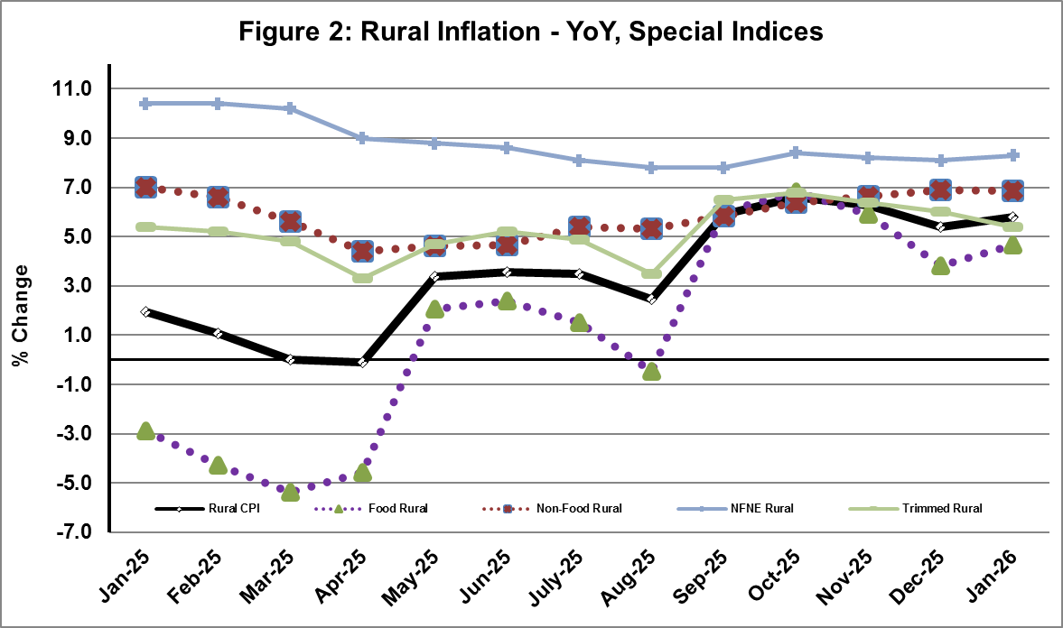
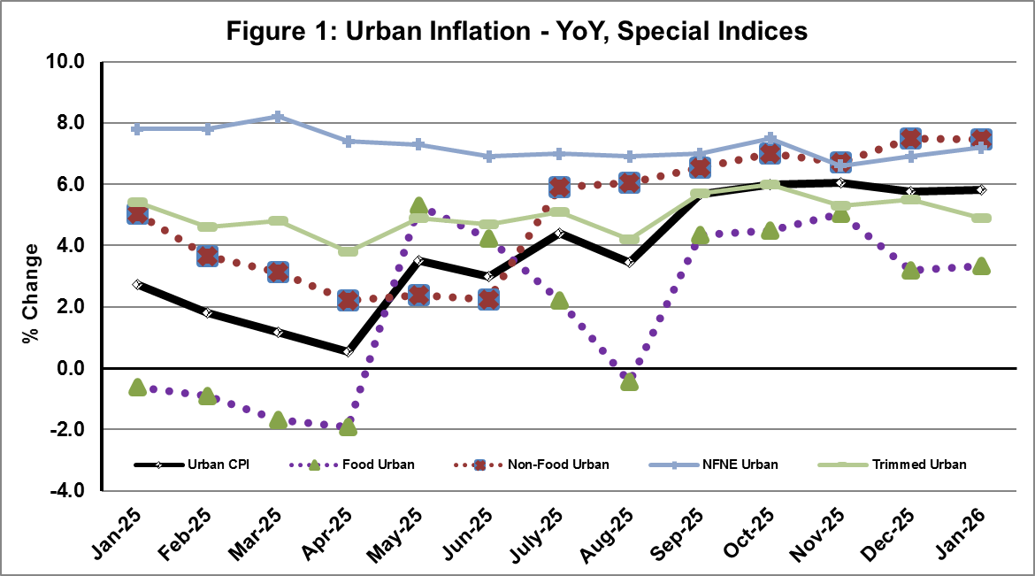
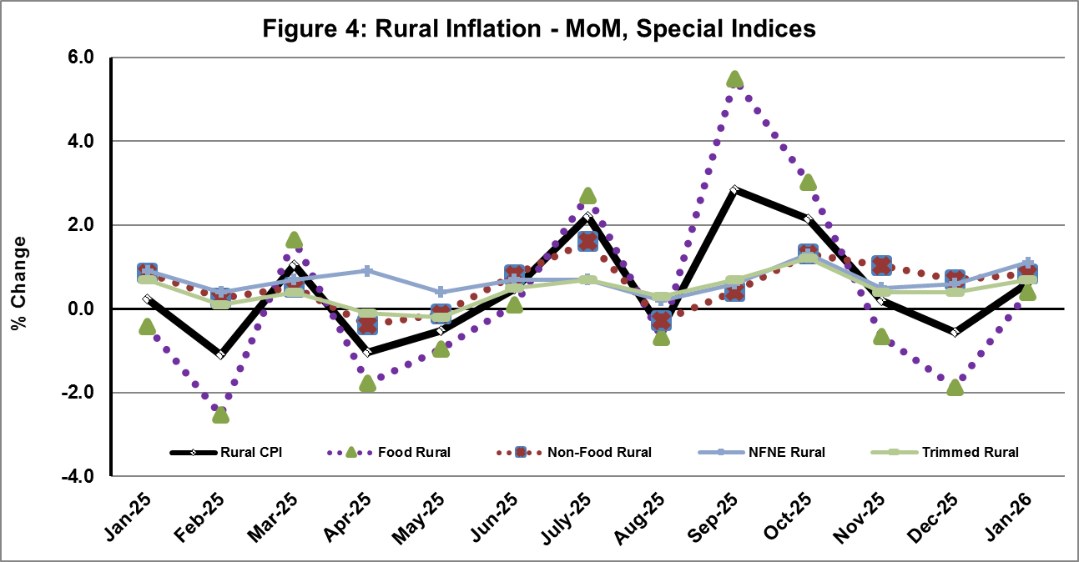
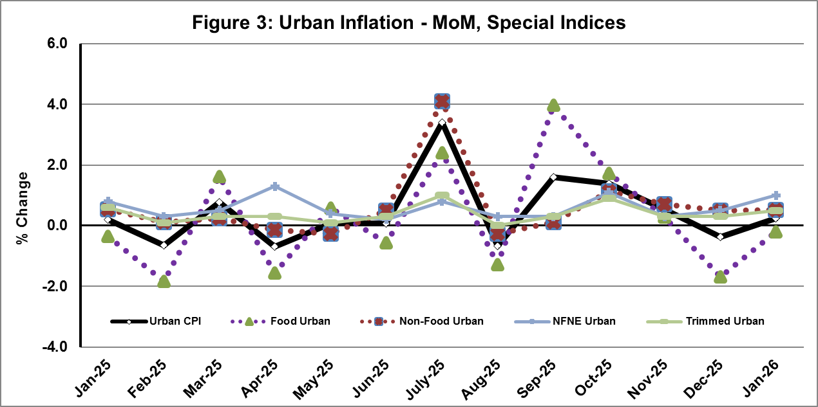

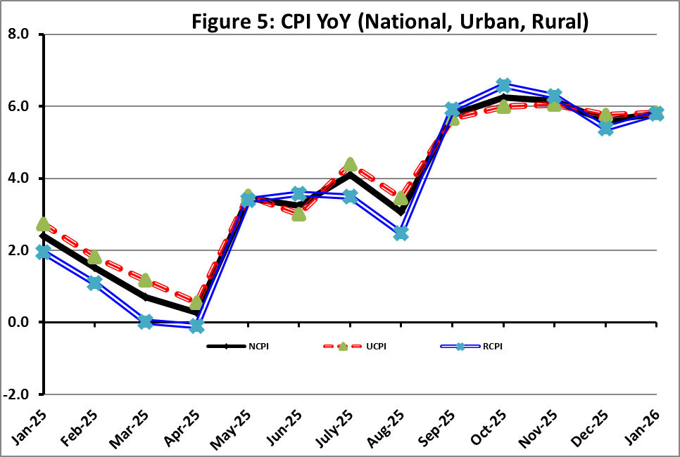

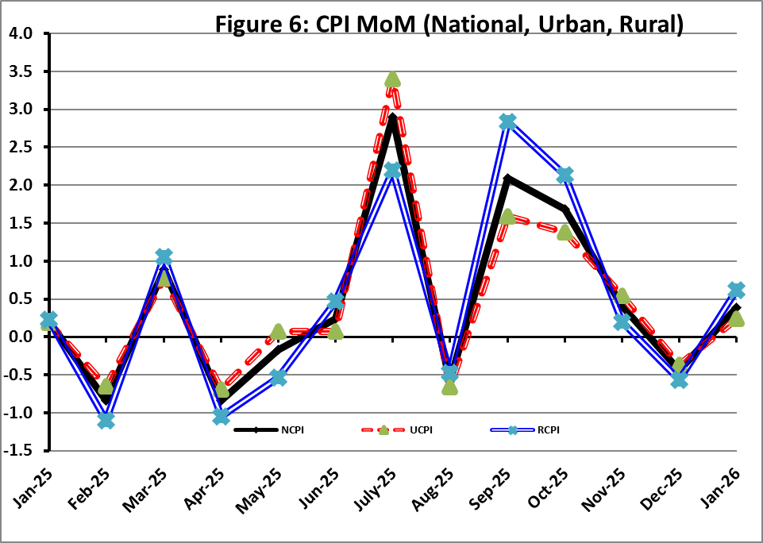
I. National Consumer Price Index (NCPI)

The National Consumer Price Index for January 2026 is increased by 0.39% over December 2025 and increased by 5.80% over corresponding month of the last year i.e. January 2025.

Table 1: Consumer Price Index (National) by Group of Commodities and Services (Base 2015-16)
No | Group | Group  Weight  (%) | Indices |  |  | % Change  Jan 2026  Over |  | Impact  (In % points)  Jan 2026 Over
No | Group | Group  Weight  (%) | Jan 26 | Dec 25 | Jan 25 | Dec 25 | Jan 25 | Dec 25 | Jan 25
No | General | 100.00 | 281.62 | 280.53 | 266.17 | 0.39 | 5.80 | 0.39 | 5.80
1. | Food & Non-alcoholic Bev. | 34.58 | 291.63 | 291.47 | 280.69 | 0.06 | 3.90 | 0.02 | 1.42
 | Non-perishable Food Items | 29.60 | 305.54 | 299.93 | 284.10 | 1.87 | 7.55 | 0.59 | 2.38
 | Perishable Food Items | 4.99 | 209.09 | 241.30 | 260.40 | -13.35 | -19.71 | -0.57 | -0.96
2. | Alcoholic Bev. & Tobacco | 1.02 | 399.91 | 399.71 | 385.70 | 0.05 | 3.68 | 0.00 | 0.05
3. | Clothing & Footwear | 8.60 | 270.26 | 269.30 | 254.80 | 0.36 | 6.06 | 0.03 | 0.50
4. | Housing, Water, Electricity, Gas & Fuels | 23.63 | 257.56 | 254.79 | 240.06 | 1.09 | 7.29 | 0.23 | 1.55
5. | Furnishing & Household Equipment Maintenance | 4.10 | 283.90 | 283.08 | 275.04 | 0.29 | 3.22 | 0.01 | 0.14
6. | Health | 2.79 | 286.76 | 285.52 | 267.65 | 0.44 | 7.14 | 0.01 | 0.20
7. | Transport | 5.91 | 315.65 | 320.05 | 307.61 | -1.37 | 2.61 | -0.09 | 0.18
8. | Communication | 2.21 | 135.74 | 135.72 | 134.89 | 0.02 | 0.63 | 0.00 | 0.01
9. | Recreation & Culture | 1.59 | 265.07 | 264.88 | 277.27 | 0.07 | -4.40 | 0.00 | -0.07
10. | Education | 3.79 | 226.13 | 225.58 | 205.48 | 0.25 | 10.05 | 0.01 | 0.29
11. | Restaurants & Hotels | 6.92 | 297.24 | 296.37 | 283.35 | 0.29 | 4.90 | 0.02 | 0.36
12. | Miscellaneous | 4.87 | 368.85 | 360.59 | 304.90 | 2.29 | 20.97 | 0.14 | 1.17

II. Urban Consumer Price Index (UCPI)

The Urban Consumer Price Index for January 2026 is increased by 0.23% over December 2025 and increased by 5.81% over corresponding month of the last year i.e. January 2025.

Table 2: Consumer Price Index (Urban) by Group of Commodities and Services (Base 2015-16)
No | Group | Group  Weight  (%) | Indices |  |  | % Change  Jan 2026  Over |  | Impact  (In % points)  Jan 2026 Over
No | Group | Group  Weight  (%) | Jan 26 | Dec 25 | Jan 25 | Dec 25 | Jan 25 | Dec 25 | Jan 25
 | General | 100.00 | 277.41 | 276.76 | 262.17 | 0.23 | 5.81 | 0.23 | 5.81
1. | Food & Non-alcoholic Bev. | 30.42 | 287.32 | 288.12 | 278.37 | -0.28 | 3.22 | -0.09 | 1.04
 | Non-perishable Food Items | 25.97 | 300.44 | 296.56 | 282.91 | 1.31 | 6.20 | 0.36 | 1.74
 | Perishable Food Items | 4.46 | 210.86 | 238.98 | 251.93 | -11.77 | -16.30 | -0.45 | -0.70
2. | Alcoholic Bev. & Tobacco | 0.85 | 423.06 | 423.08 | 406.23 | 0.00 | 4.14 | 0.00 | 0.05
3. | Clothing & Footwear | 8.01 | 259.76 | 259.13 | 246.32 | 0.24 | 5.46 | 0.02 | 0.41
4. | Housing, Water, Electricity, Gas & Fuels | 27.03 | 265.90 | 263.60 | 245.50 | 0.87 | 8.31 | 0.22 | 2.10
5. | Furnishing & Household Equip. & Maintenance | 4.09 | 272.57 | 272.53 | 264.44 | 0.01 | 3.07 | 0.00 | 0.13
6. | Health | 2.31 | 287.22 | 286.29 | 270.50 | 0.32 | 6.18 | 0.01 | 0.15
7. | Transport | 6.14 | 310.77 | 315.14 | 302.43 | -1.39 | 2.76 | -0.10 | 0.20
8. | Communication | 2.35 | 139.10 | 139.07 | 138.38 | 0.02 | 0.52 | 0.00 | 0.01
9. | Recreation & Culture | 1.73 | 249.18 | 249.17 | 260.67 | 0.00 | -4.41 | 0.00 | -0.08
10. | Education | 4.88 | 218.20 | 218.20 | 200.02 | 0.00 | 9.09 | 0.00 | 0.34
11. | Restaurants & Hotels | 7.41 | 291.46 | 290.95 | 279.39 | 0.18 | 4.32 | 0.01 | 0.34
12. | Miscellaneous | 4.77 | 356.81 | 347.83 | 294.76 | 2.58 | 21.05 | 0.15 | 1.13
Main contributors to month-on-month and year-on-year percentage changes are given below and detail is given in Annexure-A.
MONTH-ON-MONTH Top few commodities which varied from previous month i.e. December, 2025 are given below:
FOOD
Increased: Chicken (16.14%), Wheat (10.17%), Tomatoes (6.93%), Wheat Flour (4.81%), Wheat Products (2.59%), Fresh Fruits (2.28%), Condiments and Spices (2.02%), Fish (1.53%), Bakery and Confectionary (1.22%), Pulse Moong (1.14%), Dry Fruits (1.04%), Cooking Oil (0.73%), Mustard Oil (0.63%), Milk Powder (0.58%) and Meat (0.52%).
Decreased: Onions (28.48%), Potatoes (28.12%), Fresh Vegetables (16.59%), Sugar (9.60%), Eggs (6.23%), Pulse Gram (5.89%), Pulse Masoor (4.05%), Gram Whohe (3.27%), Gur (2.53%), Pulse Mash (1.93%), Besan (1.89%), Beans (0.60%) and Cigarettes (0.03%).

NON-FOOD:
Increased: Water Supply (5.83%), Major Tools & Equipments (1.72%), House Rent (1.65%), Construction Wage Rates (1.51%), Transport Services (1.35%), Woolen Cloth (1.35%), Solid Fuel (0.85%) and Readymade Garments (0.70%).
Decreased: Motor Fuel (3.31%), Liquified Hydrocarbons (0.72%), Washing Soap/Detergents/Match Box (0.12%), Electricity Charges (0.08%) and Footware (0.04%).

YEAR-ON-YEAR: Top few commodities, which varied from corresponding month of previous year i.e. January 2025, are given below:
FOOD
Increased: Wheat (38.43%), Wheat Flour (23.13%), Butter (22.51%), Fresh Fruits (16.51%), Eggs (16.19%), Condiments and Spices (14.72%), Dessert Preparation (11.29%), Sugar (10.23%), Meat (10.21%), Gur (9.31%), Milk Powder (9.26%), Dry Fruits (7.26%), Fish (6.65%) and Rice (5.77%).
Decreased: Potatoes (42.83%), Onions (40.84%), Tomatoes (36.03%), Pulse Gram (29.97%), Besan (25.64%), Gram Whohe (21.01%), Tea (17.75%), Fresh Vegetables (16.73%), Pulse Mash (14.58%), Beans (9.78%), Pulse Masoor (8.89%), Pulse Moong (5.65%), Chicken (3.79%) and Mustard Oil (3.37%).

NON-FOOD:
Increased: Gas Charges (22.91%), Postal Services (12.43%), Newspapers (11.93%), Education (9.09%), Woolen Cloth (8.79%) and Transport Services (8.37%).
Decreased: Text Books (10.61%), Electricity Charges (2.73%) and Motor Fuel (0.3%).
III. Rural Consumer Price Index (RCPI)

The Rural Consumer Price Index for January 2026 is increased by 0.61% over December 2025 and increased by 5.79% over corresponding month of the last year i.e. January 2025.

Table 3: Consumer Price Index (Rural) by Group of Commodities and Services (Base 2015-16)
No | Group | Group  Weight  (%) | Indices |  |  | % Change  Jan 2026  Over |  | Impact  (In % points)  Jan 2026 Over
No | Group | Group  Weight  (%) | Jan 26 | Dec 25 | Jan 25 | Dec 25 | Jan 25 | Dec 25 | Jan 25
 | General | 100.00 | 287.97 | 286.21 | 272.21 | 0.61 | 5.79 | 0.61 | 5.79
1. | Food & Non-alcoholic Bev. | 40.87 | 296.48 | 295.24 | 283.29 | 0.42 | 4.66 | 0.18 | 1.98
 | Non-perishable Food Items | 35.08 | 311.24 | 303.69 | 285.44 | 2.49 | 9.04 | 0.92 | 3.32
 | Perishable Food Items | 5.79 | 207.03 | 243.99 | 270.25 | -15.15 | -23.39 | -0.75 | -1.34
2. | Alcoholic Bev. & Tobacco | 1.28 | 376.56 | 376.15 | 364.99 | 0.11 | 3.17 | 0.00 | 0.05
3. | Clothing & Footwear | 9.48 | 283.64 | 282.26 | 265.62 | 0.49 | 6.78 | 0.05 | 0.63
4. | Housing, Water, Electricity, Gas & Fuels | 18.49 | 239.16 | 235.35 | 228.04 | 1.62 | 4.88 | 0.25 | 0.75
5. | Furnishing & Household Equip. & Maintenance | 4.10 | 300.95 | 298.95 | 290.99 | 0.67 | 3.42 | 0.03 | 0.15
6. | Health | 3.51 | 286.31 | 284.75 | 264.82 | 0.55 | 8.11 | 0.02 | 0.28
7. | Transport | 5.56 | 323.79 | 328.23 | 316.24 | -1.35 | 2.39 | -0.09 | 0.15
8. | Communication | 1.99 | 129.76 | 129.75 | 128.68 | 0.01 | 0.84 | 0.00 | 0.01
9. | Recreation & Culture | 1.38 | 295.21 | 294.68 | 308.76 | 0.18 | -4.39 | 0.00 | -0.07
10. | Education | 2.13 | 253.53 | 251.05 | 224.34 | 0.99 | 13.01 | 0.02 | 0.23
11. | Restaurants & Hotels | 6.19 | 307.67 | 306.16 | 290.50 | 0.49 | 5.91 | 0.03 | 0.39
12. | Miscellaneous | 5.02 | 386.13 | 378.90 | 319.46 | 1.91 | 20.87 | 0.13 | 1.23
Main contributors to Month-on-Month and Year-on-Year percentage changes are given below and detail is given in Annexure-B.
MONTH-ON-MONTH Top few commodities which varied from previous month i.e. December, 2025 are given below:

FOOD
Increased: Chicken (19.24%), Wheat (13.25%), Wheat Flour (7.68%), Dry Fruits (3.28%), Wheat Products (2.69%), Butter (2.12%), Fish (2.03%), Nimco (1.35%), Bakery and Confectionary (1.22%), Pulse Moong (1.07%), Beans (1.00%), Mustard Oil (0.91%), Milk Fresh (0.6%), Cooking Oil (0.57%), Vegetable Ghee (0.49%), Meat (0.49%) and Milk Powder (0.34%).
Decreased: Potatoes (33.14%), Onions (30.92%), Fresh Vegetables (14.67%), Sugar (9.44%), Pulse Gram (4.50%), Eggs (3.57%), Pulse Masoor (3.36%), Gram Whole (3.27%), Besan (2.87%), Pulse Mash (1.39%), Gur (0.42%), Milk Products (0.41%), Fresh Fruits (0.28%) and Rice (0.10%).

NON-FOOD

Increased: House Rent (2.37%), Solid Fuel (2.34%), Hospitals Services (1.99%), Mechanical Services (1.31%), Marriage Hall Charges (1.27%) and Woolen Readymade Garments (1.20%).

Decreased: Motor Fuels (3.56%) and Electricity Charges (0.08%).

Year-On-Year: Top few commodities which varied from corresponding month of previous year i.e. January, 2025 are given below:
FOOD
Increased: Wheat (47.41%), Wheat Flour (33.31%), Fresh Fruits (13.87%), Sugar (11.70%), Meat (11.66%), Eggs (10.88%), Dessert Preparation (10.52%), Milk Powder (9.15%), Gur (9.05%), Dry Fruits (8.88%), Butter (8.85%) and Wheat Products (6.71%).
Decreased: Potatoes (48.98%), Onions (39.83%), Tomatoes (38.95%), Pulse Gram (28.77%), Besan (23.59%), Fresh Vegetables (20.94%), Tea (18.80%), Gram Whole (18.21%), Pulse Mash (16.66%), Pulse Masoor (8.87%), Pulse Moong (3.71%) and Chicken (2.28%).

NON-FOOD
Increased: Newspapers (16.67%), Dental Services (15.47%), Doctor Clinic Fee (13.21%), Education (13.01%), Readymade Garments (10.59%) and Medical Tests (10.50%).
Decreased: Text Books (15.30%), Electricity Charges (2.73%) and Motor Fuels (0.36%).

IV. Sensitive Price Indicator (SPI)

Quintile-wise percentage changes YoY and MoM are given below in Table 4. The series from
January 2025 to January 2026 is also graphed below in Figure 7.

Table 4: Sensitive Price Indicator (Base 2015-16)
Quintiles | Indices |  |  | % Change Jan 2026  Over
Quintiles | Jan 2026 | Dec 2025 | Jan 2025 | Dec 2025 | Jan 2025
1 | 324.24 | 326.75 | 314.02 | -0.77 | 3.25
2 | 324.74 | 326.72 | 311.04 | -0.61 | 4.40
3 | 346.60 | 348.56 | 333.14 | -0.56 | 4.04
4 | 333.53 | 335.47 | 321.86 | -0.58 | 3.63
5 | 332.39 | 334.40 | 322.71 | -0.60 | 3.00
Combined | 334.04 | 335.96 | 322.03 | -0.57 | 3.73

Table 4.1: Weekly Percentage Change of SPI During January 2026
Quintiles | % Change over Previous week
Quintiles | 01-01-2026 | 08-01-2026 | 15-01-2026 | 22-01-2026 | 29-01-2026
Quintile 1 | -0.62 | 0.12 | 0.28 | -0.30 | -0.15
Combined | -0.67 | 0.12 | 0.25 | -0.48 | -0.03

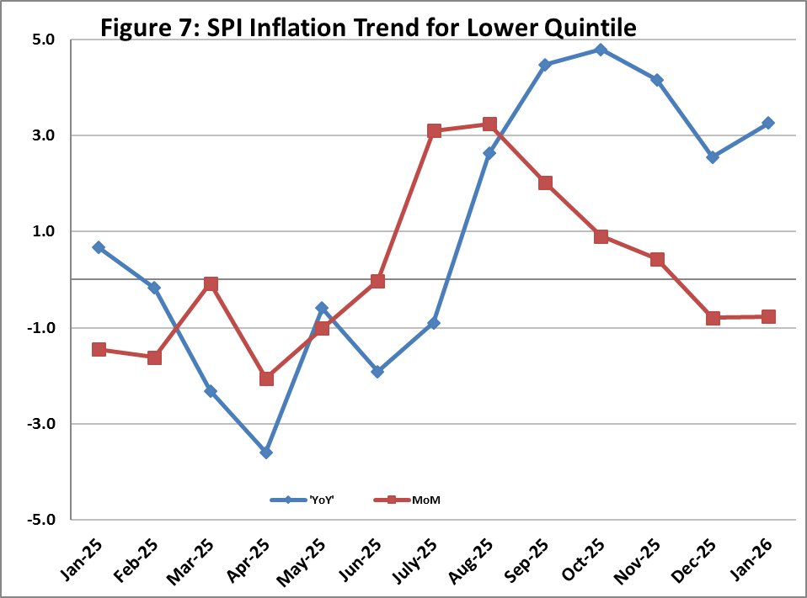

V. Wholesale Price Index
The Wholesale Price Index for January 2026 decreased by 0.18% over December 2025 and increased by 0.20% over the corresponding month of the last year i.e. January, 2025. YoY and MoM movements from January, 2025 to January, 2026 are also graphed below in Figure 8.

Table 5: Wholesale Price Index by Group of Commodities (Base 2015-16)
No | Group | Group  Weight  (%) | Indices |  |  | % Change  Jan 2026  Over |  | Impact  (In % points)  Jan 2026 Over
No | Group | Group  Weight  (%) | Jan 26 | Dec 25 | Jan 25 | Dec 25 | Jan 25 | Dec 25 | Jan 25
 | General | 100.00 | 313.15 | 313.72 | 312.51 | -0.18 | 0.20 | -0.18 | 0.20
1 | Agriculture Forestry & Fishery | 25.77 | 274.15 | 276.45 | 281.69 | -0.83 | -2.68 | -0.19 | -0.62
2 | Ores/Minerals, Elec., Gas & Water | 12.01 | 363.06 | 362.58 | 361.36 | 0.13 | 0.47 | 0.02 | 0.07
3 | Food, Beverages, Tobacco, Textiles & Leather Products | 31.11 | 293.51 | 293.01 | 278.47 | 0.17 | 5.40 | 0.05 | 1.50
 | i. Food Products, Beverages & Tobacco | 20.07 | 314.81 | 314.04 | 295.03 | 0.25 | 6.70 | 0.05 | 1.27
 | ii. Textiles & Apparels | 10.33 | 260.00 | 259.99 | 253.37 | 0.00 | 2.62 | 0.00 | 0.22
 | iii. Leather Products | 0.71 | 179.03 | 179.03 | 175.78 | 0.00 | 1.85 | 0.00 | 0.01
4 | Other Transportable Goods | 22.40 | 326.95 | 327.85 | 339.49 | -0.27 | -3.69 | -0.06 | -0.90
5 | Metal Product, Machinery & Equipment | 8.72 | 394.32 | 394.25 | 388.51 | 0.02 | 1.50 | 0.00 | 0.16

Main contributors to month-on-month and year-on-year percentage changes are given below and detail is given in Annexure-C.

MONTH-ON-MONTH: Top few commodities which varied from previous month are given below:
Increased: Printing Paper (15.78%), Poultry (13.93%), Wheat (11.22%), Furnace Oil (8.25%), Blankets (6.23%), Wheat Flour (5.59%), Fish Live Fresh or Chilled (4.96%), Spices (4.59%), Fuel Wood in Logs (3.92%), Sorghum / Jowar (3.49%), Maize (3.08%) and Chemicals (2.27%).
Decreased: Edible Roots / Potatoes (37.47%), Vegetables (19.96%), Other Cereal Flour (6.67%), Stimulant & Spice Crops (6.45%), Sugar Refined (6.24%), Eggs (6.07%), Kerosene Oil (5.89%), Diesel Oil (5.70%), Motor Spirit (4.01%), Cement (2.83%), Pulses (2.70%) and Rice (1.78%).

YEAR-ON-YEAR: Top few commodities which varied from previous year are given below:
Increased: Other Food Products (46.74%), Wheat (41.52%), Sorghum / Jowar (34.93%), Wheat Flour (28.43%), Dyeing Material (22.99%), Eggs (21.66%), Maize (20.89%), Woven Fabrics (20.13%), Dried Fruits & Nuts (19.02%), Engines & Motors (18.64%) and Printing Paper (15.78%).
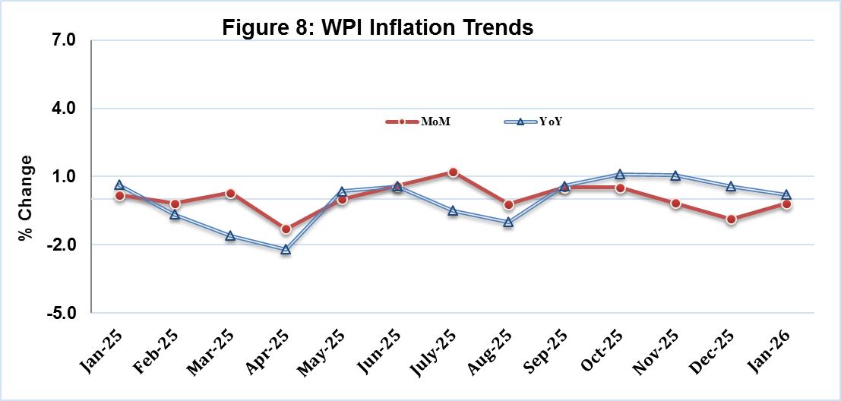
Decreased: Edible Roots / Potatoes (50.63%), Other Cereal Flour (29.49%), Furnace Oil (22.22%), Pulses (19.08%), Fibre Crops (15.38%), Vegetables (14.20%), Cotton Seeds (9.98%), Electrical Energy (7.84%), Steel Bar & Sheets (6.51%), Stimulant & Spice Crops (5.93%) and Rice (4.27%).
Annexure A: CPI (Urban) Index Numbers by Commodity Groups & Commodities (2015-16=100)
Item and Specification |  | Weight | Index Numbers  Jan 26 Dec 25 Jan 25 |  |  | % Change in Jan 2026 over  Dec 2025 Jan 2025
 | General | 100.0000 | 277.41 | 276.76 | 262.17 |  | + | 0.23 |  | + | 5.81
 | Food and non-alcoholic Beverages | 30.4215 | 287.32 | 288.12 | 278.37 |  | - | 0.28 |  | + | 3.22
01 | Wheat | 0.6120 | 331.87 | 301.23 | 239.73 |  | + | 10.17 |  | + | 38.43
02 | Wheat flour | 3.0075 | 293.09 | 279.63 | 238.03 |  | + | 4.81 |  | + | 23.13
03 | Wheat products | 0.0936 | 304.48 | 296.80 | 289.03 |  | + | 2.59 |  | + | 5.35
04 | Besan | 0.0830 | 227.14 | 231.51 | 305.48 |  | - | 1.89 |  | - | 25.64
05 | Rice | 1.1804 | 328.33 | 327.41 | 310.41 |  | + | 0.28 |  | + | 5.77
06 | Bakery and confectionary | 0.4770 | 276.49 | 273.15 | 264.66 |  | + | 1.22 |  | + | 4.47
07 | Nimco | 0.1224 | 303.17 | 302.13 | 295.60 |  | + | 0.34 |  | + | 2.56
08 | Meat | 2.0411 | 360.53 | 358.68 | 327.14 |  | + | 0.52 |  | + | 10.21
09 | Chicken | 1.3631 | 304.64 | 262.31 | 316.64 |  | + | 16.14 |  | - | 3.79
10 | Fish | 0.3855 | 233.69 | 230.17 | 219.12 |  | + | 1.53 |  | + | 6.65
11 | Milk fresh | 7.1070 | 269.25 | 268.65 | 262.53 |  | + | 0.22 |  | + | 2.56
12 | Milk products | 0.6407 | 272.53 | 272.44 | 265.77 |  | + | 0.03 |  | + | 2.54
13 | Milk powder | 0.3106 | 331.45 | 329.53 | 303.35 |  | + | 0.58 |  | + | 9.26
14 | Eggs | 0.5083 | 393.74 | 419.89 | 338.87 |  | - | 6.23 |  | + | 16.19
15 | Butter | 0.0932 | 492.40 | 492.40 | 401.94 |  | + | 0.00 |  | + | 22.51
16 | Mustard oil | 0.0120 | 313.79 | 311.83 | 324.74 |  | + | 0.63 |  | - | 3.37
17 | Cooking oil | 1.1016 | 345.06 | 342.56 | 332.42 |  | + | 0.73 |  | + | 3.80
18 | Vegetable ghee | 1.0324 | 360.52 | 359.59 | 352.75 |  | + | 0.26 |  | + | 2.20
19 | Dry fruits | 0.3299 | 318.82 | 315.53 | 297.23 |  | + | 1.04 |  | + | 7.26
20 | Fresh fruits | 1.4363 | 252.30 | 246.67 | 216.54 |  | + | 2.28 |  | + | 16.51
21 | Pulse masoor | 0.1624 | 188.40 | 196.36 | 206.79 |  | - | 4.05 |  | - | 8.89
22 | Pulse moong | 0.1697 | 235.08 | 232.42 | 249.15 |  | + | 1.14 |  | - | 5.65
23 | Pulse mash | 0.1152 | 178.38 | 181.89 | 208.82 |  | - | 1.93 |  | - | 14.58
24 | Pulse gram | 0.1660 | 209.66 | 222.79 | 299.37 |  | - | 5.89 |  | - | 29.97
25 | Gram whole | 0.0912 | 244.95 | 253.23 | 310.11 |  | - | 3.27 |  | - | 21.01
26 | Beans | 0.0408 | 350.77 | 352.87 | 388.80 |  | - | 0.60 |  | - | 9.78
27 | Potatoes | 0.4496 | 202.74 | 282.07 | 354.62 |  | - | 28.12 |  | - | 42.83
28 | Onions | 0.5928 | 173.82 | 243.04 | 293.83 |  | - | 28.48 |  | - | 40.84
29 | Tomatoes | 0.3459 | 176.11 | 164.69 | 275.30 |  | + | 6.93 |  | - | 36.03
30 | Fresh vegetables | 1.5306 | 192.13 | 230.34 | 230.73 |  | - | 16.59 |  | - | 16.73
31 | Sugar | 1.1130 | 248.88 | 275.32 | 225.78 |  | - | 9.60 |  | + | 10.23
32 | Gur | 0.0379 | 264.27 | 271.14 | 241.77 |  | - | 2.53 |  | + | 9.31
33 | Honey | 0.1017 | 222.62 | 222.62 | 217.74 |  | + | 0.00 |  | + | 2.24
34 | Sweetmeat | 0.3535 | 336.52 | 335.51 | 322.82 |  | + | 0.30 |  | + | 4.24
35 | Ice cream | 0.1044 | 199.68 | 199.68 | 199.45 |  | + | 0.00 |  | + | 0.12
36 | Condiments and Spices | 1.3340 | 383.83 | 376.23 | 334.59 |  | + | 2.02 |  | + | 14.72
37 | Dessert preparation | 0.0419 | 300.63 | 300.63 | 270.14 |  | + | 0.00 |  | + | 11.29
38 | Tea | 0.8427 | 273.67 | 273.67 | 332.73 |  | + | 0.00 |  | - | 17.75
39 | Beverages | 0.8906 | 262.45 | 262.00 | 253.86 |  | + | 0.17 |  | + | 3.38
 | Alcoholic Beverages, Tobacco | 0.8540 | 423.06 | 423.08 | 406.23 |  | + | 0.00 |  | + | 4.14
40 | Cigarettes | 0.7167 | 411.76 | 411.88 | 401.22 |  | - | 0.03 |  | + | 2.63
41 | Pan prepared | 0.1373 | 482.03 | 481.53 | 432.40 |  | + | 0.10 |  | + | 11.48
 | Clothing and footwear | 8.0096 | 259.76 | 259.13 | 246.32 |  | + | 0.24 |  | + | 5.46
42 | Cotton cloth | 2.2227 | 300.08 | 300.07 | 280.55 |  | + | 0.00 |  | + | 6.96
43 | Woollen cloth | 0.8361 | 257.78 | 254.35 | 236.95 |  | + | 1.35 |  | + | 8.79
44 | Readymade garments | 1.3196 | 226.35 | 224.78 | 212.42 |  | + | 0.70 |  | + | 6.56
45 | Woollen readymade garments | 0.4307 | 273.83 | 273.66 | 257.10 |  | + | 0.06 |  | + | 6.51
46 | Tailoring | 1.0741 | 244.02 | 243.85 | 229.72 |  | + | 0.07 |  | + | 6.22
47 | Hosiery | 0.4070 | 241.68 | 241.60 | 234.38 |  | + | 0.03 |  | + | 3.11
48 | Dupatta | 0.1713 | 206.61 | 206.53 | 199.95 |  | + | 0.04 |  | + | 3.33
49 | Cleaning and laundering | 0.0665 | 282.14 | 282.02 | 265.97 |  | + | 0.04 |  | + | 6.08
50 | Footwear | 1.4816 | 247.61 | 247.72 | 247.08 |  | - | 0.04 |  | + | 0.21
 | Housing, water, Elec., Gas and other Fuels | 27.0332 | 265.90 | 263.60 | 245.50 |  | + | 0.87 |  | + | 8.31
51 | House rent | 19.2558 | 178.39 | 175.49 | 168.09 |  | + | 1.65 |  | + | 6.13
52 | Construction input items | 0.3765 | 270.47 | 270.45 | 265.06 |  | + | 0.01 |  | + | 2.04
53 | Construction wage rates | 0.2025 | 235.38 | 231.89 | 221.55 |  | + | 1.51 |  | + | 6.24
54 | Water supply | 0.5269 | 244.90 | 231.40 | 228.99 |  | + | 5.83 |  | + | 6.95
55 | Garbage collection | 0.1064 | 266.52 | 266.16 | 261.72 |  | + | 0.14 |  | + | 1.83
56 | Electricity charges | 4.5562 | 262.92 | 263.13 | 270.31 |  | - | 0.08 |  | - | 2.73
57 | Gas charges | 1.0807 | 1817.96 | 1817.96 | 1479.08 |  | + | 0.00 |  | + | 22.91
58 | Liquefied Hydrocarbons | 0.5064 | 358.63 | 361.24 | 353.81 |  | - | 0.72 |  | + | 1.36
59 | Solid Fuel | 0.4218 | 242.09 | 240.06 | 231.37 |  | + | 0.85 |  | + | 4.63
 | Furnishing and household equipments | 4.0937 | 272.57 | 272.53 | 264.44 |  | + | 0.01 |  | + | 3.07
60 | Furniture and furnishing | 0.4750 | 265.06 | 264.74 | 256.78 |  | + | 0.12 |  | + | 3.22
61 | Carpets | 0.0308 | 157.16 | 157.04 | 150.80 |  | + | 0.08 |  | + | 4.22
62 | Household textiles | 0.3420 | 215.43 | 214.73 | 208.18 |  | + | 0.33 |  | + | 3.48
63 | Household equipments | 1.0032 | 277.54 | 277.49 | 264.71 |  | + | 0.02 |  | + | 4.85
64 | Plastic products | 0.0536 | 234.53 | 233.93 | 219.27 |  | + | 0.26 |  | + | 6.96
65 | Major tools & equipments | 0.0084 | 257.67 | 253.31 | 238.70 |  | + | 1.72 |  | + | 7.95
66 | Washing soap/detergents/match | 1.4112 | 322.97 | 323.36 | 320.23 |  | - | 0.12 |  | + | 0.86
67 | Household servant | 0.7695 | 211.16 | 210.89 | 199.47 |  | + | 0.13 |  | + | 5.86
 | Health | 2.3098 | 287.22 | 286.29 | 270.50 |  | + | 0.32 |  | + | 6.18
68 | Drugs and medicines | 1.0735 | 310.36 | 309.08 | 292.08 |  | + | 0.41 |  | + | 6.26
69 | Therapeutic Appliances and Equipments | 0.0054 | 156.75 | 156.75 | 154.74 |  | + | 0.00 |  | + | 1.30
70 | Doctor (MBBS) clinic fee | 0.4044 | 358.25 | 357.82 | 333.70 |  | + | 0.12 |  | + | 7.36
71 | Dental services | 0.0156 | 236.61 | 236.28 | 222.14 |  | + | 0.14 |  | + | 6.51
72 | Medical tests | 0.2367 | 223.09 | 222.55 | 212.30 |  | + | 0.24 |  | + | 5.08
73 | Hospitals services | 0.5742 | 222.99 | 222.17 | 212.04 |  | + | 0.37 |  | + | 5.16
 | Transport | 6.1368 | 310.77 | 315.14 | 302.43 |  | - | 1.39 |  | + | 2.76
74 | Motor vehicles | 0.8097 | 267.56 | 267.55 | 259.37 |  | + | 0.00 |  | + | 3.16
75 | Motor vehicle accessories | 0.1941 | 269.88 | 269.38 | 263.88 |  | + | 0.19 |  | + | 2.27
76 | Motor fuel | 2.9088 | 347.27 | 359.14 | 348.32 |  | - | 3.31 |  | - | 0.30
77 | Mechanical services | 0.4290 | 248.97 | 246.76 | 230.98 |  | + | 0.90 |  | + | 7.79
78 | Motor vehicle tax | 0.0482 | 399.23 | 399.23 | 399.23 |  | + | 0.00 |  | + | 0.00
79 | Transport services | 1.7470 | 287.31 | 283.48 | 265.13 |  | + | 1.35 |  | + | 8.37
 | Communication | 2.3536 | 139.10 | 139.07 | 138.38 |  | + | 0.02 |  | + | 0.52
80 | Postal services | 0.0190 | 245.15 | 243.55 | 218.04 |  | + | 0.66 |  | + | 12.43
81 | Communication apparatus | 0.4524 | 191.03 | 190.93 | 188.43 |  | + | 0.05 |  | + | 1.38
82 | Communication Services | 1.8822 | 125.55 | 125.55 | 125.55 |  | + | 0.00 |  | + | 0.00
 | Recreation and culture | 1.7301 | 249.18 | 249.17 | 260.67 |  | + | 0.00 |  | - | 4.41
83 | Recreation and culture | 0.6478 | 156.34 | 156.34 | 154.82 |  | + | 0.00 |  | + | 0.98
84 | Text books | 0.6655 | 297.49 | 297.49 | 332.81 |  | + | 0.00 |  | - | 10.61
85 | Newspapers | 0.0716 | 242.82 | 242.82 | 216.94 |  | + | 0.00 |  | + | 11.93
86 | stationery | 0.3452 | 331.59 | 331.52 | 329.33 |  | + | 0.02 |  | + | 0.69
 | Education | 4.8807 | 218.20 | 218.20 | 200.02 |  | + | 0.00 |  | + | 9.09
87 | Education | 4.8807 | 218.20 | 218.20 | 200.02 |  | + | 0.00 |  | + | 9.09
 | Restaurants and hotels | 7.4050 | 291.46 | 290.95 | 279.39 |  | + | 0.18 |  | + | 4.32
88 | Readymade food | 5.5235 | 297.74 | 297.44 | 286.90 |  | + | 0.10 |  | + | 3.78
89 | Marriage Hall Charges | 1.7514 | 279.80 | 278.57 | 263.83 |  | + | 0.44 |  | + | 6.05
90 | Accommodation Services | 0.1301 | 182.00 | 182.00 | 169.69 |  | + | 0.00 |  | + | 7.25
 | Misc. goods and services | 4.7720 | 356.81 | 347.83 | 294.76 |  | + | 2.58 |  | + | 21.05
91 | Personal Grooming Services | 0.8001 | 274.41 | 273.60 | 256.74 |  | + | 0.30 |  | + | 6.88
92 | Electrical Appliances for Per | 0.0465 | 191.91 | 191.75 | 177.26 |  | + | 0.08 |  | + | 8.26
93 | Appliances/Articles/Products | 2.9807 | 295.18 | 293.10 | 269.20 |  | + | 0.71 |  | + | 9.65
94 | Personal Effects n.e.c. | 0.9447 | 629.14 | 591.05 | 413.40 |  | + | 6.44 |  | + | 52.19

Annexure B: CPI (Rural) Index Numbers by Commodity Groups & Commodities (2015-16=100)
Item and Specification |  | Weight | Index Numbers  Jan 26 Dec 25 Jan 25 |  |  | % Change in Jan 2026 over  Dec 2025 Jan 2025
 | General | 100.0000 | 287.97 | 286.21 | 272.21 |  | + | 0.61 |  | + | 5.79
 | Food and non-alcoholic Beverages | 40.8668 | 296.48 | 295.24 | 283.29 |  | + | 0.42 |  | + | 4.66
01 | Wheat | 3.4736 | 353.15 | 311.84 | 239.57 |  | + | 13.25 |  | + | 47.41
02 | Wheat Flour | 3.4297 | 318.01 | 295.34 | 238.55 |  | + | 7.68 |  | + | 33.31
03 | Wheat Products | 0.1068 | 308.60 | 300.53 | 289.20 |  | + | 2.69 |  | + | 6.71
04 | Besan | 0.0728 | 248.06 | 255.38 | 324.65 |  | - | 2.87 |  | - | 23.59
05 | Rice | 1.5501 | 429.15 | 429.56 | 413.33 |  | - | 0.10 |  | + | 3.83
06 | Bakery and Confectionary | 0.3702 | 323.74 | 319.83 | 306.32 |  | + | 1.22 |  | + | 5.69
07 | Nimco | 0.0774 | 316.44 | 312.22 | 305.01 |  | + | 1.35 |  | + | 3.75
08 | Meat | 1.7146 | 378.82 | 376.96 | 339.25 |  | + | 0.49 |  | + | 11.66
09 | Chicken | 1.4641 | 319.56 | 268.00 | 327.03 |  | + | 19.24 |  | - | 2.28
10 | Fish | 0.2640 | 243.94 | 239.08 | 237.59 |  | + | 2.03 |  | + | 2.67
11 | Milk fresh | 10.3803 | 273.14 | 271.51 | 259.40 |  | + | 0.60 |  | + | 5.30
12 | Milk products | 0.9624 | 267.40 | 268.49 | 257.12 |  | - | 0.41 |  | + | 4.00
13 | Milk powder | 0.1062 | 301.10 | 300.08 | 275.87 |  | + | 0.34 |  | + | 9.15
14 | Eggs | 0.5665 | 388.29 | 402.66 | 350.20 |  | - | 3.57 |  | + | 10.88
15 | Butter | 0.3333 | 333.38 | 326.47 | 306.27 |  | + | 2.12 |  | + | 8.85
16 | Mustard oil | 0.0136 | 340.68 | 337.61 | 339.82 |  | + | 0.91 |  | + | 0.25
17 | Cooking oil | 0.6011 | 371.89 | 369.77 | 373.85 |  | + | 0.57 |  | - | 0.52
18 | Vegetable ghee | 2.3764 | 390.36 | 388.46 | 384.33 |  | + | 0.49 |  | + | 1.57
19 | Dry fruits | 0.2496 | 394.34 | 381.83 | 362.19 |  | + | 3.28 |  | + | 8.88
20 | Fresh fruits | 1.4505 | 254.13 | 254.85 | 223.18 |  | - | 0.28 |  | + | 13.87
21 | Pulse Masoor | 0.2076 | 213.07 | 220.48 | 233.80 |  | - | 3.36 |  | - | 8.87
22 | Pulse Moong | 0.2510 | 257.81 | 255.09 | 267.75 |  | + | 1.07 |  | - | 3.71
23 | Pulse Mash | 0.1465 | 188.64 | 191.30 | 226.34 |  | - | 1.39 |  | - | 16.66
24 | Pulse Gram | 0.2751 | 222.16 | 232.64 | 311.88 |  | - | 4.50 |  | - | 28.77
25 | Gram Whole | 0.1116 | 264.48 | 273.41 | 323.36 |  | - | 3.27 |  | - | 18.21
26 | Beans | 0.0896 | 403.18 | 399.17 | 409.11 |  | + | 1.00 |  | - | 1.45
27 | Potatoes | 0.7437 | 196.86 | 294.43 | 385.83 |  | - | 33.14 |  | - | 48.98
28 | Onions | 0.8965 | 169.79 | 245.80 | 282.20 |  | - | 30.92 |  | - | 39.83
29 | Tomatoes | 0.5069 | 171.58 | 171.34 | 281.04 |  | + | 0.14 |  | - | 38.95
30 | Fresh Vegetables | 2.0947 | 198.91 | 233.12 | 251.59 |  | - | 14.67 |  | - | 20.94
31 | Sugar | 2.0296 | 252.61 | 278.94 | 226.15 |  | - | 9.44 |  | + | 11.70
32 | Gur | 0.1522 | 260.81 | 261.92 | 239.16 |  | - | 0.42 |  | + | 9.05
33 | Honey | 0.0296 | 225.70 | 225.70 | 222.19 |  | + | 0.00 |  | + | 1.58
34 | Sweetmeat | 0.3967 | 302.51 | 301.89 | 287.86 |  | + | 0.21 |  | + | 5.09
35 | Ice Cream | 0.0568 | 198.80 | 198.80 | 199.34 |  | + | 0.00 |  | - | 0.27
36 | Condiments and Spices | 1.4919 | 292.16 | 292.16 | 296.03 |  | + | 0.00 |  | - | 1.31
37 | Dessert Preparation | 0.0133 | 296.76 | 296.76 | 268.52 |  | + | 0.00 |  | + | 10.52
38 | Tea | 1.2566 | 271.09 | 271.09 | 333.85 |  | + | 0.00 |  | - | 18.80
39 | Beverages | 0.5537 | 255.49 | 254.91 | 245.04 |  | + | 0.23 |  | + | 4.26
 | Alcoholic Beverages, Tobacco | 1.2786 | 376.56 | 376.15 | 364.99 |  | + | 0.11 |  | + | 3.17
40 | Cigarettes | 1.2364 | 376.31 | 376.05 | 365.23 |  | + | 0.07 |  | + | 3.03
41 | Pan Prepared | 0.0422 | 383.86 | 379.08 | 357.98 |  | + | 1.26 |  | + | 7.23
 | Clothing and footwear | 9.4826 | 283.64 | 282.26 | 265.62 |  | + | 0.49 |  | + | 6.78
42 | Cotton Cloth | 2.8381 | 309.03 | 306.42 | 292.21 |  | + | 0.85 |  | + | 5.76
43 | Woollen Cloth | 1.0959 | 275.18 | 274.38 | 258.11 |  | + | 0.29 |  | + | 6.61
44 | Readymade Garments | 1.1345 | 264.00 | 263.76 | 238.71 |  | + | 0.09 |  | + | 10.59
45 | Woollen Readymade Garments | 0.5401 | 334.48 | 330.52 | 309.66 |  | + | 1.20 |  | + | 8.02
46 | Tailoring | 1.2999 | 265.54 | 264.86 | 245.65 |  | + | 0.26 |  | + | 8.10
47 | Hosiery | 0.4322 | 357.16 | 357.07 | 343.63 |  | + | 0.03 |  | + | 3.94
48 | Dupatta | 0.2078 | 258.85 | 258.81 | 244.52 |  | + | 0.02 |  | + | 5.86
49 | Cleaning and Laundering | 0.0176 | 267.84 | 267.84 | 251.35 |  | + | 0.00 |  | + | 6.56
50 | Footwear | 1.9165 | 246.69 | 245.93 | 232.41 |  | + | 0.31 |  | + | 6.14
 | Housing, water, Elec., Gas and other Fuels | 18.4853 | 239.16 | 235.35 | 228.04 |  | + | 1.62 |  | + | 4.88
51 | House Rent | 8.6110 | 188.80 | 184.43 | 175.84 |  | + | 2.37 |  | + | 7.37
52 | Construction Input Items | 0.6306 | 267.20 | 265.15 | 254.64 |  | + | 0.77 |  | + | 4.93
53 | Construction Wage Rates | 0.2526 | 251.50 | 249.14 | 238.90 |  | + | 0.95 |  | + | 5.27
54 | Water Supply | 0.0645 | 325.72 | 325.72 | 311.91 |  | + | 0.00 |  | + | 4.43
55 | Garbage Collection | 0.0080 | 204.36 | 204.36 | 199.91 |  | + | 0.00 |  | + | 2.23
56 | Electricity Charges | 3.4431 | 262.92 | 263.13 | 270.31 |  | - | 0.08 |  | - | 2.73
57 | Liquefied Hydrocarbons | 0.9994 | 322.87 | 321.18 | 319.75 |  | + | 0.53 |  | + | 0.98
58 | Solid Fuel | 4.4761 | 293.24 | 286.54 | 269.97 |  | + | 2.34 |  | + | 8.62
 | Furnishing and household equipments | 4.1031 | 300.95 | 298.95 | 290.99 |  | + | 0.67 |  | + | 3.42
59 | Furniture and Furnishing | 0.5786 | 300.02 | 297.27 | 285.49 |  | + | 0.93 |  | + | 5.09
60 | Household Textiles | 0.4382 | 258.61 | 255.97 | 240.76 |  | + | 1.03 |  | + | 7.41
61 | Household Equipments | 1.2774 | 300.56 | 299.36 | 286.42 |  | + | 0.40 |  | + | 4.94
62 | Plastic Products | 0.0776 | 315.74 | 312.43 | 292.58 |  | + | 1.06 |  | + | 7.92
63 | Major Tools and Equipments | 0.0324 | 250.77 | 250.69 | 238.97 |  | + | 0.03 |  | + | 4.94
64 | Washing Soaps, Detergents and | 1.6989 | 312.77 | 310.61 | 310.16 |  | + | 0.70 |  | + | 0.84
 | Health | 3.5141 | 286.31 | 284.75 | 264.82 |  | + | 0.55 |  | + | 8.11
65 | Drugs and Medicines | 1.5792 | 333.95 | 332.98 | 315.35 |  | + | 0.29 |  | + | 5.90
66 | Doctor Clinic Fee | 0.5128 | 340.65 | 340.65 | 300.90 |  | + | 0.00 |  | + | 13.21
67 | Dental Services | 0.0181 | 257.57 | 257.57 | 223.06 |  | + | 0.00 |  | + | 15.47
68 | Medical Tests | 0.3967 | 246.73 | 246.73 | 223.28 |  | + | 0.00 |  | + | 10.50
69 | Hospitals Services | 1.0073 | 200.05 | 196.14 | 184.34 |  | + | 1.99 |  | + | 8.52
 | Transport | 5.5580 | 323.79 | 328.23 | 316.24 |  | - | 1.35 |  | + | 2.39
70 | Motor Vehicles | 0.7305 | 194.80 | 194.78 | 193.15 |  | + | 0.01 |  | + | 0.85
71 | Motor Vehicles Accessories | 0.1572 | 274.72 | 274.53 | 269.51 |  | + | 0.07 |  | + | 1.93
72 | Motor Fuels | 2.4932 | 347.93 | 360.78 | 349.17 |  | - | 3.56 |  | - | 0.36
73 | Mechanical Services | 0.3645 | 237.30 | 234.23 | 230.99 |  | + | 1.31 |  | + | 2.73
74 | Motor Vehicle Tax | 0.0174 | 342.03 | 342.03 | 342.03 |  | + | 0.00 |  | + | 0.00
75 | Transport Services | 1.7952 | 364.45 | 360.97 | 341.75 |  | + | 0.96 |  | + | 6.64
 | Communication | 1.9940 | 129.76 | 129.75 | 128.68 |  | + | 0.01 |  | + | 0.84
76 | Postal Services | 0.0070 | 179.32 | 179.32 | 179.32 |  | + | 0.00 |  | + | 0.00
77 | Communication Apparatus | 0.3362 | 168.00 | 167.95 | 161.60 |  | + | 0.03 |  | + | 3.96
78 | Communication Services | 1.6508 | 121.76 | 121.76 | 121.76 |  | + | 0.00 |  | + | 0.00
 | Recreation and culture | 1.3764 | 295.21 | 294.68 | 308.76 |  | + | 0.18 |  | - | 4.39
79 | Recreation and Culture | 0.4763 | 262.29 | 261.67 | 248.84 |  | + | 0.24 |  | + | 5.41
80 | Text Books | 0.5047 | 305.32 | 305.32 | 360.47 |  | + | 0.00 |  | - | 15.30
81 | Newspapers | 0.0230 | 282.94 | 282.94 | 242.52 |  | + | 0.00 |  | + | 16.67
82 | Stationery | 0.3724 | 324.36 | 323.21 | 319.40 |  | + | 0.36 |  | + | 1.55
 | Education | 2.1342 | 253.53 | 251.05 | 224.34 |  | + | 0.99 |  | + | 13.01
83 | Education | 2.1342 | 253.53 | 251.05 | 224.34 |  | + | 0.99 |  | + | 13.01
 | Restaurants and hotels | 6.1895 | 307.67 | 306.16 | 290.50 |  | + | 0.49 |  | + | 5.91
84 | Readymade Food | 3.8001 | 332.60 | 332.19 | 316.28 |  | + | 0.12 |  | + | 5.16
85 | Marriage Hall Charges | 2.2525 | 277.43 | 273.96 | 257.77 |  | + | 1.27 |  | + | 7.63
86 | Accommodation Services | 0.1369 | 113.40 | 113.40 | 113.40 |  | + | 0.00 |  | + | 0.00
 | Misc. goods and services | 5.0174 | 386.13 | 378.90 | 319.46 |  | + | 1.91 |  | + | 20.87
87 | Personal Grooming Services | 1.5363 | 337.46 | 334.73 | 306.05 |  | + | 0.82 |  | + | 10.26
88 | Appliances/Articles/Products | 2.2746 | 270.57 | 270.04 | 261.93 |  | + | 0.20 |  | + | 3.30
89 | Personal Effects n.e.c. | 1.2065 | 665.96 | 640.38 | 445.01 |  | + | 3.99 |  | + | 49.65

Annexure C: Wholesale Price Indices by Major Groups & Commodities (2015-16=100)
Item and Specification |  | Weight | Index Numbers  Jan 26 Dec 25 Jan 25 |  |  | % Change in Jan 2026 over  Dec 2025 Jan 2025
 | General | 100.0000 | 313.15 | 313.72 | 312.51 |  | - | 0.18 |  | + | 0.20
 | Agriculture Forestry & Fishery | 25.7674 | 274.15 | 276.45 | 281.69 |  | - | 0.83 |  | - | 2.68
001 | Wheat | 0.6297 | 330.08 | 296.78 | 233.24 |  | + | 11.22 |  | + | 41.52
002 | Maize | 0.6764 | 340.34 | 330.16 | 281.54 |  | + | 3.08 |  | + | 20.89
003 | Rice | 2.4413 | 315.60 | 321.31 | 329.67 |  | - | 1.78 |  | - | 4.27
004 | Sorghum / Jowar | 0.0214 | 361.14 | 348.96 | 267.64 |  | + | 3.49 |  | + | 34.93
005 | Millet / Bajra | 0.0374 | 314.86 | 310.30 | 308.40 |  | + | 1.47 |  | + | 2.09
006 | Vegetables | 1.2441 | 244.07 | 304.92 | 284.45 |  | - | 19.96 |  | - | 14.20
007 | Fresh Fruits | 1.5144 | 249.61 | 248.47 | 237.23 |  | + | 0.46 |  | + | 5.22
008 | Dry Fruits | 0.2478 | 389.50 | 386.08 | 365.41 |  | + | 0.89 |  | + | 6.59
009 | Cotton Seeds | 1.1511 | 180.96 | 180.69 | 201.02 |  | + | 0.15 |  | - | 9.98
010 | Other Oil Seeds | 0.0722 | 296.96 | 297.67 | 286.03 |  | - | 0.24 |  | + | 3.82
011 | Edible Roots / Potatoes | 0.2540 | 194.75 | 311.47 | 394.51 |  | - | 37.47 |  | - | 50.63
012 | Stimulant & Spice Crops | 0.1634 | 312.60 | 334.16 | 332.30 |  | - | 6.45 |  | - | 5.93
013 | Pulses | 0.4901 | 237.42 | 244.02 | 293.40 |  | - | 2.70 |  | - | 19.08
014 | Sugar Crops | 1.0725 | 337.20 | 337.20 | 305.35 |  | + | 0.00 |  | + | 10.43
015 | Fibre Crops | 5.3169 | 296.04 | 296.01 | 349.84 |  | + | 0.01 |  | - | 15.38
016 | Unmanufactured Tobacco | 0.0742 | 553.94 | 557.51 | 564.24 |  | - | 0.64 |  | - | 1.83
017 | Poultry | 0.5633 | 298.61 | 262.11 | 308.80 |  | + | 13.93 |  | - | 3.30
018 | Raw Milk from Bovine Animals | 7.0279 | 257.05 | 255.85 | 247.86 |  | + | 0.47 |  | + | 3.71
019 | Eggs | 0.5034 | 399.88 | 425.73 | 328.69 |  | - | 6.07 |  | + | 21.66
020 | Raw Animal Materials / Wool | 0.0351 | 257.31 | 257.31 | 251.59 |  | + | 0.00 |  | + | 2.27
021 | Hides, Skins & Fur Skins, Raw | 0.4834 | 58.69 | 58.64 | 59.81 |  | + | 0.09 |  | - | 1.87
022 | Fuel Wood in Logs | 0.0179 | 240.19 | 231.13 | 215.39 |  | + | 3.92 |  | + | 11.51
023 | Fish Live Fresh or Chilled | 1.7295 | 241.02 | 229.64 | 226.98 |  | + | 4.96 |  | + | 6.19
 | Ores/Minerals, Elec., Gas & Water | 12.0069 | 363.06 | 362.58 | 361.36 |  | + | 0.13 |  | + | 0.47
024 | Coal not Agglomerated | 0.7508 | 219.17 | 219.17 | 227.51 |  | + | 0.00 |  | - | 3.67
025 | Natural Gas Liquefied | 5.7065 | 448.71 | 448.34 | 420.30 |  | + | 0.08 |  | + | 6.76
026 | Salt & Pure Sodium Chloride | 0.0584 | 432.51 | 429.60 | 407.92 |  | + | 0.68 |  | + | 6.03
027 | Electrical Energy | 5.4912 | 293.00 | 292.36 | 317.91 |  | + | 0.22 |  | - | 7.84
 | Food,Beverages,Tobacco,Textile | 31.1122 | 293.51 | 293.01 | 278.47 |  | + | 0.17 |  | + | 5.40
 | Food Products, Beverages & Tobacco | 20.0718 | 314.81 | 314.04 | 295.03 |  | + | 0.25 |  | + | 6.70
028 | Meat of Animals | 3.4559 | 355.89 | 355.21 | 322.41 |  | + | 0.19 |  | + | 10.38
029 | Vegetables & Fruit Juice | 0.0058 | 251.58 | 251.32 | 250.48 |  | + | 0.10 |  | + | 0.44
030 | Dried Fruits & Nuts | 0.1733 | 465.26 | 461.54 | 390.92 |  | + | 0.81 |  | + | 19.02
031 | Fruit Juices | 0.3880 | 285.65 | 285.57 | 270.77 |  | + | 0.03 |  | + | 5.50
032 | Vegetable Oils Refined | 1.9242 | 287.83 | 287.28 | 287.93 |  | + | 0.19 |  | - | 0.03
033 | Vegetable Ghee | 1.5632 | 370.73 | 371.15 | 375.71 |  | - | 0.11 |  | - | 1.33
034 | Oil Cakes | 0.9611 | 271.16 | 268.23 | 267.83 |  | + | 1.09 |  | + | 1.24
035 | Processed Liquid Milk | 4.4437 | 332.40 | 332.40 | 320.15 |  | + | 0.00 |  | + | 3.83
036 | Milk & Cream in Solid Form | 0.0316 | 313.03 | 308.22 | 289.97 |  | + | 1.56 |  | + | 7.95
037 | Ice Cream | 0.0047 | 200.56 | 200.56 | 200.56 |  | + | 0.00 |  | + | 0.00
038 | Dairy Products N.E.C | 0.0117 | 342.39 | 340.66 | 325.97 |  | + | 0.51 |  | + | 5.04
039 | Wheat Flour | 2.3034 | 305.49 | 289.33 | 237.86 |  | + | 5.59 |  | + | 28.43
040 | Other Cereal Flour | 0.0604 | 228.35 | 244.66 | 323.87 |  | - | 6.67 |  | - | 29.49
041 | Sugar Refined | 1.7975 | 249.33 | 265.92 | 230.93 |  | - | 6.24 |  | + | 7.97
042 | Chocolate | 0.0139 | 144.31 | 144.31 | 143.40 |  | + | 0.00 |  | + | 0.63
043 | Sugar Confectionary | 0.0738 | 315.42 | 315.42 | 312.20 |  | + | 0.00 |  | + | 1.03
044 | Coffee & Tea | 0.7303 | 269.99 | 269.69 | 281.01 |  | + | 0.11 |  | - | 3.92
045 | Spices | 0.1449 | 332.63 | 318.02 | 300.86 |  | + | 4.59 |  | + | 10.56
046 | Other Food Products | 0.0336 | 364.80 | 360.19 | 248.60 |  | + | 1.28 |  | + | 46.74
047 | Mineral Water | 0.0207 | 213.77 | 213.58 | 206.22 |  | + | 0.09 |  | + | 3.66
048 | Beverages | 0.6303 | 262.60 | 262.50 | 260.59 |  | + | 0.04 |  | + | 0.77
049 | Tobacco Products | 1.2998 | 301.20 | 301.20 | 280.52 |  | + | 0.00 |  | + | 7.37
 | Textiles & Apparels | 10.3289 | 260.00 | 259.99 | 253.37 |  | + | 0.00 |  | + | 2.62
050 | Cotton Yarn | 5.2491 | 239.61 | 239.61 | 239.61 |  | + | 0.00 |  | + | 0.00
051 | Nylon Yarn | 0.1719 | 95.24 | 95.24 | 95.24 |  | + | 0.00 |  | + | 0.00
052 | Blended Yarn | 0.1689 | 148.12 | 148.12 | 148.12 |  | + | 0.00 |  | + | 0.00
053 | Woven Fabrics | 0.0128 | 307.27 | 307.27 | 255.78 |  | + | 0.00 |  | + | 20.13
054 | Cotton Fabrics | 0.6343 | 376.67 | 376.67 | 339.15 |  | + | 0.00 |  | + | 11.06
055 | Other Fabrics | 1.1016 | 272.56 | 272.56 | 259.21 |  | + | 0.00 |  | + | 5.15
056 | Silk & Reyon Fabrics | 0.7350 | 403.39 | 403.36 | 398.81 |  | + | 0.01 |  | + | 1.15
057 | Towels | 0.1235 | 205.30 | 205.30 | 202.83 |  | + | 0.00 |  | + | 1.22
058 | Blankets | 0.0029 | 168.88 | 158.98 | 158.72 |  | + | 6.23 |  | + | 6.40
059 | Bed Sheets | 0.0913 | 222.66 | 222.66 | 203.39 |  | + | 0.00 |  | + | 9.47
060 | Quilts | 0.0019 | 243.70 | 243.57 | 243.00 |  | + | 0.05 |  | + | 0.29
061 | Woollen Carpets | 0.0383 | 180.61 | 180.61 | 177.15 |  | + | 0.00 |  | + | 1.95
062 | Synthetic Carpets | 0.0566 | 160.49 | 160.49 | 156.16 |  | + | 0.00 |  | + | 2.77
063 | Hosiery Products | 0.8832 | 214.43 | 214.39 | 204.74 |  | + | 0.02 |  | + | 4.73
064 | Readymade Garments | 1.0576 | 278.68 | 278.68 | 264.59 |  | + | 0.00 |  | + | 5.33
 | Leather Products | 0.7115 | 179.03 | 179.03 | 175.78 |  | + | 0.00 |  | + | 1.85
065 | Leather Without Hair | 0.2973 | 175.98 | 175.98 | 167.33 |  | + | 0.00 |  | + | 5.17
066 | Other Leather N.E.C | 0.2567 | 141.18 | 141.18 | 142.17 |  | + | 0.00 |  | - | 0.70
067 | Footwears | 0.1575 | 246.48 | 246.48 | 246.48 |  | + | 0.00 |  | + | 0.00
 | Other Transportable Goods | 22.3979 | 326.95 | 327.85 | 339.49 |  | - | 0.27 |  | - | 3.69
068 | Timber | 0.0165 | 247.16 | 247.16 | 237.52 |  | + | 0.00 |  | + | 4.06
069 | Printing Paper | 0.4279 | 299.45 | 258.64 | 258.64 |  | + | 15.78 |  | + | 15.78
070 | Hard Board | 0.1579 | 261.62 | 261.62 | 261.62 |  | + | 0.00 |  | + | 0.00
071 | Motor Spirit | 1.6268 | 358.62 | 373.62 | 360.41 |  | - | 4.01 |  | - | 0.50
072 | Diesel Oil | 5.4849 | 321.61 | 341.06 | 326.81 |  | - | 5.70 |  | - | 1.59
073 | Kerosene Oil | 0.2151 | 344.60 | 366.15 | 325.75 |  | - | 5.89 |  | + | 5.79
074 | Furnace Oil | 3.2664 | 423.37 | 391.12 | 544.34 |  | + | 8.25 |  | - | 22.22
075 | Mobil Oil | 0.7114 | 251.76 | 251.76 | 251.76 |  | + | 0.00 |  | + | 0.00
076 | Chemicals | 1.7720 | 289.12 | 282.71 | 264.34 |  | + | 2.27 |  | + | 9.37
077 | Dyeing Material | 0.1539 | 335.16 | 335.16 | 272.52 |  | + | 0.00 |  | + | 22.99
078 | Fertilizers | 2.8657 | 283.56 | 285.22 | 271.70 |  | - | 0.58 |  | + | 4.37
079 | Pesticides | 0.2763 | 237.67 | 237.67 | 211.30 |  | + | 0.00 |  | + | 12.48
080 | Insecticides | 0.1276 | 197.82 | 197.82 | 174.37 |  | + | 0.00 |  | + | 13.45
081 | Paints & Varnishes | 0.1916 | 280.66 | 277.95 | 278.01 |  | + | 0.97 |  | + | 0.95
082 | Medicines | 1.1428 | 393.02 | 392.02 | 371.31 |  | + | 0.26 |  | + | 5.85
083 | Soaps & Detergents | 0.8168 | 240.14 | 239.58 | 237.49 |  | + | 0.23 |  | + | 1.12
084 | Auto Tyres | 0.2703 | 268.90 | 273.61 | 262.09 |  | - | 1.72 |  | + | 2.60
085 | Plastic Products | 0.4550 | 215.07 | 215.63 | 204.95 |  | - | 0.26 |  | + | 4.94
086 | Glass sheets | 0.2089 | 380.21 | 380.21 | 383.08 |  | + | 0.00 |  | - | 0.75
087 | Other Glass Articles | 0.1635 | 238.98 | 241.73 | 215.98 |  | - | 1.14 |  | + | 10.65
088 | Ceramics & Sanitary Fixture | 0.0244 | 237.41 | 233.89 | 226.07 |  | + | 1.50 |  | + | 5.02
089 | Bricks, Blocks & Tiles | 0.1566 | 218.36 | 215.62 | 204.62 |  | + | 1.27 |  | + | 6.71
090 | Cement | 1.8145 | 276.05 | 284.10 | 284.03 |  | - | 2.83 |  | - | 2.81
091 | Bed Foam | 0.0006 | 329.14 | 329.14 | 333.84 |  | + | 0.00 |  | - | 1.41
092 | Matches | 0.0505 | 3351.94 | 3351.94 | 3329.35 |  | + | 0.00 |  | + | 0.68
 | Metal Product, Machinery & Equipments | 8.7156 | 394.32 | 394.25 | 388.51 |  | + | 0.02 |  | + | 1.50
093 | Steel Bar & Sheets | 1.4615 | 300.89 | 303.28 | 321.85 |  | - | 0.79 |  | - | 6.51
094 | Pipe Fittings | 0.0780 | 512.35 | 515.22 | 485.91 |  | - | 0.56 |  | + | 5.44
095 | Steel Products | 0.3879 | 285.30 | 285.30 | 276.50 |  | + | 0.00 |  | + | 3.18
096 | Engines & Motors | 0.0046 | 242.26 | 242.26 | 204.19 |  | + | 0.00 |  | + | 18.64
097 | Vacuum Pumps | 0.0155 | 107.56 | 107.56 | 107.56 |  | + | 0.00 |  | + | 0.00
098 | Air Conditioners | 0.0049 | 310.77 | 310.77 | 309.58 |  | + | 0.00 |  | + | 0.38
099 | Cultivators | 0.0551 | 361.67 | 361.67 | 351.39 |  | + | 0.00 |  | + | 2.93
100 | Chuff Cutter | 0.1293 | 519.00 | 519.00 | 519.00 |  | + | 0.00 |  | + | 0.00
101 | Tractors | 0.0028 | 344.29 | 344.29 | 320.14 |  | + | 0.00 |  | + | 7.54
102 | Lathe Machines | 0.0525 | 527.32 | 536.70 | 523.49 |  | - | 1.75 |  | + | 0.73
103 | Concrete Mixture | 0.0107 | 450.82 | 445.73 | 426.37 |  | + | 1.14 |  | + | 5.73
104 | Fridge,WashM,SewM,Fans,Iron | 1.1645 | 314.16 | 312.39 | 304.01 |  | + | 0.57 |  | + | 3.34
105 | Electric Wires | 0.0912 | 380.80 | 380.80 | 338.91 |  | + | 0.00 |  | + | 12.36
106 | Lighting Equipments | 1.4431 | 757.41 | 757.41 | 757.41 |  | + | 0.00 |  | + | 0.00
107 | Radio & Television | 0.1843 | 190.54 | 190.54 | 190.53 |  | + | 0.00 |  | + | 0.01
108 | Motor Vehicles | 0.0244 | 271.56 | 271.56 | 256.95 |  | + | 0.00 |  | + | 5.69
109 | Motorcycles | 0.2570 | 271.29 | 271.29 | 263.76 |  | + | 0.00 |  | + | 2.85
110 | Bicycles | 3.3483 | 333.45 | 332.64 | 316.55 |  | + | 0.24 |  | + | 5.34

***********************

