Annex-I




Monthly Review

on


Price Indices

February 2026

(Base Year 2015-16)
Government of Pakistan
Ministry of Planning, Development & Special Initiatives
Pakistan Bureau of Statistics
Islamabad

PRICE STATISTICS TEAM

S# | Name | Designation
- 1 | Dr. Naeem Uz Zafar (S.I) | Chief Statistician
 | Syed Abdul Qader Shah | Director General
 | Mr. Naseer Ahmad | Director
- 2 | Dr. Ahtasham Gul | Chief Statistical Officer
- 3 | Mr. Kashif Ali | Statistical Officer
- 6 | Miss. Umaira Zareen | Statistical Officer
 | Mr. Abdul Qadir | Statistical Officer
 | Mrs. Safia Akram | Statistical Officer
 | Mrs. Faiza Razzaq | Statistical Officer
 | Mr. Umer Farooq | Statistical Officer
11. | Mr. Ansar Mahmood | Statistical Assistant
12. | Mrs. Madiha Gulfraz | Statistical Assistant
13.  14. | Mrs. Humail Fatima  Mr. Muhammad Asif | Statistical Assistant  Statistical Assistant

IT & SOFTWARE TEAM
1.  2.  3. | Mr. Muhammad Ehtesham  Mr. Arsalan Bashir  Mr. Muhammad Kibria | Director (DP)  Chief System Analyst  Data Processing Officer
4. | Mr. Irfan Bajwa | Data Processing Officer

Inflation in Brief
- CPI inflation General, increased by 7.0% on year-on-year basis in February 2026 as compared to an increase of 5.8% in the previous month and 1.5% in February 2025. On month-on-month basis, it increased by 0.3% in February 2026 as compared to an increase of 0.4% in the previous month and a decrease of 0.8% in February 2025.

- CPI inflation Urban, increased by 6.8% on year-on-year basis in February 2026 as compared to an increase of 5.8% in the previous month and an increased of 1.8% in February 2025. On month-on-month basis, it increased by 0.3% in February 2026 as compared to an increase of 0.2% in the previous month and a decrease of 0.7% in February 2025.

- CPI inflation Rural, increased by 7.3% on year-on-year basis in February 2026 as compared to an increase of 5.8% in the previous month and 1.1% in February 2025. On month-on-month basis, it increased by 0.3% in February 2026 as compared to an increase of 0.6% in the previous month and a decrease of 1.1% in February 2025.

- SPI inflation on YoY basis increased by 4.8% in February 2026 as compared to an increase of 3.3% in the previous month and -0.2% in February 2025. On MoM basis, it decreased by 0.1% in February 2026 as compared to a decrease of 0.8% in January 2026 and a decrease of 1.6% in February 2025.

- WPI inflation on YoY basis increased by 1.0% in February 2026 as compared to an increase of 0.2% in the previous month and a decrease of 0.7% in February 2025. On month-on-month basis, it increased by 0.7% in February 2026 as compared to a decrease of 0.2% in the previous month and a decrease of 0.2% in February 2025.

- Figures 1 and 2 show graphically the yearly data of Table 1.a for Urban and Rural CPI while Table 1.1 shows “Period Average” and “YoY” percentage changes in indices.

Table 1.a General Inflation (%) (Base 2015-16)
PERIOD | CPI |  |  |  |  |  |  |  |  |  |  |  |  |  | SPI* |  | WPI
PERIOD | General |  |  |  |  |  | Food |  |  |  | Non-Food
PERIOD | National |  | Urban |  | Rural |  | Urban |  | Rural |  | Urban |  | Rural
PERIOD | YoY | MoM | YoY | MoM | YoY | MoM | YoY | MoM | YoY | MoM | YoY | MoM | YoY | MoM | YoY | MoM | YoY | MoM
May-24 | 11.8 | -3.2 | 14.3 | -2.8 | 8.2 | -3.9 | 2.2 | -6.3 | -0.1 | -7.4 | 23.6 | -0.4 | 17.2 | -0.4 | 15.3 | -4.0 | 9.9 | -2.5
June-24 | 12.6 | 0.5 | 14.9 | 0.6 | 9.3 | 0.3 | 2.6 | 0.4 | 1.3 | -0.2 | 24.3 | 0.7 | 17.9 | 0.8 | 16.6 | 1.3 | 10.6 | 0.4
July-24 | 11.1 | 2.1 | 13.2 | 2.0 | 8.1 | 2.2 | 3.4 | 4.5 | 1.3 | 3.6 | 20.7 | 0.5 | 15.5 | 0.9 | 15.7 | 2.0 | 10.4 | 2.3
Aug-24 | 9.6 | 0.4 | 11.7 | 0.3 | 6.7 | 0.6 | 4.1 | 1.3 | 1.9 | 1.3 | 17.4 | -0.4 | 11.9 | -0.2 | 10.8 | -0.3 | 6.3 | 0.3
Sep-24 | 6.9 | -0.5 | 9.3 | -0.5 | 3.6 | -0.5 | 1.7 | -0.8 | -0.9 | -1.0 | 15.0 | -0.3 | 8.4 | -0.1 | 9.2 | 0.2 | 1.9 | -1.1
Oct-24 | 7.2 | 1.2 | 9.3 | 1.1 | 4.2 | 1.5 | 2.7 | 1.6 | 0.6 | 2.2 | 14.2 | 0.7 | 8.0 | 0.8 | 9.7 | 0.6 | 3.9 | 0.0
Nov-24 | 4.9 | 0.5 | 5.2 | 0.5 | 4.3 | 0.5 | 1.7 | -0.2 | -0.2 | 0.2 | 7.8 | 1.0 | 9.1 | 0.8 | 7.3 | 1.0 | 2.3 | -0.1
Dec-24 | 4.1 | 0.1 | 4.4 | -0.1 | 3.6 | 0.3 | 2.5 | 0.1 | -0.2 | 0.1 | 5.7 | -0.2 | 7.6 | 0.5 | 4.2 | 0.8 | 1.9 | -0.4
Jan-25 | 2.4 | 0.2 | 2.7 | 0.2 | 1.9 | 0.2 | -0.6 | -0.3 | -2.9 | -0.4 | 5.0 | 0.5 | 7.0 | 0.9 | 0.7 | -1.4 | 0.6 | 0.2
Feb-25 | 1.5 | -0.8 | 1.8 | -0.7 | 1.1 | -1.1 | -0.9 | -1.8 | -4.3 | -2.5 | 3.6 | 0.1 | 6.6 | 0.3 | -0.2 | -1.6 | -0.7 | -0.2
Mar-25 | 0.7 | 0.9 | 1.2 | 0.8 | 0.0 | 1.1 | -1.7 | 1.6 | -5.4 | 1.6 | 3.1 | 0.2 | 5.6 | 0.5 | -2.3 | -0.1 | -1.6 | 0.3
Apr-25 | 0.3 | -0.8 | 0.5 | -0.7 | -0.1 | -1.0 | -1.9 | -1.6 | -4.6 | -1.8 | 2.2 | -0.1 | 4.4 | -0.4 | -3.6 | -2.1 | -2.2 | -1.3
May-25 | 3.5 | -0.2 | 3.5 | 0.1 | 3.4 | -0.5 | 5.3 | 0.6 | 2.1 | -1.0 | 2.4 | -0.3 | 4.6 | -0.1 | -0.6 | -1.0 | 0.4 | 0.0
June-25 | 3.2 | 0.2 | 3.0 | 0.1 | 3.6 | 0.5 | 4.2 | -0.6 | 2.4 | 0.1 | 2.2 | 0.5 | 4.7 | 0.8 | -1.9 | 0.0 | 0.6 | 0.6
July-25 | 4.1 | 2.9 | 4.4 | 3.4 | 3.5 | 2.2 | 2.2 | 2.4 | 1.5 | 2.7 | 5.9 | 4.1 | 5.4 | 1.6 | -0.9 | 3.1 | -0.5 | 1.2
Aug-25 | 3.1 | -0.6 | 3.5 | -0.7 | 2.5 | -0.5 | -0.5 | -1.3 | -0.5 | -0.7 | 6.1 | -0.3 | 5.3 | -0.3 | 2.6 | 3.2 | -1.0 | -0.2
Sep-25 | 5.8 | 2.1 | 5.7 | 1.6 | 5.9 | 2.8 | 4.4 | 4.0 | 6.0 | 5.5 | 6.5 | 0.1 | 5.8 | 0.4 | 4.5 | 2.0 | 0.6 | 0.5
Oct-25 | 6.2 | 1.7 | 6.0 | 1.4 | 6.6 | 2.1 | 4.5 | 1.7 | 6.8 | 3.0 | 7.0 | 1.1 | 6.4 | 1.3 | 4.8 | 0.9 | 1.1 | 0.5
Nov-25 | 6.1 | 0.4 | 6.1 | 0.5 | 6.3 | 0.2 | 5.0 | 0.3 | 5.9 | -0.7 | 6.7 | 0.7 | 6.7 | 1.0 | 4.2 | 0.4 | 1.1 | -0.2
Dec-25 | 5.6 | -0.4 | 5.8 | -0.4 | 5.4 | -0.6 | 3.2 | -1.7 | 3.8 | -1.9 | 7.5 | 0.5 | 6.9 | 0.7 | 2.5 | -0.8 | 0.6 | -0.9
Jan-26 | 5.8 | 0.4 | 5.8 | 0.2 | 5.8 | 0.6 | 3.3 | -0.2 | 4.7 | 0.4 | 7.4 | 0.5 | 6.9 | 0.8 | 3.3 | -0.8 | 0.2 | -0.2
Feb-26 | 7.0 | 0.3 | 6.8 | 0.3 | 7.3 | 0.3 | 4.4 | -0.8 | 6.8 | -0.5 | 8.3 | 0.9 | 7.7 | 1.0 | 4.8 | -0.1 | 1.0 | 0.7
* SPI for quintile 1. Digits 0.0* are due to rounding off.

Core inflation (NFNE)
- Measured by non-food non-energy Urban increased by 7.1% on (YoY) basis in February 2026 as compared to 7.2% of the previous month and 7.8% in February 2025. On (MoM) basis, it increased by 0.2% in February 2026 as compared to 1.0% in previous month and an increase of 0.3% in the corresponding month of last year i.e. February 2025.

- Measured by non-food non-energy Rural remained stable at 8.3% on (YoY) basis in February 2026 as compared to the previous month and an increase of 10.4% in February 2025. On (MoM) basis, it increased by 0.4% in February 2026 as compared to 1.1% in the previous month and an increase of 0.4% in the corresponding month of last year i.e. February 2025.

Core inflation (Trimmed)
- Measured by 20% weighted trimmed mean Urban increased by 5.1% on (YoY) basis in February 2026 as compared to 4.9% in the previous month and 4.6% in February 2025. On (MoM) basis, it increased by 0.2% in February 2026 as compared to an increase of 0.5% a month earlier and an increase of 0.1% in the corresponding month of last year i.e. February 2025.

- Measured by 20% weighted trimmed mean Rural increased by 5.6% on (YoY) basis in February 2026 as compared to an increase of 5.4% of the previous month and 5.2% in February 2025. On (MoM) basis, it increased by 0.3% in February 2026 as compared to an increase of 0.7% in the previous month and an increase of 0.1% in the corresponding month of last year i.e. February 2025.

Table 1.b Core Inflation (%) (Base 2015-16)
Period | NFNE |  |  |  | Trimmed
Period | Urban |  | Rural |  | Urban |  | Rural
Period | YoY | MoM | YoY | MoM | YoY | MoM | YoY | MoM
Feb-25 | 7.8 | 0.3 | 10.4 | 0.4 | 4.6 | 0.1 | 5.2 | 0.1
Mar-25 | 8.2 | 0.5 | 10.2 | 0.7 | 4.8 | 0.3 | 4.8 | 0.4
Apr-25 | 7.4 | 1.3 | 9.0 | 0.9 | 3.8 | 0.3 | 3.3 | -0.1
May-25 | 7.3 | 0.4 | 8.8 | 0.4 | 4.9 | 0.1 | 4.7 | -0.2
June-25 | 6.9 | 0.2 | 8.6 | 0.7 | 4.7 | 0.3 | 5.2 | 0.5
July-25 | 7.0 | 0.8 | 8.1 | 0.7 | 5.1 | 1.0 | 4.9 | 0.7
Aug-25 | 6.9 | 0.3 | 7.8 | 0.2 | 4.2 | 0.0 | 3.5 | 0.3
Sep-25 | 7.0 | 0.3 | 7.8 | 0.6 | 5.7 | 0.3 | 6.5 | 0.7
Oct-25 | 7.5 | 1.1 | 8.4 | 1.3 | 6.0 | 0.9 | 6.8 | 1.2
Nov-25 | 6.6 | 0.3 | 8.2 | 0.5 | 5.3 | 0.3 | 6.4 | 0.4
Dec-25 | 6.9 | 0.5 | 8.1 | 0.6 | 5.5 | 0.3 | 6.0 | 0.4
Jan-26 | 7.2 | 1.0 | 8.3 | 1.1 | 4.9 | 0.5 | 5.4 | 0.7
Feb-26 | 7.1 | 0.2 | 8.3 | 0.4 | 5.1 | 0.2 | 5.6 | 0.3

Table 1.1 Period Average and Y-o-Y % Change
INDEX | Average July - February  % Changes |  |  | February over February  % Changes
INDEX | 2025-2026 | 2024-2025 | 2023-2024 | 2025-2026 | 2024-2025 | 2023-2024
CPI (National) | 5.46 | 5.85 | 27.96 | 6.98 | 1.52 | 23.06
CPI (Urban) | 5.50 | 7.04 | 27.86 | 6.79 | 1.81 | 24.87
CPI (Rural) | 5.41 | 4.16 | 28.10 | 7.27 | 1.09 | 20.54
SPI | 3.22 | 6.94 | 32.02 | 4.80 | -0.17 | 30.37
WPI | 0.38 | 3.25 | 24.66 | 1.05 | -0.66 | 18.66

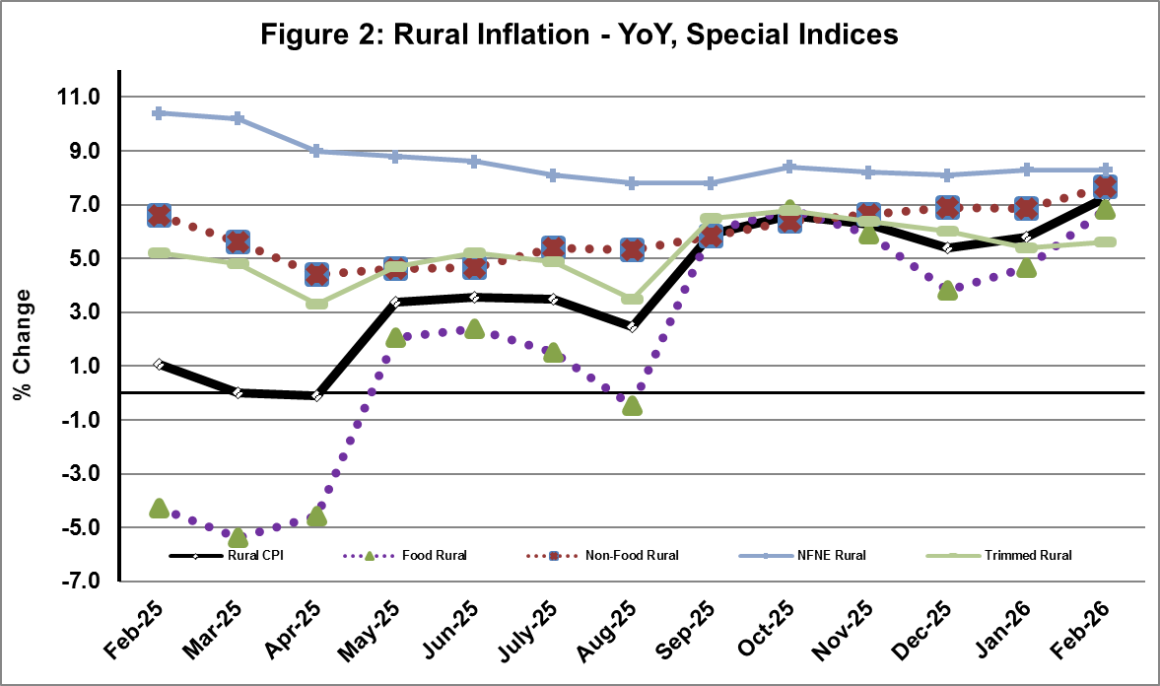
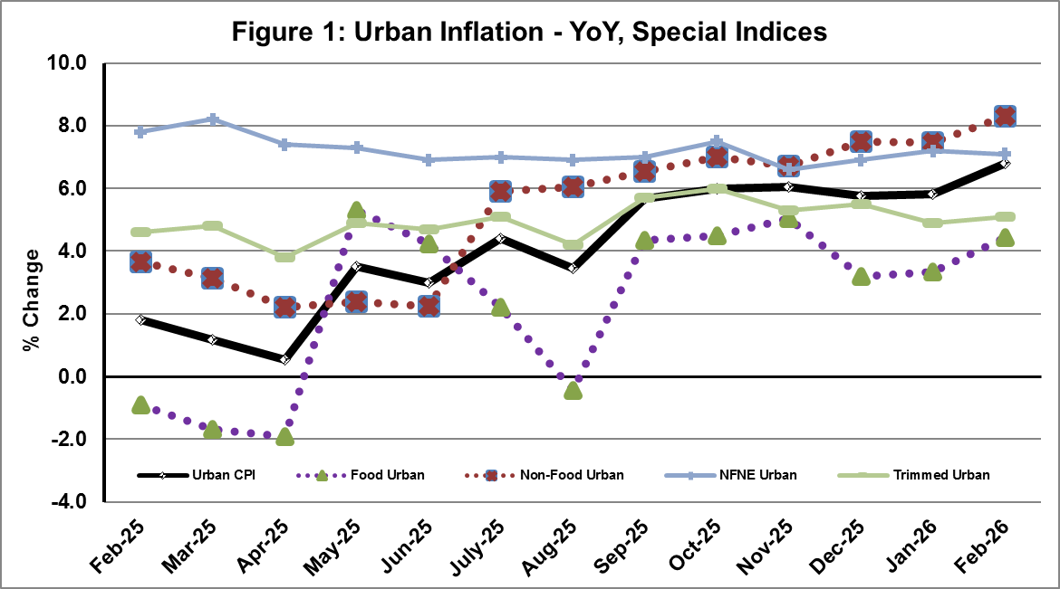
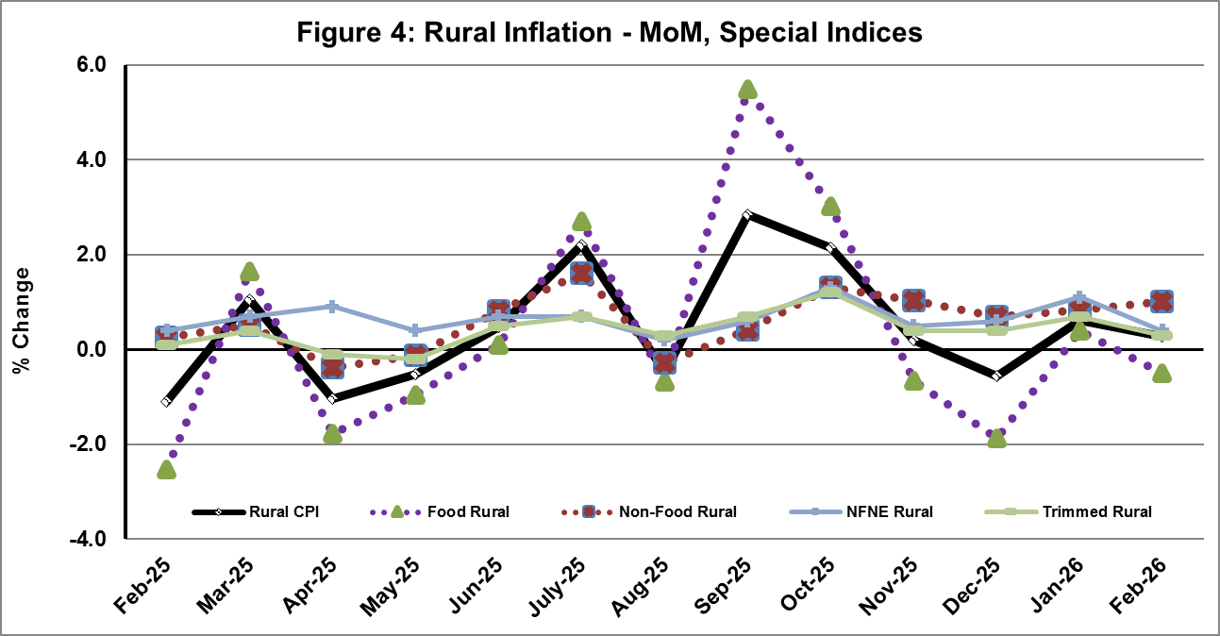
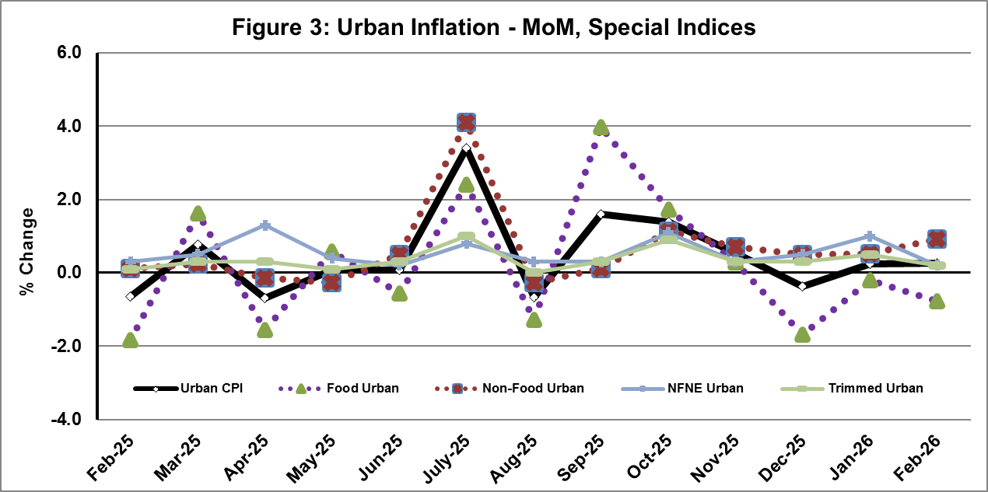

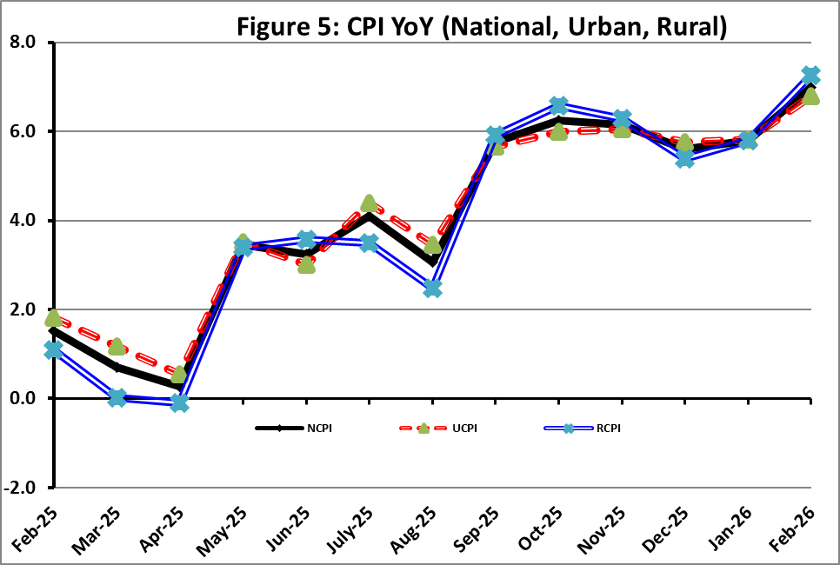

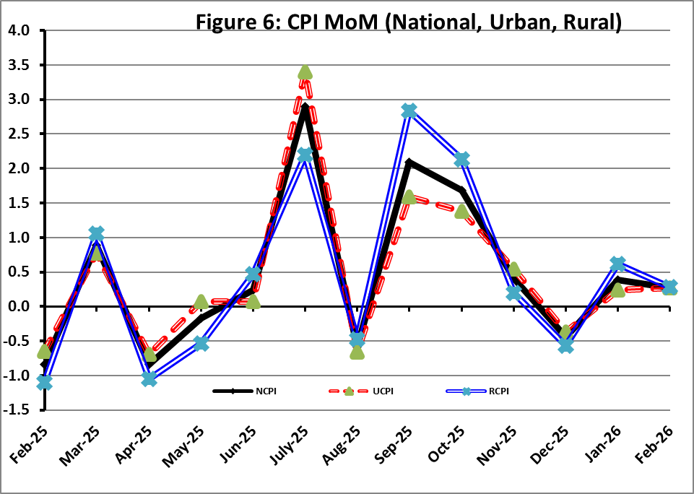
I. National Consumer Price Index (NCPI)

The National Consumer Price Index for February 2026 is increased by 0.27% over January 2026 and increased by 6.98% over corresponding month of the last year i.e. February 2025.

Table 1: Consumer Price Index (National) by Group of Commodities and Services (Base 2015-16)
No | Group | Group  Weight  (%) | Indices |  |  | % Change  Feb 2026  Over |  | Impact  (In % points)  Feb 2026 Over
No | Group | Group  Weight  (%) | Feb 26 | Jan 26 | Feb 25 | Jan 26 | Feb 25 | Jan 26 | Feb 25
No | General | 100.00 | 282.39 | 281.62 | 263.95 | 0.27 | 6.98 | 0.27 | 6.98
1. | Food & Non-alcoholic Bev. | 34.58 | 289.14 | 291.63 | 273.24 | -0.85 | 5.82 | -0.31 | 2.08
 | Non-perishable Food Items | 29.60 | 301.93 | 305.54 | 282.41 | -1.18 | 6.91 | -0.38 | 2.19
 | Perishable Food Items | 4.99 | 213.21 | 209.09 | 218.84 | 1.97 | -2.57 | 0.07 | -0.11
2. | Alcoholic Bev. & Tobacco | 1.02 | 401.38 | 399.91 | 389.99 | 0.37 | 2.92 | 0.01 | 0.04
3. | Clothing & Footwear | 8.60 | 271.19 | 270.26 | 255.41 | 0.35 | 6.18 | 0.03 | 0.51
4. | Housing, Water, Electricity, Gas & Fuels | 23.63 | 262.35 | 257.56 | 239.26 | 1.86 | 9.65 | 0.40 | 2.07
5. | Furnishing & Household Equipment Maintenance | 4.10 | 284.50 | 283.90 | 274.96 | 0.21 | 3.47 | 0.01 | 0.15
6. | Health | 2.79 | 288.52 | 286.76 | 269.16 | 0.61 | 7.19 | 0.02 | 0.20
7. | Transport | 5.91 | 309.69 | 315.65 | 308.55 | -1.89 | 0.37 | -0.13 | 0.03
8. | Communication | 2.21 | 135.75 | 135.74 | 134.89 | 0.00 | 0.63 | 0.00 | 0.01
9. | Recreation & Culture | 1.59 | 265.16 | 265.07 | 277.89 | 0.03 | -4.58 | 0.00 | -0.08
10. | Education | 3.79 | 226.28 | 226.13 | 206.38 | 0.06 | 9.64 | 0.00 | 0.29
11. | Restaurants & Hotels | 6.92 | 298.26 | 297.24 | 284.26 | 0.35 | 4.93 | 0.03 | 0.37
12. | Miscellaneous | 4.87 | 381.22 | 368.85 | 309.92 | 3.36 | 23.01 | 0.21 | 1.32

II. Urban Consumer Price Index (UCPI)

The Urban Consumer Price Index for February 2026 is increased by 0.27% over January 2026 and increased by 6.79% over corresponding month of the last year i.e. February 2025.

Table 2: Consumer Price Index (Urban) by Group of Commodities and Services (Base 2015-16)
No | Group | Group  Weight  (%) | Indices |  |  | % Change  Feb 2026  Over |  | Impact  (In % points)  Feb 2026 Over
No | Group | Group  Weight  (%) | Feb 26 | Jan 26 | Feb 25 | Jan 26 | Feb 25 | Jan 26 | Feb 25
 | General | 100.00 | 278.15 | 277.41 | 260.46 | 0.27 | 6.79 | 0.27 | 6.79
1. | Food & Non-alcoholic Bev. | 30.42 | 284.29 | 287.32 | 271.84 | -1.05 | 4.58 | -0.33 | 1.45
 | Non-perishable Food Items | 25.97 | 295.92 | 300.44 | 281.18 | -1.50 | 5.24 | -0.42 | 1.47
 | Perishable Food Items | 4.46 | 216.49 | 210.86 | 217.41 | 2.67 | -0.42 | 0.09 | -0.02
2. | Alcoholic Bev. & Tobacco | 0.85 | 425.08 | 423.06 | 410.59 | 0.48 | 3.53 | 0.01 | 0.05
3. | Clothing & Footwear | 8.01 | 260.80 | 259.76 | 246.69 | 0.40 | 5.72 | 0.03 | 0.43
4. | Housing, Water, Electricity, Gas & Fuels | 27.03 | 270.49 | 265.90 | 244.76 | 1.73 | 10.51 | 0.45 | 2.67
5. | Furnishing & Household Equip. & Maintenance | 4.09 | 273.11 | 272.57 | 264.72 | 0.20 | 3.17 | 0.01 | 0.13
6. | Health | 2.31 | 288.28 | 287.22 | 271.35 | 0.37 | 6.24 | 0.01 | 0.15
7. | Transport | 6.14 | 303.91 | 310.77 | 303.09 | -2.21 | 0.27 | -0.15 | 0.02
8. | Communication | 2.35 | 139.11 | 139.10 | 138.38 | 0.01 | 0.53 | 0.00 | 0.01
9. | Recreation & Culture | 1.73 | 249.21 | 249.18 | 260.96 | 0.01 | -4.50 | 0.00 | -0.08
10. | Education | 4.88 | 218.23 | 218.20 | 200.61 | 0.01 | 8.78 | 0.00 | 0.33
11. | Restaurants & Hotels | 7.41 | 292.50 | 291.46 | 280.26 | 0.36 | 4.37 | 0.03 | 0.35
12. | Miscellaneous | 4.77 | 369.72 | 356.81 | 299.81 | 3.62 | 23.32 | 0.22 | 1.28
Main contributors to month-on-month and year-on-year percentage changes are given below and detail is given in Annexure-A.
MONTH-ON-MONTH Top few commodities which varied from previous month i.e. January, 2026 are given below:
FOOD
Increased: Tomatoes (23.05%), Fresh Fruits (11.48%), Pulse Mash (8.19%), Beverages (1.65%), Meat (1.45%), Pulse Moong (1.25%), Mustard Oil (1.20%), Dry Fruits (0.78%), Wheat Products (0.68%), Readymade Food (0.44%) and Pulse Gram (0.34%).
Decreased: Eggs (22.39%), Chicken (19.99%), Potatoes (15.89%), Pulse Masoor (4.03%), Onions (3.90%), Fresh Vegetables (3.88%), Besan (1.67%), Vegetable Ghee (0.99%), Cooking Oil (0.94%), Gur (0.39%), Sugar (0.35%) and Gram Whole (0.17%).

NON-FOOD:
Increased: Electricity Charges (10.03%), Cleaning and Laundring (2.09%), Tailoring (2.04%), Solid Fuel (1.71%), Doctor (MBBS) Clinic Fee (1.05%), Liquified Hydrocarbons (0.97%), Motor Fuel (0.88%) and Mechanical Services (0.76%).
Decreased: Transport Services (10.38%) and Stationery (0.03%).

YEAR-ON-YEAR: Top few commodities, which varied from corresponding month of previous year i.e. February 2025, are given below:
FOOD
Increased: Tomatoes (82.05%), Wheat (42.63%), Wheat Flour (25.94%), Butter (16.00%), Fresh Fruits (12.96%), Condiments and Spices (12.87%), Dessert Preparation (11.29%), Meat (11.29%), Milk Powder (9.42%), Dry Fruits (8.10%), Gur (8.03%), Wheat Products (7.40%), Fish (6.68%), Rice (5.32%) and Eggs (5.15%).
Decreased: Potatoes (39.82%), Chicken (21.84%), Pulse Gram (21.74%), Besan (19.94%), Onions (17.02%), Gram Whole (16.59%), Pulse Masoor (11.24%), Beans (9.96%), Tea (8.58%), Pulse Mash (4.90%), Fresh Vegetables (3.88%) and Pulse Moong (3.18%).

NON-FOOD:
Increased: Gas Charges (22.91%), Postal Services (12.56%), Newspapers (11.93%), Liquified Hydrocarbons (11.63%) and Education (8.78%).
Decreased: Text Books (10.90%), Transport Services (1.93%) and Motor Fuel (0.18%).
III. Rural Consumer Price Index (RCPI)

The Rural Consumer Price Index for February 2026 is increased by 0.28% over January 2026 and increased by 7.27% over corresponding month of the last year i.e. February 2025.

Table 3: Consumer Price Index (Rural) by Group of Commodities and Services (Base 2015-16)
No | Group | Group  Weight  (%) | Indices |  |  | % Change  Feb 2026  Over |  | Impact  (In % points)  Feb 2026 Over
No | Group | Group  Weight  (%) | Feb 26 | Jan 26 | Feb 25 | Jan 26 | Feb 25 | Jan 26 | Feb 25
 | General | 100.00 | 288.78 | 287.97 | 269.22 | 0.28 | 7.27 | 0.28 | 7.27
1. | Food & Non-alcoholic Bev. | 40.87 | 294.59 | 296.48 | 274.82 | -0.64 | 7.19 | -0.27 | 3.00
 | Non-perishable Food Items | 35.08 | 308.65 | 311.24 | 283.78 | -0.83 | 8.76 | -0.32 | 3.24
 | Perishable Food Items | 5.79 | 209.40 | 207.03 | 220.51 | 1.14 | -5.04 | 0.05 | -0.24
2. | Alcoholic Bev. & Tobacco | 1.28 | 377.49 | 376.56 | 369.21 | 0.25 | 2.24 | 0.00 | 0.04
3. | Clothing & Footwear | 9.48 | 284.44 | 283.64 | 266.53 | 0.28 | 6.72 | 0.03 | 0.63
4. | Housing, Water, Electricity, Gas & Fuels | 18.49 | 244.39 | 239.16 | 227.13 | 2.19 | 7.60 | 0.34 | 1.19
5. | Furnishing & Household Equip. & Maintenance | 4.10 | 301.65 | 300.95 | 290.37 | 0.23 | 3.88 | 0.01 | 0.17
6. | Health | 3.51 | 288.76 | 286.31 | 266.98 | 0.86 | 8.16 | 0.03 | 0.28
7. | Transport | 5.56 | 319.33 | 323.79 | 317.65 | -1.38 | 0.53 | -0.09 | 0.03
8. | Communication | 1.99 | 129.76 | 129.76 | 128.68 | 0.00 | 0.84 | 0.00 | 0.01
9. | Recreation & Culture | 1.38 | 295.42 | 295.21 | 310.02 | 0.07 | -4.71 | 0.00 | -0.07
10. | Education | 2.13 | 254.06 | 253.53 | 226.30 | 0.21 | 12.27 | 0.00 | 0.22
11. | Restaurants & Hotels | 6.19 | 308.67 | 307.67 | 291.47 | 0.33 | 5.90 | 0.02 | 0.40
12. | Miscellaneous | 5.02 | 397.74 | 386.13 | 324.44 | 3.01 | 22.59 | 0.20 | 1.37
Main contributors to month-on-month and year-on-year percentage changes are given below and detail is given in Annexure-B.
MONTH-ON-MONTH Top few commodities which varied from previous month i.e. January, 2026 are given below:

FOOD
Increased: Tomatoes (17.61%), Fresh Fruits (11.47%), Pulse Mash (3.21%), Wheat Flour (2.74%), Beans (1.66%), Meat (1.60%), Beverages (1.46%) and Wheat Products (1.20%).
Decreased: Potatoes (21.50%), Eggs (19.18%), Chicken (18.68%), Onions (5.91%), Pulse Masoor (2.60%), Besan (1.91%), Gram Whole (1.75%), Wheat (1.03%), Sugar (0.81%), Fresh Vegetables (0.48%), Gur (0.32%), Butter (0.17%), Vegetable Ghee (0.13%) and Cooking Oil (0.04%).

NON-FOOD

Increased: Electricity Charges (10.03%), Doctor Clinic Fee (1.75%), Hospital Services (1.68%), Construction Wage Rates (1.37%), Tailoring (1.28%) and Household Textiles (0.98%).

Decreased: Transport Services (5.06%).

Year-On-Year: Top few commodities which varied from corresponding month of previous year i.e. February, 2025 are given below:
FOOD
Increased: Tomatoes (61.61%), Wheat (48.12%), Wheat Flour (40.19%), Meat (12.43%), Eggs (11.52%), Fresh Fruits (11.37%), Dry Fruits (10.35%), Milk Powder (9.51%), Gur (9.41%) and Wheat Products (8.89%),.
Decreased: Potatoes (45.44%), Pulse Gram (21.47%), Onions (21.22%), Besan (20.76%), Chicken (17.87%), Gram Whole (15.86%), Tea (14.64%), Pulse Mash (10.11%), Pulse Masoor (9.23%), Pulse Moong (3.57%) and Fresh Vegetables (1.97%).

NON-FOOD
Increased: Newspapers (16.67%), Doctor Clinic Fee (14.10%), Education (12.27%), Medical Tests (10.70%), Personal Grooming Services (10.44%) and Readymade Garments (9.83%).
Decreased: Text Books (15.30%) and Motor Fuels (0.24%).

IV. Sensitive Price Indicator (SPI)

Quintile-wise percentage changes YoY and MoM are given below in Table 4. The series from
February 2025 to February 2026 is also graphed below in Figure 7.

Table 4: Sensitive Price Indicator (Base 2015-16)
Quintiles | Indices |  |  | % Change Feb 2026  Over
Quintiles | Feb 2026 | Jan 2026 | Feb 2025 | Jan 2026 | Feb 2025
1 | 323.76 | 324.24 | 308.94 | -0.15 | 4.80
2 | 324.69 | 324.74 | 306.66 | -0.02 | 5.88
3 | 345.91 | 346.60 | 329.37 | -0.20 | 5.02
4 | 332.53 | 333.53 | 318.68 | -0.30 | 4.35
5 | 331.49 | 332.39 | 320.29 | -0.27 | 3.50
Combined | 333.64 | 334.04 | 318.97 | -0.12 | 4.60

Table 4.1: Weekly Percentage Change of SPI During February 2026
Quintiles | % Change over Previous week
Quintiles | 04-02-2026 | 12-02-2026 | 19-02-2026 | 26-02-2026
Quintile 1 | 0.13 | -0.62 | 1.11 | -0.71
Combined | 0.09 | -0.59 | 1.16 | -0.54

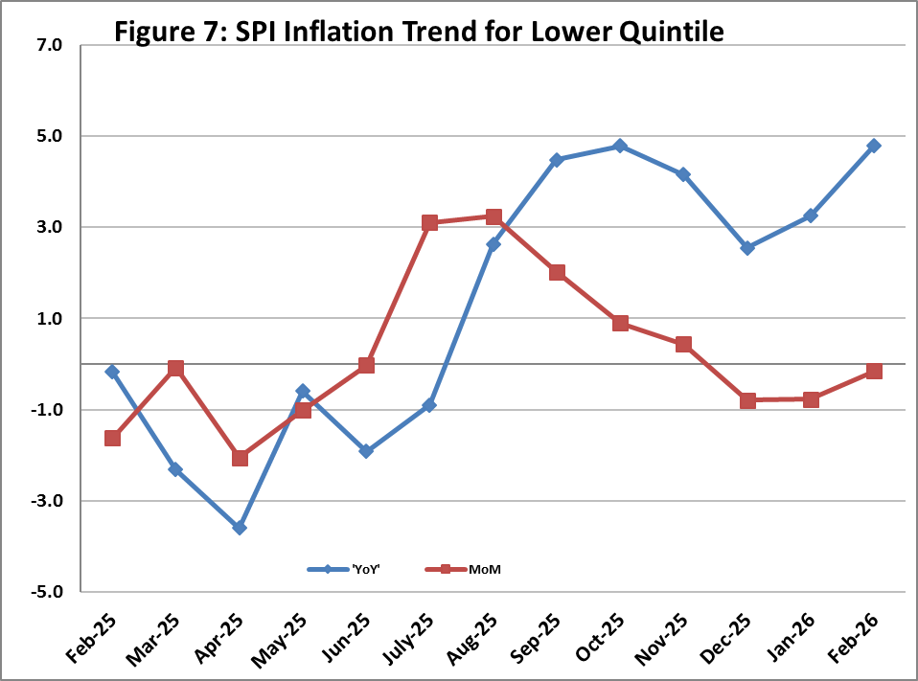

V. Wholesale Price Index
The Wholesale Price Index for February 2026 increased by 0.66% over January 2026 and increased by 1.05% over the corresponding month of the last year i.e. February, 2025. YoY and MoM movements from February, 2025 to February, 2026 are also graphed below in Figure 8.

Table 5: Wholesale Price Index by Group of Commodities (Base 2015-16)
No | Group | Group  Weight  (%) | Indices |  |  | % Change  Feb 2026  Over |  | Impact  (In % points)  Feb 2026 Over
No | Group | Group  Weight  (%) | Feb 26 | Jan 26 | Feb 25 | Jan 26 | Feb 25 | Jan 26 | Feb 25
 | General | 100.00 | 315.21 | 313.15 | 311.94 | 0.66 | 1.05 | 0.66 | 1.05
1 | Agriculture Forestry & Fishery | 25.77 | 273.24 | 274.15 | 276.43 | -0.33 | -1.15 | -0.07 | -0.26
2 | Ores/Minerals, Elec., Gas & Water | 12.01 | 361.74 | 363.06 | 359.16 | -0.36 | 0.72 | -0.05 | 0.10
3 | Food, Beverages, Tobacco, Textiles & Leather Products | 31.11 | 295.45 | 293.51 | 279.35 | 0.66 | 5.76 | 0.19 | 1.61
 | i. Food Products, Beverages & Tobacco | 20.07 | 317.77 | 314.81 | 295.70 | 0.94 | 7.46 | 0.19 | 1.42
 | ii. Textiles & Apparels | 10.33 | 260.08 | 260.00 | 254.82 | 0.03 | 2.06 | 0.00 | 0.17
 | iii. Leather Products | 0.71 | 179.03 | 179.03 | 174.41 | 0.00 | 2.65 | 0.00 | 0.01
4 | Other Transportable Goods | 22.40 | 335.17 | 326.95 | 342.96 | 2.51 | -2.27 | 0.59 | -0.56
5 | Metal Product, Machinery & Equipment | 8.72 | 394.46 | 394.32 | 388.47 | 0.04 | 1.54 | 0.00 | 0.17

Main contributors to month-on-month and year-on-year percentage changes are given below and detail is given in Annexure-C.

MONTH-ON-MONTH: Top few commodities which varied from previous month are given below:
Increased: Fresh Fruits (28.59%), Raw Animal Materials / Wool (17.06%), Sorghum / Jowar (8.28%), Glass sheets (6.74%), Diesel Oil (5.77%), Furnace Oil (4.76%) and Dried Fruits & Nuts (4.73%).
Decreased: Eggs (28.67%), Poultry (21.07%), Edible Roots / Potatoes (19.30%), Vegetables (11.69%), Vegetables & Fruit Juice (2.23%), Maize (1.85%), Dry Fruits (1.72%), Sugar Refined (1.31%), Wheat (1.10%) and Wheat Flour (1.06%).

YEAR-ON-YEAR: Top few commodities which varied from previous year are given below:
Increased: Sorghum / Jowar (48.18%), Other Food Products (45.66%), Wheat (43.92%), Wheat Flour (32.67%), Dried Fruits & Nuts (24.65%), Dyeing Material (22.99%), Woven Fabrics (20.13%), Raw Animal Materials / Wool (19.72%) and Maize (19.71%).
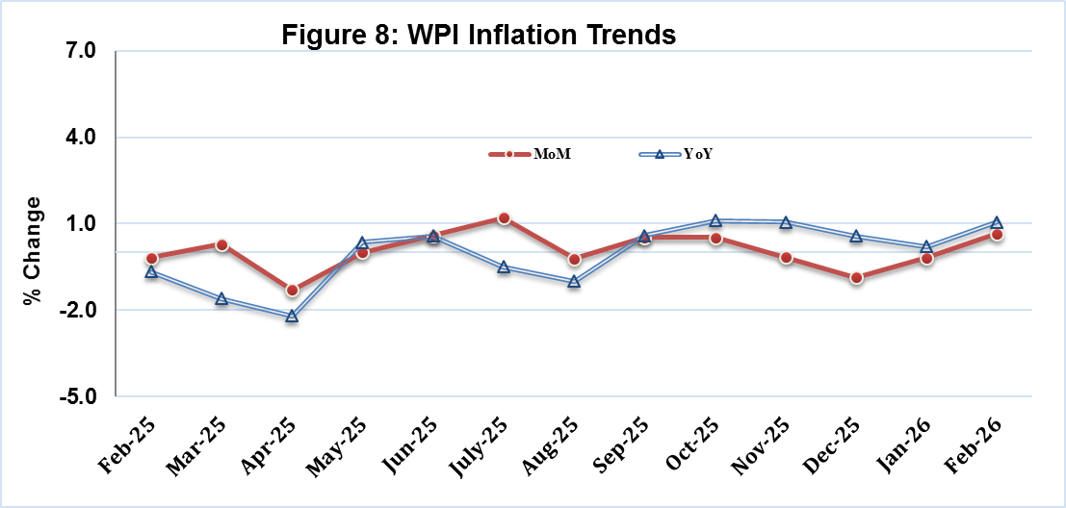
Decreased: Edible Roots / Potatoes (51.83%), Other Cereal Flour (23.25%), Poultry (22.57%), Furnace Oil (19.42%), Pulses (15.72%), Fibre Crops (11.68%), Electrical Energy (8.11%), Cotton Seeds (8.00%), Stimulant & Spice Crops (6.58%), Steel Bar & Sheets (6.07%) and Rice (3.86%).

Annexure A: CPI (Urban) Index Numbers by Commodity Groups & Commodities (2015-16=100)
Item and Specification |  | Weight | Index Numbers  Feb 26 Jan 26 Feb 25 |  |  | % Change in Feb 2026 over  Jan 2026 Feb 2025
 | General | 100.0000 | 278.15 | 277.41 | 260.46 |  | + | 0.27 |  | + | 6.79
 | Food and non-alcoholic Beverages | 30.4215 | 284.29 | 287.32 | 271.84 |  | - | 1.05 |  | + | 4.58
01 | Wheat | 0.6120 | 331.77 | 331.87 | 232.61 |  | - | 0.03 |  | + | 42.63
02 | Wheat flour | 3.0075 | 293.08 | 293.09 | 232.72 |  | + | 0.00 |  | + | 25.94
03 | Wheat products | 0.0936 | 306.55 | 304.48 | 285.42 |  | + | 0.68 |  | + | 7.40
04 | Besan | 0.0830 | 223.35 | 227.14 | 278.97 |  | - | 1.67 |  | - | 19.94
05 | Rice | 1.1804 | 328.22 | 328.33 | 311.63 |  | - | 0.03 |  | + | 5.32
06 | Bakery and confectionary | 0.4770 | 277.31 | 276.49 | 267.82 |  | + | 0.30 |  | + | 3.54
07 | Nimco | 0.1224 | 303.87 | 303.17 | 295.66 |  | + | 0.23 |  | + | 2.78
08 | Meat | 2.0411 | 365.75 | 360.53 | 328.66 |  | + | 1.45 |  | + | 11.29
09 | Chicken | 1.3631 | 243.75 | 304.64 | 311.85 |  | - | 19.99 |  | - | 21.84
10 | Fish | 0.3855 | 233.48 | 233.69 | 218.86 |  | - | 0.09 |  | + | 6.68
11 | Milk fresh | 7.1070 | 269.32 | 269.25 | 262.54 |  | + | 0.03 |  | + | 2.58
12 | Milk products | 0.6407 | 273.21 | 272.53 | 265.51 |  | + | 0.25 |  | + | 2.90
13 | Milk powder | 0.3106 | 332.05 | 331.45 | 303.45 |  | + | 0.18 |  | + | 9.42
14 | Eggs | 0.5083 | 305.60 | 393.74 | 290.64 |  | - | 22.39 |  | + | 5.15
15 | Butter | 0.0932 | 492.40 | 492.40 | 424.47 |  | + | 0.00 |  | + | 16.00
16 | Mustard oil | 0.0120 | 317.56 | 313.79 | 320.88 |  | + | 1.20 |  | - | 1.03
17 | Cooking oil | 1.1016 | 341.83 | 345.06 | 333.57 |  | - | 0.94 |  | + | 2.48
18 | Vegetable ghee | 1.0324 | 356.94 | 360.52 | 355.08 |  | - | 0.99 |  | + | 0.52
19 | Dry fruits | 0.3299 | 321.30 | 318.82 | 297.23 |  | + | 0.78 |  | + | 8.10
20 | Fresh fruits | 1.4363 | 281.27 | 252.30 | 248.99 |  | + | 11.48 |  | + | 12.96
21 | Pulse masoor | 0.1624 | 180.81 | 188.40 | 203.70 |  | - | 4.03 |  | - | 11.24
22 | Pulse moong | 0.1697 | 238.03 | 235.08 | 245.84 |  | + | 1.25 |  | - | 3.18
23 | Pulse mash | 0.1152 | 192.99 | 178.38 | 202.93 |  | + | 8.19 |  | - | 4.90
24 | Pulse gram | 0.1660 | 210.37 | 209.66 | 268.81 |  | + | 0.34 |  | - | 21.74
25 | Gram whole | 0.0912 | 244.54 | 244.95 | 293.18 |  | - | 0.17 |  | - | 16.59
26 | Beans | 0.0408 | 350.83 | 350.77 | 389.63 |  | + | 0.02 |  | - | 9.96
27 | Potatoes | 0.4496 | 170.52 | 202.74 | 283.34 |  | - | 15.89 |  | - | 39.82
28 | Onions | 0.5928 | 167.04 | 173.82 | 201.29 |  | - | 3.90 |  | - | 17.02
29 | Tomatoes | 0.3459 | 216.70 | 176.11 | 119.03 |  | + | 23.05 |  | + | 82.05
30 | Fresh vegetables | 1.5306 | 184.67 | 192.13 | 192.12 |  | - | 3.88 |  | - | 3.88
31 | Sugar | 1.1130 | 248.00 | 248.88 | 246.88 |  | - | 0.35 |  | + | 0.45
32 | Gur | 0.0379 | 263.24 | 264.27 | 243.68 |  | - | 0.39 |  | + | 8.03
33 | Honey | 0.1017 | 222.56 | 222.62 | 220.17 |  | - | 0.03 |  | + | 1.09
34 | Sweetmeat | 0.3535 | 338.53 | 336.52 | 322.98 |  | + | 0.60 |  | + | 4.81
35 | Ice cream | 0.1044 | 200.62 | 199.68 | 199.45 |  | + | 0.47 |  | + | 0.59
36 | Condiments and Spices | 1.3340 | 383.64 | 383.83 | 339.91 |  | - | 0.05 |  | + | 12.87
37 | Dessert preparation | 0.0419 | 300.63 | 300.63 | 270.14 |  | + | 0.00 |  | + | 11.29
38 | Tea | 0.8427 | 273.67 | 273.67 | 299.35 |  | + | 0.00 |  | - | 8.58
39 | Beverages | 0.8906 | 266.79 | 262.45 | 256.80 |  | + | 1.65 |  | + | 3.89
 | Alcoholic Beverages, Tobacco | 0.8540 | 425.08 | 423.06 | 410.59 |  | + | 0.48 |  | + | 3.53
40 | Cigarettes | 0.7167 | 414.06 | 411.76 | 402.86 |  | + | 0.56 |  | + | 2.78
41 | Pan prepared | 0.1373 | 482.61 | 482.03 | 450.94 |  | + | 0.12 |  | + | 7.02
 | Clothing and footwear | 8.0096 | 260.80 | 259.76 | 246.69 |  | + | 0.40 |  | + | 5.72
42 | Cotton cloth | 2.2227 | 300.73 | 300.08 | 281.50 |  | + | 0.22 |  | + | 6.83
43 | Woolen cloth | 0.8361 | 258.39 | 257.78 | 237.12 |  | + | 0.24 |  | + | 8.97
44 | Readymade garments | 1.3196 | 226.61 | 226.35 | 212.63 |  | + | 0.11 |  | + | 6.57
45 | Woolen readymade garments | 0.4307 | 273.83 | 273.83 | 257.23 |  | + | 0.00 |  | + | 6.45
46 | Tailoring | 1.0741 | 248.99 | 244.02 | 229.85 |  | + | 2.04 |  | + | 8.33
47 | Hosiery | 0.4070 | 242.09 | 241.68 | 234.60 |  | + | 0.17 |  | + | 3.19
48 | Dupatta | 0.1713 | 206.93 | 206.61 | 200.63 |  | + | 0.15 |  | + | 3.14
49 | Cleaning and laundering | 0.0665 | 288.04 | 282.14 | 266.32 |  | + | 2.09 |  | + | 8.16
50 | Footwear | 1.4816 | 247.61 | 247.61 | 247.12 |  | + | 0.00 |  | + | 0.20
 | Housing, water, Elec., Gas and other Fuels | 27.0332 | 270.49 | 265.90 | 244.76 |  | + | 1.73 |  | + | 10.51
51 | House rent | 19.2558 | 178.39 | 178.39 | 168.09 |  | + | 0.00 |  | + | 6.13
52 | Construction input items | 0.3765 | 270.88 | 270.47 | 263.77 |  | + | 0.15 |  | + | 2.70
53 | Construction wage rates | 0.2025 | 236.62 | 235.38 | 223.20 |  | + | 0.53 |  | + | 6.01
54 | Water supply | 0.5269 | 244.90 | 244.90 | 228.99 |  | + | 0.00 |  | + | 6.95
55 | Garbage collection | 0.1064 | 266.52 | 266.52 | 262.24 |  | + | 0.00 |  | + | 1.63
56 | Electricity charges | 4.5562 | 289.28 | 262.92 | 269.56 |  | + | 10.03 |  | + | 7.32
57 | Gas charges | 1.0807 | 1817.96 | 1817.96 | 1479.08 |  | + | 0.00 |  | + | 22.91
58 | Liquefied Hydrocarbons | 0.5064 | 362.10 | 358.63 | 324.38 |  | + | 0.97 |  | + | 11.63
59 | Solid Fuel | 0.4218 | 246.24 | 242.09 | 227.94 |  | + | 1.71 |  | + | 8.03
 | Furnishing and household equipments | 4.0937 | 273.11 | 272.57 | 264.72 |  | + | 0.20 |  | + | 3.17
60 | Furniture and furnishing | 0.4750 | 265.61 | 265.06 | 258.02 |  | + | 0.21 |  | + | 2.94
61 | Carpets | 0.0308 | 157.75 | 157.16 | 150.80 |  | + | 0.38 |  | + | 4.61
62 | Household textiles | 0.3420 | 215.67 | 215.43 | 208.77 |  | + | 0.11 |  | + | 3.31
63 | Household equipments | 1.0032 | 278.43 | 277.54 | 265.44 |  | + | 0.32 |  | + | 4.89
64 | Plastic products | 0.0536 | 234.65 | 234.53 | 220.66 |  | + | 0.05 |  | + | 6.34
65 | Major tools & equipments | 0.0084 | 258.12 | 257.67 | 241.46 |  | + | 0.17 |  | + | 6.90
66 | Washing soap/detergents/match | 1.4112 | 323.42 | 322.97 | 319.78 |  | + | 0.14 |  | + | 1.14
67 | Household servant | 0.7695 | 211.55 | 211.16 | 199.69 |  | + | 0.18 |  | + | 5.94
 | Health | 2.3098 | 288.28 | 287.22 | 271.35 |  | + | 0.37 |  | + | 6.24
68 | Drugs and medicines | 1.0735 | 311.17 | 310.36 | 292.45 |  | + | 0.26 |  | + | 6.40
69 | Therapeutic Appliances and Equipments | 0.0054 | 156.87 | 156.75 | 154.81 |  | + | 0.08 |  | + | 1.33
70 | Doctor (MBBS) clinic fee | 0.4044 | 362.01 | 358.25 | 336.38 |  | + | 1.05 |  | + | 7.62
71 | Dental services | 0.0156 | 236.82 | 236.61 | 223.27 |  | + | 0.09 |  | + | 6.07
72 | Medical tests | 0.2367 | 223.28 | 223.09 | 213.10 |  | + | 0.09 |  | + | 4.78
73 | Hospitals services | 0.5742 | 223.00 | 222.99 | 212.51 |  | + | 0.00 |  | + | 4.94
 | Transport | 6.1368 | 303.91 | 310.77 | 303.09 |  | - | 2.21 |  | + | 0.27
74 | Motor vehicles | 0.8097 | 267.62 | 267.56 | 259.34 |  | + | 0.02 |  | + | 3.19
75 | Motor vehicle accessories | 0.1941 | 271.30 | 269.88 | 264.18 |  | + | 0.53 |  | + | 2.70
76 | Motor fuel | 2.9088 | 350.32 | 347.27 | 350.94 |  | + | 0.88 |  | - | 0.18
77 | Mechanical services | 0.4290 | 250.86 | 248.97 | 233.04 |  | + | 0.76 |  | + | 7.65
78 | Motor vehicle tax | 0.0482 | 399.23 | 399.23 | 399.23 |  | + | 0.00 |  | + | 0.00
79 | Transport services | 1.7470 | 257.50 | 287.31 | 262.57 |  | - | 10.38 |  | - | 1.93
 | Communication | 2.3536 | 139.11 | 139.10 | 138.38 |  | + | 0.01 |  | + | 0.53
80 | Postal services | 0.0190 | 245.15 | 245.15 | 217.79 |  | + | 0.00 |  | + | 12.56
81 | Communication apparatus | 0.4524 | 191.06 | 191.03 | 188.43 |  | + | 0.02 |  | + | 1.40
82 | Communication Services | 1.8822 | 125.55 | 125.55 | 125.55 |  | + | 0.00 |  | + | 0.00
 | Recreation and culture | 1.7301 | 249.21 | 249.18 | 260.96 |  | + | 0.01 |  | - | 4.50
83 | Recreation and culture | 0.6478 | 156.46 | 156.34 | 154.84 |  | + | 0.08 |  | + | 1.05
84 | Text books | 0.6655 | 297.49 | 297.49 | 333.89 |  | + | 0.00 |  | - | 10.90
85 | Newspapers | 0.0716 | 242.82 | 242.82 | 216.94 |  | + | 0.00 |  | + | 11.93
86 | stationery | 0.3452 | 331.50 | 331.59 | 328.63 |  | - | 0.03 |  | + | 0.87
 | Education | 4.8807 | 218.23 | 218.20 | 200.61 |  | + | 0.01 |  | + | 8.78
87 | Education | 4.8807 | 218.23 | 218.20 | 200.61 |  | + | 0.01 |  | + | 8.78
 | Restaurants and hotels | 7.4050 | 292.50 | 291.46 | 280.26 |  | + | 0.36 |  | + | 4.37
88 | Readymade food | 5.5235 | 299.06 | 297.74 | 287.84 |  | + | 0.44 |  | + | 3.90
89 | Marriage Hall Charges | 1.7514 | 280.00 | 279.80 | 263.95 |  | + | 0.07 |  | + | 6.08
90 | Accommodation Services | 0.1301 | 182.04 | 182.00 | 178.30 |  | + | 0.02 |  | + | 2.10
 | Misc. goods and services | 4.7720 | 369.72 | 356.81 | 299.81 |  | + | 3.62 |  | + | 23.32
91 | Personal Grooming Services | 0.8001 | 274.58 | 274.41 | 257.13 |  | + | 0.06 |  | + | 6.79
92 | Electrical Appliances for Per | 0.0465 | 192.09 | 191.91 | 177.43 |  | + | 0.09 |  | + | 8.26
93 | Appliances/Articles/Products | 2.9807 | 295.99 | 295.18 | 272.16 |  | + | 0.27 |  | + | 8.76
94 | Personal Effects n.e.c. | 0.9447 | 691.68 | 629.14 | 429.18 |  | + | 9.94 |  | + | 61.16

Annexure B: CPI (Rural) Index Numbers by Commodity Groups & Commodities (2015-16=100)
Item and Specification |  | Weight | Index Numbers  Feb 26 Jan 26 Feb 25 |  |  | % Change in Feb 2026 over  Jan 2026 Feb 2025
 | General | 100.0000 | 288.78 | 287.97 | 269.22 |  | + | 0.28 |  | + | 7.27
 | Food and non-alcoholic Beverages | 40.8668 | 294.59 | 296.48 | 274.82 |  | - | 0.64 |  | + | 7.19
01 | Wheat | 3.4736 | 349.51 | 353.15 | 235.97 |  | - | 1.03 |  | + | 48.12
02 | Wheat Flour | 3.4297 | 326.73 | 318.01 | 233.07 |  | + | 2.74 |  | + | 40.19
03 | Wheat Products | 0.1068 | 312.31 | 308.60 | 286.80 |  | + | 1.20 |  | + | 8.89
04 | Besan | 0.0728 | 243.31 | 248.06 | 307.05 |  | - | 1.91 |  | - | 20.76
05 | Rice | 1.5501 | 430.80 | 429.15 | 412.76 |  | + | 0.38 |  | + | 4.37
06 | Bakery and Confectionary | 0.3702 | 326.89 | 323.74 | 306.90 |  | + | 0.97 |  | + | 6.51
07 | Nimco | 0.0774 | 316.73 | 316.44 | 306.34 |  | + | 0.09 |  | + | 3.39
08 | Meat | 1.7146 | 384.89 | 378.82 | 342.34 |  | + | 1.60 |  | + | 12.43
09 | Chicken | 1.4641 | 259.87 | 319.56 | 316.40 |  | - | 18.68 |  | - | 17.87
10 | Fish | 0.2640 | 244.96 | 243.94 | 237.64 |  | + | 0.42 |  | + | 3.08
11 | Milk fresh | 10.3803 | 273.77 | 273.14 | 260.55 |  | + | 0.23 |  | + | 5.07
12 | Milk products | 0.9624 | 267.40 | 267.40 | 257.19 |  | + | 0.00 |  | + | 3.97
13 | Milk powder | 0.1062 | 302.22 | 301.10 | 275.97 |  | + | 0.37 |  | + | 9.51
14 | Eggs | 0.5665 | 313.80 | 388.29 | 281.38 |  | - | 19.18 |  | + | 11.52
15 | Butter | 0.3333 | 332.82 | 333.38 | 307.05 |  | - | 0.17 |  | + | 8.39
16 | Mustard oil | 0.0136 | 341.71 | 340.68 | 339.07 |  | + | 0.30 |  | + | 0.78
17 | Cooking oil | 0.6011 | 371.75 | 371.89 | 369.81 |  | - | 0.04 |  | + | 0.52
18 | Vegetable ghee | 2.3764 | 389.87 | 390.36 | 382.72 |  | - | 0.13 |  | + | 1.87
19 | Dry fruits | 0.2496 | 398.96 | 394.34 | 361.53 |  | + | 1.17 |  | + | 10.35
20 | Fresh fruits | 1.4505 | 283.27 | 254.13 | 254.35 |  | + | 11.47 |  | + | 11.37
21 | Pulse Masoor | 0.2076 | 207.52 | 213.07 | 228.61 |  | - | 2.60 |  | - | 9.23
22 | Pulse Moong | 0.2510 | 258.71 | 257.81 | 268.28 |  | + | 0.35 |  | - | 3.57
23 | Pulse Mash | 0.1465 | 194.70 | 188.64 | 216.60 |  | + | 3.21 |  | - | 10.11
24 | Pulse Gram | 0.2751 | 223.34 | 222.16 | 284.39 |  | + | 0.53 |  | - | 21.47
25 | Gram Whole | 0.1116 | 259.86 | 264.48 | 308.86 |  | - | 1.75 |  | - | 15.86
26 | Beans | 0.0896 | 409.88 | 403.18 | 410.10 |  | + | 1.66 |  | - | 0.05
27 | Potatoes | 0.7437 | 154.53 | 196.86 | 283.23 |  | - | 21.50 |  | - | 45.44
28 | Onions | 0.8965 | 159.76 | 169.79 | 202.78 |  | - | 5.91 |  | - | 21.22
29 | Tomatoes | 0.5069 | 201.79 | 171.58 | 124.86 |  | + | 17.61 |  | + | 61.61
30 | Fresh Vegetables | 2.0947 | 197.96 | 198.91 | 201.93 |  | - | 0.48 |  | - | 1.97
31 | Sugar | 2.0296 | 250.57 | 252.61 | 248.15 |  | - | 0.81 |  | + | 0.98
32 | Gur | 0.1522 | 259.97 | 260.81 | 237.61 |  | - | 0.32 |  | + | 9.41
33 | Honey | 0.0296 | 225.70 | 225.70 | 223.43 |  | + | 0.00 |  | + | 1.02
34 | Sweetmeat | 0.3967 | 303.02 | 302.51 | 288.78 |  | + | 0.17 |  | + | 4.93
35 | Ice Cream | 0.0568 | 200.83 | 198.80 | 199.34 |  | + | 1.02 |  | + | 0.75
36 | Condiments and Spices | 1.4919 | 292.64 | 292.16 | 297.71 |  | + | 0.16 |  | - | 1.70
37 | Dessert Preparation | 0.0133 | 296.76 | 296.76 | 268.52 |  | + | 0.00 |  | + | 10.52
38 | Tea | 1.2566 | 271.09 | 271.09 | 317.58 |  | + | 0.00 |  | - | 14.64
39 | Beverages | 0.5537 | 259.21 | 255.49 | 246.29 |  | + | 1.46 |  | + | 5.25
 | Alcoholic Beverages, Tobacco | 1.2786 | 377.49 | 376.56 | 369.21 |  | + | 0.25 |  | + | 2.24
40 | Cigarettes | 1.2364 | 377.27 | 376.31 | 369.60 |  | + | 0.26 |  | + | 2.08
41 | Pan Prepared | 0.0422 | 383.86 | 383.86 | 357.98 |  | + | 0.00 |  | + | 7.23
 | Clothing and footwear | 9.4826 | 284.44 | 283.64 | 266.53 |  | + | 0.28 |  | + | 6.72
42 | Cotton Cloth | 2.8381 | 309.03 | 309.03 | 292.87 |  | + | 0.00 |  | + | 5.52
43 | Woollen Cloth | 1.0959 | 275.18 | 275.18 | 258.25 |  | + | 0.00 |  | + | 6.56
44 | Readymade Garments | 1.1345 | 264.06 | 264.00 | 240.43 |  | + | 0.02 |  | + | 9.83
45 | Woollen Readymade Garments | 0.5401 | 334.48 | 334.48 | 309.66 |  | + | 0.00 |  | + | 8.02
46 | Tailoring | 1.2999 | 268.94 | 265.54 | 246.58 |  | + | 1.28 |  | + | 9.07
47 | Hosiery | 0.4322 | 357.87 | 357.16 | 346.40 |  | + | 0.20 |  | + | 3.31
48 | Dupatta | 0.2078 | 258.89 | 258.85 | 244.42 |  | + | 0.02 |  | + | 5.92
49 | Cleaning and Laundering | 0.0176 | 267.84 | 267.84 | 258.58 |  | + | 0.00 |  | + | 3.58
50 | Footwear | 1.9165 | 248.18 | 246.69 | 233.56 |  | + | 0.60 |  | + | 6.26
 | Housing, Water, Elec., Gas and other Fuels | 18.4853 | 244.39 | 239.16 | 227.13 |  | + | 2.19 |  | + | 7.60
51 | House Rent | 8.6110 | 188.80 | 188.80 | 175.84 |  | + | 0.00 |  | + | 7.37
52 | Construction Input Items | 0.6306 | 269.74 | 267.20 | 251.31 |  | + | 0.95 |  | + | 7.33
53 | Construction Wage Rates | 0.2526 | 254.94 | 251.50 | 239.74 |  | + | 1.37 |  | + | 6.34
54 | Water Supply | 0.0645 | 325.72 | 325.72 | 311.91 |  | + | 0.00 |  | + | 4.43
55 | Garbage Collection | 0.0080 | 204.36 | 204.36 | 204.36 |  | + | 0.00 |  | + | 0.00
56 | Electricity Charges | 3.4431 | 289.28 | 262.92 | 269.56 |  | + | 10.03 |  | + | 7.32
57 | Liquefied Hydrocarbons | 0.9994 | 324.98 | 322.87 | 301.13 |  | + | 0.65 |  | + | 7.92
58 | Solid Fuel | 4.4761 | 293.56 | 293.24 | 271.33 |  | + | 0.11 |  | + | 8.19
 | Furnishing and household equipments | 4.1031 | 301.65 | 300.95 | 290.37 |  | + | 0.23 |  | + | 3.88
59 | Furniture and Furnishing | 0.5786 | 301.48 | 300.02 | 285.45 |  | + | 0.49 |  | + | 5.62
60 | Household Textiles | 0.4382 | 261.14 | 258.61 | 241.47 |  | + | 0.98 |  | + | 8.15
61 | Household Equipments | 1.2774 | 300.74 | 300.56 | 288.28 |  | + | 0.06 |  | + | 4.32
62 | Plastic Products | 0.0776 | 316.37 | 315.74 | 294.42 |  | + | 0.20 |  | + | 7.46
63 | Major Tools and Equipments | 0.0324 | 250.77 | 250.77 | 241.33 |  | + | 0.00 |  | + | 3.91
64 | Washing Soaps, Detergents and | 1.6989 | 313.15 | 312.77 | 306.98 |  | + | 0.12 |  | + | 2.01
 | Health | 3.5141 | 288.76 | 286.31 | 266.98 |  | + | 0.86 |  | + | 8.16
65 | Drugs and Medicines | 1.5792 | 335.09 | 333.95 | 318.21 |  | + | 0.34 |  | + | 5.30
66 | Doctor Clinic Fee | 0.5128 | 346.60 | 340.65 | 303.77 |  | + | 1.75 |  | + | 14.10
67 | Dental Services | 0.0181 | 264.76 | 257.57 | 225.18 |  | + | 2.79 |  | + | 17.58
68 | Medical Tests | 0.3967 | 247.30 | 246.73 | 223.39 |  | + | 0.23 |  | + | 10.70
69 | Hospitals Services | 1.0073 | 203.42 | 200.05 | 185.84 |  | + | 1.68 |  | + | 9.46
 | Transport | 5.5580 | 319.33 | 323.79 | 317.65 |  | - | 1.38 |  | + | 0.53
70 | Motor Vehicles | 0.7305 | 194.80 | 194.80 | 193.15 |  | + | 0.00 |  | + | 0.85
71 | Motor Vehicles Accessories | 0.1572 | 275.47 | 274.72 | 270.52 |  | + | 0.27 |  | + | 1.83
72 | Motor Fuels | 2.4932 | 351.20 | 347.93 | 352.05 |  | + | 0.94 |  | - | 0.24
73 | Mechanical Services | 0.3645 | 237.30 | 237.30 | 230.99 |  | + | 0.00 |  | + | 2.73
74 | Motor Vehicle Tax | 0.0174 | 342.03 | 342.03 | 342.03 |  | + | 0.00 |  | + | 0.00
75 | Transport Services | 1.7952 | 346.02 | 364.45 | 342.03 |  | - | 5.06 |  | + | 1.17
 | Communication | 1.9940 | 129.76 | 129.76 | 128.68 |  | + | 0.00 |  | + | 0.84
76 | Postal Services | 0.0070 | 179.32 | 179.32 | 179.32 |  | + | 0.00 |  | + | 0.00
77 | Communication Apparatus | 0.3362 | 168.00 | 168.00 | 161.60 |  | + | 0.00 |  | + | 3.96
78 | Communication Services | 1.6508 | 121.76 | 121.76 | 121.76 |  | + | 0.00 |  | + | 0.00
 | Recreation and culture | 1.3764 | 295.42 | 295.21 | 310.02 |  | + | 0.07 |  | - | 4.71
79 | Recreation and Culture | 0.4763 | 262.93 | 262.29 | 252.48 |  | + | 0.24 |  | + | 4.14
80 | Text Books | 0.5047 | 305.32 | 305.32 | 360.47 |  | + | 0.00 |  | - | 15.30
81 | Newspapers | 0.0230 | 282.94 | 282.94 | 242.52 |  | + | 0.00 |  | + | 16.67
82 | Stationery | 0.3724 | 324.36 | 324.36 | 319.40 |  | + | 0.00 |  | + | 1.55
 | Education | 2.1342 | 254.06 | 253.53 | 226.30 |  | + | 0.21 |  | + | 12.27
83 | Education | 2.1342 | 254.06 | 253.53 | 226.30 |  | + | 0.21 |  | + | 12.27
 | Restaurants and hotels | 6.1895 | 308.67 | 307.67 | 291.47 |  | + | 0.33 |  | + | 5.90
84 | Readymade Food | 3.8001 | 334.23 | 332.60 | 317.85 |  | + | 0.49 |  | + | 5.15
85 | Marriage Hall Charges | 2.2525 | 277.43 | 277.43 | 257.77 |  | + | 0.00 |  | + | 7.63
86 | Accommodation Services | 0.1369 | 113.40 | 113.40 | 113.40 |  | + | 0.00 |  | + | 0.00
 | Misc. goods and services | 5.0174 | 397.74 | 386.13 | 324.44 |  | + | 3.01 |  | + | 22.59
87 | Personal Grooming Services | 1.5363 | 338.01 | 337.46 | 306.05 |  | + | 0.16 |  | + | 10.44
88 | Appliances/Articles/Products | 2.2746 | 271.12 | 270.57 | 262.90 |  | + | 0.20 |  | + | 3.13
89 | Personal Effects n.e.c. | 1.2065 | 712.50 | 665.96 | 463.85 |  | + | 6.99 |  | + | 53.61

Annexure C: Wholesale Price Indices by Major Groups & Commodities (2015-16=100)
Item and Specification |  | Weight | Index Numbers  Feb 26 Jan 26 Feb 25 |  |  | % Change in Feb 2026 over  Jan 2026 Feb 2025
 | General | 100.0000 | 315.21 | 313.15 | 311.94 |  | + | 0.66 |  | + | 1.05
 | Agriculture Forestry & Fishery | 25.7674 | 273.24 | 274.15 | 276.43 |  | - | 0.33 |  | - | 1.15
001 | Wheat | 0.6297 | 326.45 | 330.08 | 226.82 |  | - | 1.10 |  | + | 43.92
002 | Maize | 0.6764 | 334.06 | 340.34 | 279.05 |  | - | 1.85 |  | + | 19.71
003 | Rice | 2.4413 | 316.08 | 315.60 | 328.77 |  | + | 0.15 |  | - | 3.86
004 | Sorghum / Jowar | 0.0214 | 391.06 | 361.14 | 263.90 |  | + | 8.28 |  | + | 48.18
005 | Millet / Bajra | 0.0374 | 314.33 | 314.86 | 305.69 |  | - | 0.17 |  | + | 2.83
006 | Vegetables | 1.2441 | 215.54 | 244.07 | 216.43 |  | - | 11.69 |  | - | 0.41
007 | Fresh Fruits | 1.5144 | 320.97 | 249.61 | 288.73 |  | + | 28.59 |  | + | 11.17
008 | Dry Fruits | 0.2478 | 382.79 | 389.50 | 364.06 |  | - | 1.72 |  | + | 5.14
009 | Cotton Seeds | 1.1511 | 181.16 | 180.96 | 196.92 |  | + | 0.11 |  | - | 8.00
010 | Other Oil Seeds | 0.0722 | 295.91 | 296.96 | 282.03 |  | - | 0.35 |  | + | 4.92
011 | Edible Roots / Potatoes | 0.2540 | 157.17 | 194.75 | 326.27 |  | - | 19.30 |  | - | 51.83
012 | Stimulant & Spice Crops | 0.1634 | 313.29 | 312.60 | 335.34 |  | + | 0.22 |  | - | 6.58
013 | Pulses | 0.4901 | 237.59 | 237.42 | 281.90 |  | + | 0.07 |  | - | 15.72
014 | Sugar Crops | 1.0725 | 346.42 | 337.20 | 309.44 |  | + | 2.73 |  | + | 11.95
015 | Fibre Crops | 5.3169 | 296.04 | 296.04 | 335.18 |  | + | 0.00 |  | - | 11.68
016 | Unmanufactured Tobacco | 0.0742 | 562.34 | 553.94 | 569.34 |  | + | 1.52 |  | - | 1.23
017 | Poultry | 0.5633 | 235.68 | 298.61 | 304.36 |  | - | 21.07 |  | - | 22.57
018 | Raw Milk from Bovine Animals | 7.0279 | 257.05 | 257.05 | 247.86 |  | + | 0.00 |  | + | 3.71
019 | Eggs | 0.5034 | 285.22 | 399.88 | 294.42 |  | - | 28.67 |  | - | 3.12
020 | Raw Animal Materials / Wool | 0.0351 | 301.21 | 257.31 | 251.59 |  | + | 17.06 |  | + | 19.72
021 | Hides, Skins & Fur Skins, Raw | 0.4834 | 60.04 | 58.69 | 59.72 |  | + | 2.30 |  | + | 0.54
022 | Fuel Wood in Logs | 0.0179 | 244.23 | 240.19 | 215.59 |  | + | 1.68 |  | + | 13.28
023 | Fish Live Fresh or Chilled | 1.7295 | 241.02 | 241.02 | 226.98 |  | + | 0.00 |  | + | 6.19
 | Ores/Minerals, Elec., Gas & Water | 12.0069 | 361.74 | 363.06 | 359.16 |  | - | 0.36 |  | + | 0.72
024 | Coal not Agglomerated | 0.7508 | 219.17 | 219.17 | 219.17 |  | + | 0.00 |  | + | 0.00
025 | Natural Gas Liquefied | 5.7065 | 448.40 | 448.71 | 418.54 |  | - | 0.07 |  | + | 7.13
026 | Salt & Pure Sodium Chloride | 0.0584 | 432.51 | 432.51 | 407.92 |  | + | 0.00 |  | + | 6.03
027 | Electrical Energy | 5.4912 | 290.43 | 293.00 | 316.06 |  | - | 0.88 |  | - | 8.11
 | Food,Beverages,Tobacco,Textile | 31.1122 | 295.45 | 293.51 | 279.35 |  | + | 0.66 |  | + | 5.76
 | Food Products, Beverages & Tobacco | 20.0718 | 317.77 | 314.81 | 295.70 |  | + | 0.94 |  | + | 7.46
028 | Meat of Animals | 3.4559 | 367.67 | 355.89 | 325.25 |  | + | 3.31 |  | + | 13.04
029 | Vegetables & Fruit Juice | 0.0058 | 245.96 | 251.58 | 251.61 |  | - | 2.23 |  | - | 2.25
030 | Dried Fruits & Nuts | 0.1733 | 487.29 | 465.26 | 390.92 |  | + | 4.73 |  | + | 24.65
031 | Fruit Juices | 0.3880 | 290.35 | 285.65 | 272.04 |  | + | 1.65 |  | + | 6.73
032 | Vegetable Oils Refined | 1.9242 | 294.87 | 287.83 | 287.31 |  | + | 2.45 |  | + | 2.63
033 | Vegetable Ghee | 1.5632 | 368.34 | 370.73 | 372.11 |  | - | 0.64 |  | - | 1.01
034 | Oil Cakes | 0.9611 | 283.48 | 271.16 | 265.89 |  | + | 4.54 |  | + | 6.62
035 | Processed Liquid Milk | 4.4437 | 333.29 | 332.40 | 320.55 |  | + | 0.27 |  | + | 3.97
036 | Milk & Cream in Solid Form | 0.0316 | 313.07 | 313.03 | 289.72 |  | + | 0.01 |  | + | 8.06
037 | Ice Cream | 0.0047 | 200.56 | 200.56 | 200.56 |  | + | 0.00 |  | + | 0.00
038 | Dairy Products N.E.C | 0.0117 | 342.99 | 342.39 | 326.63 |  | + | 0.18 |  | + | 5.01
039 | Wheat Flour | 2.3034 | 302.24 | 305.49 | 227.82 |  | - | 1.06 |  | + | 32.67
040 | Other Cereal Flour | 0.0604 | 227.50 | 228.35 | 296.40 |  | - | 0.37 |  | - | 23.25
041 | Sugar Refined | 1.7975 | 246.07 | 249.33 | 250.30 |  | - | 1.31 |  | - | 1.69
042 | Chocolate | 0.0139 | 144.39 | 144.31 | 143.40 |  | + | 0.06 |  | + | 0.69
043 | Sugar Confectionary | 0.0738 | 316.68 | 315.42 | 313.54 |  | + | 0.40 |  | + | 1.00
044 | Coffee & Tea | 0.7303 | 269.99 | 269.99 | 280.22 |  | + | 0.00 |  | - | 3.65
045 | Spices | 0.1449 | 337.90 | 332.63 | 300.88 |  | + | 1.58 |  | + | 12.30
046 | Other Food Products | 0.0336 | 364.87 | 364.80 | 250.49 |  | + | 0.02 |  | + | 45.66
047 | Mineral Water | 0.0207 | 213.84 | 213.77 | 205.35 |  | + | 0.03 |  | + | 4.13
048 | Beverages | 0.6303 | 262.85 | 262.60 | 261.51 |  | + | 0.10 |  | + | 0.51
049 | Tobacco Products | 1.2998 | 301.20 | 301.20 | 280.52 |  | + | 0.00 |  | + | 7.37
 | Textiles & Apparels | 10.3289 | 260.08 | 260.00 | 254.82 |  | + | 0.03 |  | + | 2.06
050 | Cotton Yarn | 5.2491 | 239.61 | 239.61 | 239.61 |  | + | 0.00 |  | + | 0.00
051 | Nylon Yarn | 0.1719 | 95.24 | 95.24 | 95.24 |  | + | 0.00 |  | + | 0.00
052 | Blended Yarn | 0.1689 | 148.12 | 148.12 | 148.12 |  | + | 0.00 |  | + | 0.00
053 | Woven Fabrics | 0.0128 | 307.27 | 307.27 | 255.78 |  | + | 0.00 |  | + | 20.13
054 | Cotton Fabrics | 0.6343 | 376.67 | 376.67 | 340.86 |  | + | 0.00 |  | + | 10.51
055 | Other Fabrics | 1.1016 | 273.30 | 272.56 | 259.21 |  | + | 0.27 |  | + | 5.44
056 | Silk & Reyon Fabrics | 0.7350 | 403.43 | 403.39 | 399.20 |  | + | 0.01 |  | + | 1.06
057 | Towels | 0.1235 | 205.34 | 205.30 | 202.83 |  | + | 0.02 |  | + | 1.24
058 | Blankets | 0.0029 | 168.88 | 168.88 | 158.72 |  | + | 0.00 |  | + | 6.40
059 | Bed Sheets | 0.0913 | 222.66 | 222.66 | 203.39 |  | + | 0.00 |  | + | 9.47
060 | Quilts | 0.0019 | 243.70 | 243.70 | 243.00 |  | + | 0.00 |  | + | 0.29
061 | Woollen Carpets | 0.0383 | 180.61 | 180.61 | 177.15 |  | + | 0.00 |  | + | 1.95
062 | Synthetic Carpets | 0.0566 | 160.49 | 160.49 | 156.16 |  | + | 0.00 |  | + | 2.77
063 | Hosiery Products | 0.8832 | 214.44 | 214.43 | 209.19 |  | + | 0.00 |  | + | 2.51
064 | Readymade Garments | 1.0576 | 278.68 | 278.68 | 273.70 |  | + | 0.00 |  | + | 1.82
 | Leather Products | 0.7115 | 179.03 | 179.03 | 174.41 |  | + | 0.00 |  | + | 2.65
065 | Leather Without Hair | 0.2973 | 175.98 | 175.98 | 167.33 |  | + | 0.00 |  | + | 5.17
066 | Other Leather N.E.C | 0.2567 | 141.18 | 141.18 | 138.40 |  | + | 0.00 |  | + | 2.01
067 | Footwears | 0.1575 | 246.48 | 246.48 | 246.48 |  | + | 0.00 |  | + | 0.00
 | Other Transportable Goods | 22.3979 | 335.17 | 326.95 | 342.96 |  | + | 2.51 |  | - | 2.27
068 | Timber | 0.0165 | 247.16 | 247.16 | 237.52 |  | + | 0.00 |  | + | 4.06
069 | Printing Paper | 0.4279 | 296.27 | 299.45 | 258.64 |  | - | 1.06 |  | + | 14.55
070 | Hard Board | 0.1579 | 261.62 | 261.62 | 261.62 |  | + | 0.00 |  | + | 0.00
071 | Motor Spirit | 1.6268 | 362.26 | 358.62 | 363.67 |  | + | 1.02 |  | - | 0.39
072 | Diesel Oil | 5.4849 | 340.18 | 321.61 | 336.87 |  | + | 5.77 |  | + | 0.98
073 | Kerosene Oil | 0.2151 | 349.42 | 344.60 | 339.77 |  | + | 1.40 |  | + | 2.84
074 | Furnace Oil | 3.2664 | 443.53 | 423.37 | 550.39 |  | + | 4.76 |  | - | 19.42
075 | Mobil Oil | 0.7114 | 251.76 | 251.76 | 251.76 |  | + | 0.00 |  | + | 0.00
076 | Chemicals | 1.7720 | 289.06 | 289.12 | 269.04 |  | - | 0.02 |  | + | 7.44
077 | Dyeing Material | 0.1539 | 335.16 | 335.16 | 272.52 |  | + | 0.00 |  | + | 22.99
078 | Fertilizers | 2.8657 | 283.13 | 283.56 | 269.89 |  | - | 0.15 |  | + | 4.91
079 | Pesticides | 0.2763 | 237.67 | 237.67 | 210.57 |  | + | 0.00 |  | + | 12.87
080 | Insecticides | 0.1276 | 197.82 | 197.82 | 174.37 |  | + | 0.00 |  | + | 13.45
081 | Paints & Varnishes | 0.1916 | 279.10 | 280.66 | 278.07 |  | - | 0.56 |  | + | 0.37
082 | Medicines | 1.1428 | 392.99 | 393.02 | 375.65 |  | - | 0.01 |  | + | 4.62
083 | Soaps & Detergents | 0.8168 | 240.12 | 240.14 | 239.93 |  | - | 0.01 |  | + | 0.08
084 | Auto Tyres | 0.2703 | 269.64 | 268.90 | 262.33 |  | + | 0.28 |  | + | 2.79
085 | Plastic Products | 0.4550 | 215.07 | 215.07 | 209.21 |  | + | 0.00 |  | + | 2.80
086 | Glass sheets | 0.2089 | 405.83 | 380.21 | 393.19 |  | + | 6.74 |  | + | 3.21
087 | Other Glass Articles | 0.1635 | 238.98 | 238.98 | 215.98 |  | + | 0.00 |  | + | 10.65
088 | Ceramics & Sanitary Fixture | 0.0244 | 236.96 | 237.41 | 227.09 |  | - | 0.19 |  | + | 4.35
089 | Bricks, Blocks & Tiles | 0.1566 | 218.23 | 218.36 | 201.31 |  | - | 0.06 |  | + | 8.40
090 | Cement | 1.8145 | 279.98 | 276.05 | 273.56 |  | + | 1.42 |  | + | 2.35
091 | Bed Foam | 0.0006 | 329.14 | 329.14 | 333.84 |  | + | 0.00 |  | - | 1.41
092 | Matches | 0.0505 | 3351.94 | 3351.94 | 3329.35 |  | + | 0.00 |  | + | 0.68
 | Metal Product, Machinery & Equipments | 8.7156 | 394.46 | 394.32 | 388.47 |  | + | 0.04 |  | + | 1.54
093 | Steel Bar & Sheets | 1.4615 | 300.74 | 300.89 | 320.19 |  | - | 0.05 |  | - | 6.07
094 | Pipe Fittings | 0.0780 | 511.21 | 512.35 | 485.91 |  | - | 0.22 |  | + | 5.21
095 | Steel Products | 0.3879 | 285.41 | 285.30 | 276.50 |  | + | 0.04 |  | + | 3.22
096 | Engines & Motors | 0.0046 | 242.26 | 242.26 | 204.19 |  | + | 0.00 |  | + | 18.64
097 | Vacuum Pumps | 0.0155 | 107.56 | 107.56 | 107.56 |  | + | 0.00 |  | + | 0.00
098 | Air Conditioners | 0.0049 | 310.77 | 310.77 | 309.58 |  | + | 0.00 |  | + | 0.38
099 | Cultivators | 0.0551 | 361.67 | 361.67 | 351.39 |  | + | 0.00 |  | + | 2.93
100 | Chuff Cutter | 0.1293 | 519.00 | 519.00 | 519.00 |  | + | 0.00 |  | + | 0.00
101 | Tractors | 0.0028 | 348.19 | 344.29 | 320.14 |  | + | 1.13 |  | + | 8.76
102 | Lathe Machines | 0.0525 | 531.22 | 527.32 | 523.49 |  | + | 0.74 |  | + | 1.48
103 | Concrete Mixture | 0.0107 | 450.82 | 450.82 | 426.37 |  | + | 0.00 |  | + | 5.73
104 | Fridge,WashM,SewM,Fans,Iron | 1.1645 | 314.16 | 314.16 | 304.01 |  | + | 0.00 |  | + | 3.34
105 | Electric Wires | 0.0912 | 391.71 | 380.80 | 360.52 |  | + | 2.87 |  | + | 8.65
106 | Lighting Equipments | 1.4431 | 757.41 | 757.41 | 757.41 |  | + | 0.00 |  | + | 0.00
107 | Radio & Television | 0.1843 | 191.49 | 190.54 | 190.53 |  | + | 0.50 |  | + | 0.50
108 | Motor Vehicles | 0.0244 | 271.56 | 271.56 | 261.82 |  | + | 0.00 |  | + | 3.72
109 | Motorcycles | 0.2570 | 271.57 | 271.29 | 263.76 |  | + | 0.10 |  | + | 2.96
110 | Bicycles | 3.3483 | 333.45 | 333.45 | 316.55 |  | + | 0.00 |  | + | 5.34

***********************

