Annex-I




Monthly Review

on


Price Indices

December 2025

(Base Year 2015-16)
Government of Pakistan
Ministry of Planning, Development & Special Initiatives
Pakistan Bureau of Statistics
Islamabad

PRICE STATISTICS TEAM

S# | Name | Designation
- 1 | Dr. Naeem Uz Zafar (S.I) | Chief Statistician
 | Dr. Bahrawar Jan | Deputy Director General
 | Mr. Naseer Ahmad | Director
- 2 | Dr. Ahtasham Gul | Chief Statistical Officer
- 3 | Mr. Kashif Ali | Statistical Officer
- 6 | Miss. Umaira Zareen | Statistical Officer
 | Mr. Abdul Qadir | Statistical Officer
 | Mrs. Safia Akram | Statistical Officer
 | Mrs. Faiza Razzaq | Statistical Officer
 | Mr. Umer Farooq | Statistical Officer
11. | Mr. Ansar Mahmood | Statistical Assistant
12. | Mrs. Madiha Gulfraz | Statistical Assistant
13.  14. | Mrs. Humail Fatima  Mr. Muhammad Asif | Statistical Assistant  Statistical Assistant

IT & SOFTWARE TEAM

1. | Mr. Muhammad Sarwar Gondal (S.I) | Member (Support Services)
2.  3.  4. | Mr. Muhammad Ehtesham  Mr. Arsalan Bashir  Mr. Muhammad Kibria | Director (DP)  Chief System Analyst  Data Processing Officer
5. | Mr. Irfan Bajwa | Data Processing Officer

Inflation in Brief
- CPI inflation General, increased by 5.6% on year-on-year basis in December 2025 as compared to an increase of 6.1% in the previous month and 4.1% in December 2024. On month-on-month basis, it decreased by 0.4% in December 2025 as compared to an increase of 0.4% in the previous month and an increase of 0.1% in December 2024.

- CPI inflation Urban, increased by 5.8% on year-on-year basis in December 2025 as compared to an increase of 6.1% in the previous month and 4.4% in December 2024. On month-on-month basis, it decreased by 0.4% in December 2025 as compared to an increase of 0.5% in the previous month and a decrease of 0.1% in December 2024.

- CPI inflation Rural, increased by 5.4% on year-on-year basis in December 2025 as compared to an increase of 6.3% in the previous month and 3.6% in December 2024. On month-on-month basis, it decreased by 0.6% in December 2025 as compared to an increase of 0.2% in the previous month and an increase of 0.3% in December 2024.

- SPI inflation on YoY basis increased by 2.5% in December 2025 as compared to an increase of 4.2% in the previous month and in December 2024 each. On MoM basis, it decreased by 0.8% in December 2025 as compared to an increase of 0.4% in a month earlier and an increase of 0.8% in December 2024.

- WPI inflation on YoY basis increased by 0.6% in December 2025 as compared to an increase of 1.1% in the previous month and an increase of 1.9% in December 2024. On month-on-month basis, it decreased by 0.9% in December 2025 as compared to a decrease of 0.2% in the previous month and a decrease of 0.4% in December 2024.

- Figures 1 and 2 show graphically the yearly data of Table 1.a for Urban and Rural CPI while Table 1.1 shows “Period Average” and “YoY” percentage changes in indices.

Table 1.a General Inflation (%) (Base 2015-16)
PERIOD | CPI |  |  |  |  |  |  |  |  |  |  |  |  |  | SPI* |  | WPI
PERIOD | General |  |  |  |  |  | Food |  |  |  | Non-Food
PERIOD | National |  | Urban |  | Rural |  | Urban |  | Rural |  | Urban |  | Rural
PERIOD | YoY | MoM | YoY | MoM | YoY | MoM | YoY | MoM | YoY | MoM | YoY | MoM | YoY | MoM | YoY | MoM | YoY | MoM
Mar-24 | 20.7 | 1.7 | 21.9 | 1.4 | 19.0 | 2.1 | 16.6 | 2.4 | 17.1 | 2.8 | 25.8 | 0.7 | 21.0 | 1.4 | 25.9 | 2.1 | 14.8 | 1.3
Apr-24 | 17.3 | -0.4 | 19.4 | -0.1 | 14.5 | -0.9 | 11.3 | -1.3 | 9.5 | -2.6 | 25.6 | 0.8 | 20.0 | 0.8 | 21.6 | -0.7 | 13.9 | -0.7
May-24 | 11.8 | -3.2 | 14.3 | -2.8 | 8.2 | -3.9 | 2.2 | -6.3 | -0.1 | -7.4 | 23.6 | -0.4 | 17.2 | -0.4 | 15.3 | -4.0 | 9.9 | -2.5
June-24 | 12.6 | 0.5 | 14.9 | 0.6 | 9.3 | 0.3 | 2.6 | 0.4 | 1.3 | -0.2 | 24.3 | 0.7 | 17.9 | 0.8 | 16.6 | 1.3 | 10.6 | 0.4
July-24 | 11.1 | 2.1 | 13.2 | 2.0 | 8.1 | 2.2 | 3.4 | 4.5 | 1.3 | 3.6 | 20.7 | 0.5 | 15.5 | 0.9 | 15.7 | 2.0 | 10.4 | 2.3
Aug-24 | 9.6 | 0.4 | 11.7 | 0.3 | 6.7 | 0.6 | 4.1 | 1.3 | 1.9 | 1.3 | 17.4 | -0.4 | 11.9 | -0.2 | 10.8 | -0.3 | 6.3 | 0.3
Sep-24 | 6.9 | -0.5 | 9.3 | -0.5 | 3.6 | -0.5 | 1.7 | -0.8 | -0.9 | -1.0 | 15.0 | -0.3 | 8.4 | -0.1 | 9.2 | 0.2 | 1.9 | -1.1
Oct-24 | 7.2 | 1.2 | 9.3 | 1.1 | 4.2 | 1.5 | 2.7 | 1.6 | 0.6 | 2.2 | 14.2 | 0.7 | 8.0 | 0.8 | 9.7 | 0.6 | 3.9 | 0.0
Nov-24 | 4.9 | 0.5 | 5.2 | 0.5 | 4.3 | 0.5 | 1.7 | -0.2 | -0.2 | 0.2 | 7.8 | 1.0 | 9.1 | 0.8 | 7.3 | 1.0 | 2.3 | -0.1
Dec-24 | 4.1 | 0.1 | 4.4 | -0.1 | 3.6 | 0.3 | 2.5 | 0.1 | -0.2 | 0.1 | 5.7 | -0.2 | 7.6 | 0.5 | 4.2 | 0.8 | 1.9 | -0.4
Jan-25 | 2.4 | 0.2 | 2.7 | 0.2 | 1.9 | 0.2 | -0.6 | -0.3 | -2.9 | -0.4 | 5.0 | 0.5 | 7.0 | 0.9 | 0.7 | -1.4 | 0.6 | 0.2
Feb-25 | 1.5 | -0.8 | 1.8 | -0.7 | 1.1 | -1.1 | -0.9 | -1.8 | -4.3 | -2.5 | 3.6 | 0.1 | 6.6 | 0.3 | -0.2 | -1.6 | -0.7 | -0.2
Mar-25 | 0.7 | 0.9 | 1.2 | 0.8 | 0.0 | 1.1 | -1.7 | 1.6 | -5.4 | 1.6 | 3.1 | 0.2 | 5.6 | 0.5 | -2.3 | -0.1 | -1.6 | 0.3
Apr-25 | 0.3 | -0.8 | 0.5 | -0.7 | -0.1 | -1.0 | -1.9 | -1.6 | -4.6 | -1.8 | 2.2 | -0.1 | 4.4 | -0.4 | -3.6 | -2.1 | -2.2 | -1.3
May-25 | 3.5 | -0.2 | 3.5 | 0.1 | 3.4 | -0.5 | 5.3 | 0.6 | 2.1 | -1.0 | 2.4 | -0.3 | 4.6 | -0.1 | -0.6 | -1.0 | 0.4 | 0.0
June-25 | 3.2 | 0.2 | 3.0 | 0.1 | 3.6 | 0.5 | 4.2 | -0.6 | 2.4 | 0.1 | 2.2 | 0.5 | 4.7 | 0.8 | -1.9 | 0.0 | 0.6 | 0.6
July-25 | 4.1 | 2.9 | 4.4 | 3.4 | 3.5 | 2.2 | 2.2 | 2.4 | 1.5 | 2.7 | 5.9 | 4.1 | 5.4 | 1.6 | -0.9 | 3.1 | -0.5 | 1.2
Aug-25 | 3.1 | -0.6 | 3.5 | -0.7 | 2.5 | -0.5 | -0.5 | -1.3 | -0.5 | -0.7 | 6.1 | -0.3 | 5.3 | -0.3 | 2.6 | 3.2 | -1.0 | -0.2
Sep-25 | 5.8 | 2.1 | 5.7 | 1.6 | 5.9 | 2.8 | 4.4 | 4.0 | 6.0 | 5.5 | 6.5 | 0.1 | 5.8 | 0.4 | 4.5 | 2.0 | 0.6 | 0.5
Oct-25 | 6.2 | 1.7 | 6.0 | 1.4 | 6.6 | 2.1 | 4.5 | 1.7 | 6.8 | 3.0 | 7.0 | 1.1 | 6.4 | 1.3 | 4.8 | 0.9 | 1.1 | 0.5
Nov-25 | 6.1 | 0.4 | 6.1 | 0.5 | 6.3 | 0.2 | 5.0 | 0.3 | 5.9 | -0.7 | 6.7 | 0.7 | 6.7 | 1.0 | 4.2 | 0.4 | 1.1 | -0.2
Dec-25 | 5.6 | -0.4 | 5.8 | -0.4 | 5.4 | -0.6 | 3.2 | -1.7 | 3.8 | -1.9 | 7.5 | 0.5 | 6.9 | 0.7 | 2.5 | -0.8 | 0.6 | -0.9
* SPI for quintile 1. Digits 0.0* are due to rounding off.
* August, September and October, 2025 inflation rates have been slightly revised due to FCA correction.

Core inflation (NFNE)
- Measured by non-food non-energy Urban increased by 6.9% on (YoY) basis in December 2025 as compared to 6.6% of the previous month and 8.1% in December 2024. On (MoM) basis, it increased by 0.5% in December 2025 as compared to 0.3% in previous month and an increase of 0.2% in the corresponding month of last year i.e. December 2024.

- Measured by non-food non-energy Rural increased by 8.1% on (YoY) basis in December 2025 compared to 8.2% in previous month and an increase of 10.7% in December 2024. On (MoM) basis, it increased by 0.6% in December 2025 as compared to 0.5% in the previous month and an increase of 0.6% in corresponding month of last year i.e. December 2024.

Core inflation (Trimmed)
- Measured by 20% weighted trimmed mean Urban increased by 5.5% on (YoY) basis in December 2025 as compared to 5.3% in the previous month and 6.2% in December 2024. On (MoM) basis, it remained stable at 0.3% in December 2025 as compared to the previous month and an increase of 0.1% in corresponding month of last year i.e. December 2024.

- Measured by 20% weighted trimmed mean Rural increased by 6.0% on (YoY) basis in December 2025 as compared to an increase of 6.4% of the previous month and 6.5% in December 2024. On (MoM) basis, it remained stable at 0.4% in December 2025 as compared to the previous month and an increase of 0.6% in corresponding month of last year i.e. December 2024.

Table 1.b Core Inflation (%) (Base 2015-16)
Period | NFNE |  |  |  | Trimmed
Period | Urban |  | Rural |  | Urban |  | Rural
Period | YoY | MoM | YoY | MoM | YoY | MoM | YoY | MoM
Dec-24 | 8.1 | 0.2 | 10.7 | 0.6 | 6.2 | 0.1 | 6.5 | 0.6
Jan-25 | 7.8 | 0.8 | 10.4 | 0.9 | 5.4 | 0.6 | 5.4 | 0.7
Feb-25 | 7.8 | 0.3 | 10.4 | 0.4 | 4.6 | 0.1 | 5.2 | 0.1
Mar-25 | 8.2 | 0.5 | 10.2 | 0.7 | 4.8 | 0.3 | 4.8 | 0.4
Apr-25 | 7.4 | 1.3 | 9.0 | 0.9 | 3.8 | 0.3 | 3.3 | -0.1
May-25 | 7.3 | 0.4 | 8.8 | 0.4 | 4.9 | 0.1 | 4.7 | -0.2
June-25 | 6.9 | 0.2 | 8.6 | 0.7 | 4.7 | 0.3 | 5.2 | 0.5
July-25 | 7.0 | 0.8 | 8.1 | 0.7 | 5.1 | 1.0 | 4.9 | 0.7
Aug-25 | 6.9 | 0.3 | 7.8 | 0.2 | 4.2 | 0.0 | 3.5 | 0.3
Sep-25 | 7.0 | 0.3 | 7.8 | 0.6 | 5.7 | 0.3 | 6.5 | 0.7
Oct-25 | 7.5 | 1.1 | 8.4 | 1.3 | 6.0 | 0.9 | 6.8 | 1.2
Nov-25 | 6.6 | 0.3 | 8.2 | 0.5 | 5.3 | 0.3 | 6.4 | 0.4
Dec-25 | 6.9 | 0.5 | 8.1 | 0.6 | 5.5 | 0.3 | 6.0 | 0.4

Table 1.1 Period Average and Y-o-Y % Change
INDEX | Average July - December  % Changes |  |  | December over December  % Changes
INDEX | 2025-2026 | 2024-2025 | 2023-2024 | 2025-2026 | 2024-2025 | 2023-2024
CPI (National) | 5.15 | 7.22 | 28.79 | 5.61 | 4.07 | 29.66
CPI (Urban) | 5.23 | 8.74 | 27.99 | 5.77 | 4.38 | 30.93
CPI (Rural) | 5.04 | 5.08 | 29.95 | 5.38 | 3.62 | 27.86
SPI | 2.96 | 9.36 | 31.58 | 2.55 | 4.21 | 35.32
WPI | 0.30 | 4.38 | 25.37 | 0.57 | 1.93 | 27.33

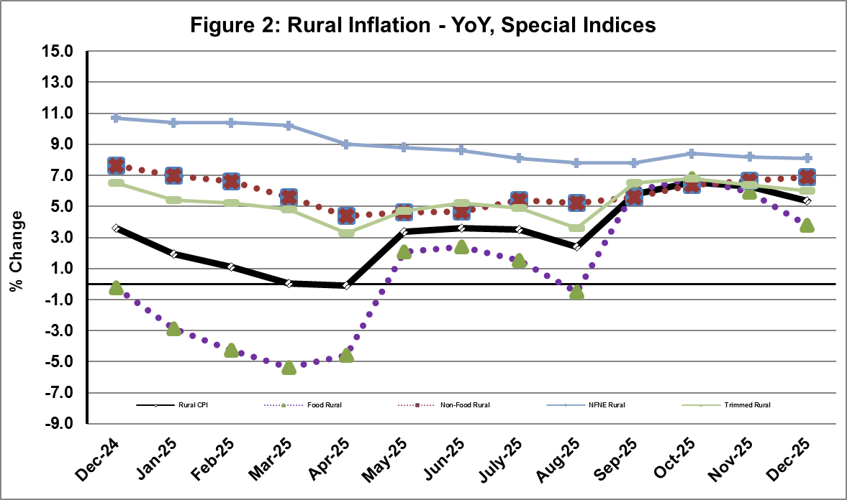
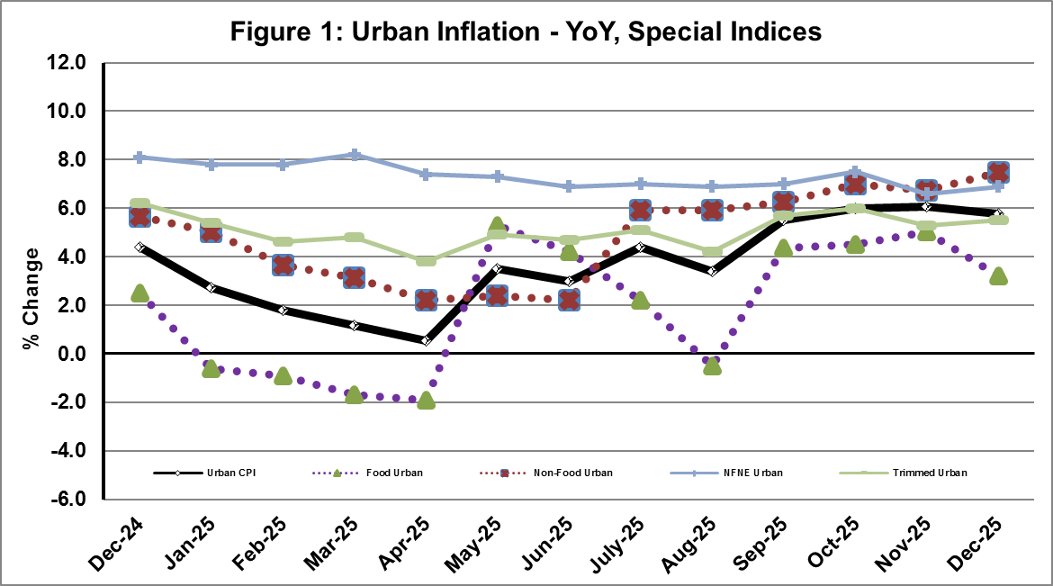
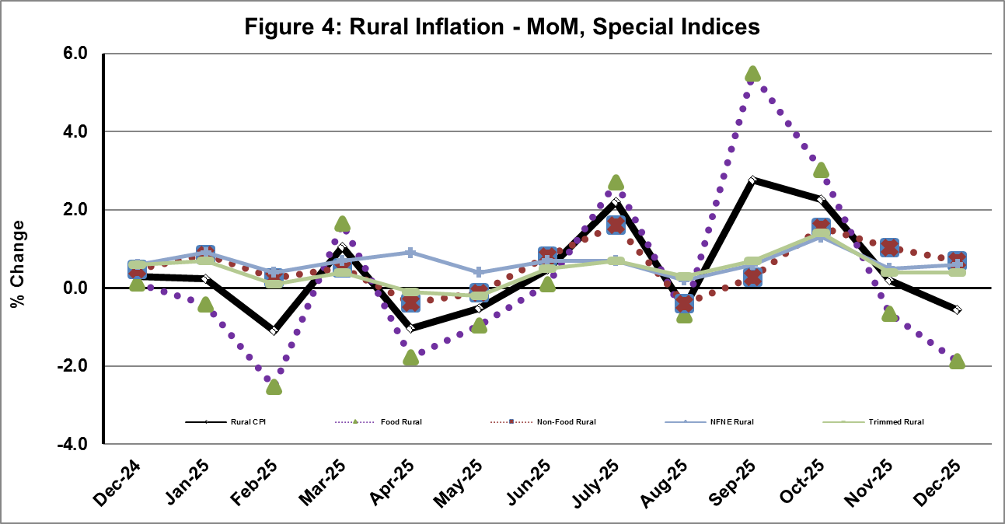
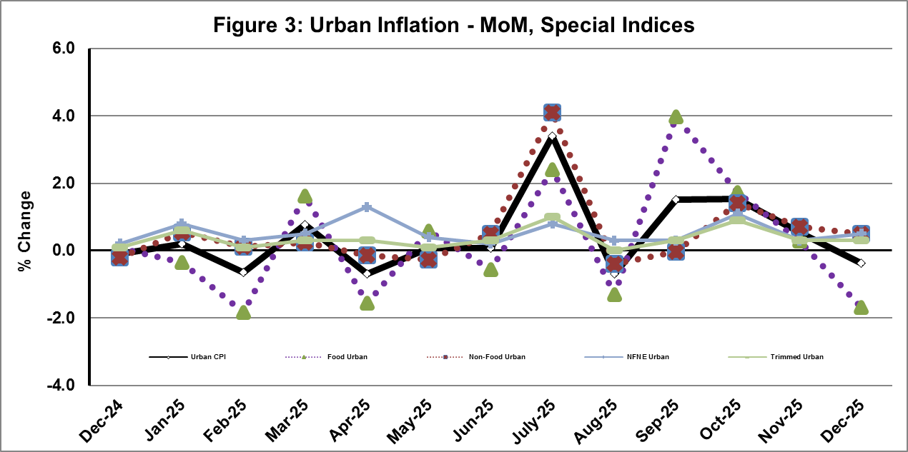

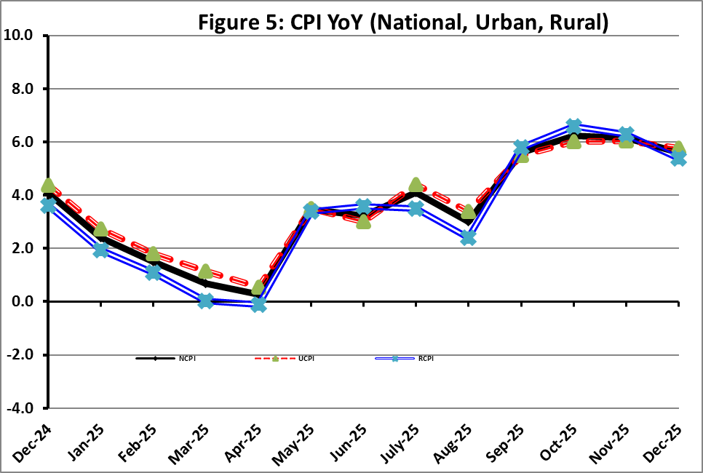

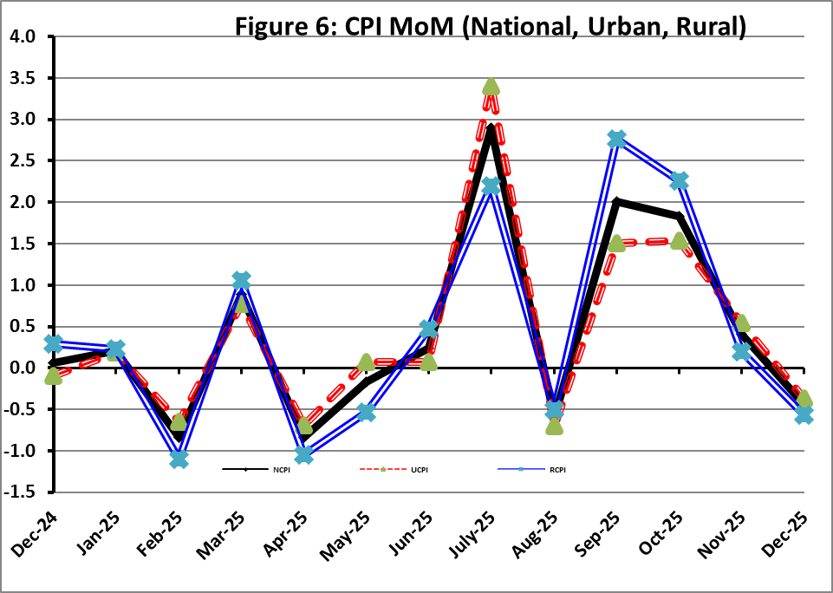
I. National Consumer Price Index (NCPI)

The National Consumer Price Index for December 2025 is decreased by 0.45% over November 2025 and increased by 5.61% over corresponding month of the last year i.e. December 2024.

Table 1: Consumer Price Index (National) by Group of Commodities and Services (Base 2015-16)
No | Group | Group  Weight  (%) | Indices |  |  | % Change  Dec 2025  Over |  | Impact  (In % points)  Dec 2025 Over
No | Group | Group  Weight  (%) | Dec 25 | Nov 25 | Dec 24 | Nov 25 | Dec 24 | Nov 25 | Dec 24
No | General | 100.00 | 280.53 | 281.78 | 265.63 | -0.45 | 5.61 | -0.45 | 5.61
1. | Food & Non-alcoholic Bev. | 34.58 | 291.47 | 297.90 | 282.32 | -2.16 | 3.24 | -0.79 | 1.19
 | Non-perishable Food Items | 29.60 | 299.93 | 298.67 | 279.03 | 0.42 | 7.49 | 0.13 | 2.33
 | Perishable Food Items | 4.99 | 241.30 | 293.35 | 301.87 | -17.74 | -20.07 | -0.92 | -1.14
2. | Alcoholic Bev. & Tobacco | 1.02 | 399.71 | 399.67 | 384.67 | 0.01 | 3.91 | 0.00 | 0.06
3. | Clothing & Footwear | 8.60 | 269.30 | 268.48 | 253.53 | 0.30 | 6.22 | 0.02 | 0.51
4. | Housing, Water, Electricity, Gas & Fuels | 23.63 | 254.79 | 253.10 | 238.43 | 0.67 | 6.86 | 0.14 | 1.46
5. | Furnishing & Household Equipment Maintenance | 4.10 | 283.08 | 282.83 | 273.77 | 0.09 | 3.40 | 0.00 | 0.14
6. | Health | 2.79 | 285.52 | 284.42 | 265.00 | 0.38 | 7.74 | 0.01 | 0.22
7. | Transport | 5.91 | 320.05 | 320.24 | 304.98 | -0.06 | 4.94 | 0.00 | 0.34
8. | Communication | 2.21 | 135.72 | 135.68 | 134.89 | 0.03 | 0.61 | 0.00 | 0.01
9. | Recreation & Culture | 1.59 | 264.88 | 264.55 | 276.71 | 0.13 | -4.28 | 0.00 | -0.07
10. | Education | 3.79 | 225.58 | 223.61 | 205.25 | 0.88 | 9.90 | 0.03 | 0.29
11. | Restaurants & Hotels | 6.92 | 296.37 | 294.70 | 280.75 | 0.57 | 5.57 | 0.04 | 0.41
12. | Miscellaneous | 4.87 | 360.59 | 354.92 | 302.35 | 1.60 | 19.26 | 0.10 | 1.07

II. Urban Consumer Price Index (UCPI)

The Urban Consumer Price Index for December 2025 is decreased by 0.36% over November 2025 and increased by 5.77% over corresponding month of the last year i.e. December 2024.

Table 2: Consumer Price Index (Urban) by Group of Commodities and Services (Base 2015-16)
No | Group | Group  Weight  (%) | Indices |  |  | % Change  Dec 2025  Over |  | Impact  (In % points)  Dec 2025 Over
No | Group | Group  Weight  (%) | Dec 25 | Nov 25 | Dec 24 | Nov 25 | Dec 24 | Nov 25 | Dec 24
 | General | 100.00 | 276.76 | 277.77 | 261.67 | -0.36 | 5.77 | -0.36 | 5.77
1. | Food & Non-alcoholic Bev. | 30.42 | 288.12 | 294.42 | 279.90 | -2.14 | 2.94 | -0.69 | 0.96
 | Non-perishable Food Items | 25.97 | 296.56 | 295.31 | 277.20 | 0.42 | 6.98 | 0.12 | 1.92
 | Perishable Food Items | 4.46 | 238.98 | 289.28 | 295.67 | -17.39 | -19.17 | -0.81 | -0.97
2. | Alcoholic Bev. & Tobacco | 0.85 | 423.08 | 422.93 | 405.62 | 0.04 | 4.30 | 0.00 | 0.06
3. | Clothing & Footwear | 8.01 | 259.13 | 258.42 | 245.42 | 0.27 | 5.59 | 0.02 | 0.42
4. | Housing, Water, Electricity, Gas & Fuels | 27.03 | 263.60 | 262.30 | 244.15 | 0.50 | 7.97 | 0.13 | 2.01
5. | Furnishing & Household Equip. & Maintenance | 4.09 | 272.53 | 272.54 | 263.20 | 0.00 | 3.54 | 0.00 | 0.15
6. | Health | 2.31 | 286.29 | 285.70 | 268.54 | 0.21 | 6.61 | 0.00 | 0.16
7. | Transport | 6.14 | 315.14 | 315.13 | 300.02 | 0.00 | 5.04 | 0.00 | 0.35
8. | Communication | 2.35 | 139.07 | 139.02 | 138.40 | 0.04 | 0.48 | 0.00 | 0.01
9. | Recreation & Culture | 1.73 | 249.17 | 248.81 | 260.51 | 0.14 | -4.35 | 0.00 | -0.08
10. | Education | 4.88 | 218.20 | 216.38 | 199.96 | 0.84 | 9.12 | 0.03 | 0.34
11. | Restaurants & Hotels | 7.41 | 290.95 | 288.70 | 277.24 | 0.78 | 4.95 | 0.06 | 0.39
12. | Miscellaneous | 4.77 | 347.83 | 343.10 | 292.40 | 1.38 | 18.96 | 0.08 | 1.01
Main contributors to month-on-month and year-on-year percentage changes are given below and detail is given in Annexure-A.
MONTH-ON-MONTH Top few commodities which varied from previous month i.e. November, 2025 are given below:
FOOD
Increased: Fresh Fruits (6.78%), Wheat (3.48%), Dry Fruits (3.29%), Eggs (3.27%), Cooking Oil (2.84%), Milk Powder (2.03%), Wheat Flour (2.01%), Vegetable Ghee (1.92%), Fish (1.89%), Wheat Products (1.53%), Beans (0.63%) and Condiments & Spices (0.57%).
Decreased: Tomatoes (45.20%), Onions (32.99%), Fresh Vegetables (21.30%), Potatoes (17.88%), Sugar (6.96%), Gram Whole (3.07%), Gur (2.93%), Chicken (2.79%), Besan (2.65%), Pulse Gram (2.40%), Pulse Mash (1.17%), Mustard Oil (0.81%), Pulse Masoor (0.74%), Rice (0.21%) and Pulse Moong (0.12%).

NON-FOOD:
Increased: Liquified Hydrocarbons (16.37%), Personal Effects (3.77%), Solid Fuel (2.76%), Woolen Readymade Garments (2.44%), Marriage Hall Charges (1.96%), Mechanical Services (1.92%), Household Servant (0.97%), Transport Services (0.96%), Education (0.84%) and Electricity Charges (0.53%).
Decreased: Motor fuel (0.66%) and Washing soap/detergents/match box (0.54%).

YEAR-ON-YEAR: Top few commodities, which varied from corresponding month of previous year i.e. December 2024, are given below:
FOOD
Increased: Sugar (26.69%), Wheat (25.27%), Butter (24.12%), Fresh Fruits (19.62%), Wheat Flour (17.76%), Condiments and Spices (12.52%), Gur (12.36%), Chicken (12.05%) and Meat (9.96%).
Decreased: Tomatoes (52.56%), Potatoes (42.79%), Onions (28.85%), Pulse Gram (26.41%), Besan (26.03%), Fresh Vegetables (20.11%), Gram Whole (19.51%), Tea (17.75%), Pulse Mash (15.19%), Beans (8.67%), Pulse Masoor (5.11%), Mustard Oil (2.44%) and Pulse Moong (1.65%).

NON-FOOD:
Increased: Gas Charges (22.91%), Newspapers (11.93%), Postal Services (10.48%), Medical Tests (10.45%) and Education (9.12%).
Decreased: Text Books (10.61%) and Electricity Charges (3.42%).
III. Rural Consumer Price Index (RCPI)

The Rural Consumer Price Index for December 2025 is decreased by 0.57% over November 2025 and increased by 5.38% over corresponding month of the last year i.e December 2024.

Table 3: Consumer Price Index (Rural) by Group of Commodities and Services (Base 2015-16)
No | Group | Group  Weight  (%) | Indices |  |  | % Change  Dec 2025  Over |  | Impact  (In % points)  Dec 2025 Over
No | Group | Group  Weight  (%) | Dec 25 | Nov 25 | Dec 24 | Nov 25 | Dec 24 | Nov 25 | Dec 24
 | General | 100.00 | 286.21 | 287.84 | 271.60 | -0.57 | 5.38 | -0.57 | 5.38
1. | Food & Non-alcoholic Bev. | 40.87 | 295.24 | 301.81 | 285.04 | -2.18 | 3.58 | -0.93 | 1.54
 | Non-perishable Food Items | 35.08 | 303.69 | 302.43 | 281.07 | 0.42 | 8.05 | 0.15 | 2.92
 | Perishable Food Items | 5.79 | 243.99 | 298.07 | 309.07 | -18.14 | -21.06 | -1.09 | -1.39
2. | Alcoholic Bev. & Tobacco | 1.28 | 376.15 | 376.21 | 363.54 | -0.02 | 3.47 | 0.00 | 0.06
3. | Clothing & Footwear | 9.48 | 282.26 | 281.31 | 263.86 | 0.34 | 6.97 | 0.03 | 0.64
4. | Housing, Water, Electricity, Gas & Fuels | 18.49 | 235.35 | 232.79 | 225.79 | 1.10 | 4.23 | 0.16 | 0.65
5. | Furnishing & Household Equip. & Maintenance | 4.10 | 298.95 | 298.32 | 289.68 | 0.21 | 3.20 | 0.01 | 0.14
6. | Health | 3.51 | 284.75 | 283.16 | 261.49 | 0.56 | 8.90 | 0.02 | 0.30
7. | Transport | 5.56 | 328.23 | 328.76 | 313.24 | -0.16 | 4.79 | -0.01 | 0.31
8. | Communication | 1.99 | 129.75 | 129.74 | 128.64 | 0.01 | 0.86 | 0.00 | 0.01
9. | Recreation & Culture | 1.38 | 294.68 | 294.40 | 307.45 | 0.10 | -4.15 | 0.00 | -0.06
10. | Education | 2.13 | 251.05 | 248.58 | 223.51 | 0.99 | 12.32 | 0.02 | 0.22
11. | Restaurants & Hotels | 6.19 | 306.16 | 305.53 | 287.08 | 0.21 | 6.65 | 0.01 | 0.43
12. | Miscellaneous | 5.02 | 378.90 | 371.89 | 316.64 | 1.88 | 19.66 | 0.12 | 1.15
Main contributors to Month-on-Month and Year-on-Year percentage changes are given below and detail is given in Annexure-B.
MONTH-ON-MONTH Top few commodities which varied from previous month i.e. November, 2025 are given below:

FOOD
Increased: Fresh Fruits (5.12%), Wheat (4.94%), Fish (2.71%), Eggs (2.36%), Wheat Flour (1.81%), Vegetable Ghee (1.19%), Sweetmeat (1.07%), Milk Powder (0.94%), Beans & Milk Fresh (0.83%) each and Wheat Products (0.69%).
Decreased: Tomatoes (33.50%), Onions (32.62%), Fresh Vegetables (19.65%), Potatoes (19.03%), Sugar (7.06%), Chicken (4.12%), Pulse Gram (3.09%), Condiments and Spices (2.60%), Besan (2.44%), Gram Whole (2.27%), Gur (1.86%), Pulse Masoor (1.28%), Pulse Mash (0.85%) and Rice (0.65%).

Non-Food

Increased: Liquified Hydrocarbons (8.14%), Woolen Readymade Garments (1.83%), Doctor Clinic Fee (1.63%), Construction Input Items (1.30%), Cleaning & Laundering (1.28%) and Solid Fuel (1.27%).

Decreased: Motor Fuels (0.71%).

Year-On-Year: Top few commodities which varied from corresponding month of previous year i.e. December, 2024 are given below:
Food
Increased: Sugar (29.28%), Wheat (28.67%), Wheat Flour (24.82%), Fresh Fruits (23.12%), Meat (11.21%), Gur (9.5%), Chicken (9.01%) and Milk Powder (8.76%).
Decreased: Tomatoes (42.32%), Potatoes (42.07%), Pulse Gram (28.46%), Onions (26.56%), Besan (22.35%), Fresh Vegetables (21.50%), Tea (18.80%), Pulse Mash (17.96%), Gram Whole (16.01%), Pulse Masoor (4.31%) and Condiments & Spices (2.32%).

Non-Food
Increased: Education (12.32%), Medical Tests (12.23%), Readymade Garments (11.61%), Woolen Readymade Garments (10.62%), Personal Grooming Services (10.17%), Tailoring (7.99%) and Solid Fuel (7.97%).
Decreased: Text Books (15.30%) and Electricity Charges (3.42%).

IV. Sensitive Price Indicator (SPI)

Quintile-wise percentage changes YoY and MoM are given below in Table 4. The series from
December 2024 to December 2025 is also graphed below in Figure 7.

Table 4: Sensitive Price Indicator (Base 2015-16)
Quintiles | Indices |  |  | % Change Dec 2025  Over
Quintiles | Dec 25 | Nov 25 | Dec 24 | Nov 25 | Dec 24
1 | 326.75 | 329.36 | 318.64 | -0.79 | 2.55
2 | 326.72 | 326.68 | 315.25 | 0.01 | 3.64
3 | 348.56 | 349.36 | 335.92 | -0.23 | 3.76
4 | 335.47 | 336.38 | 323.61 | -0.27 | 3.66
5 | 334.40 | 333.52 | 323.79 | 0.26 | 3.28
Combined | 335.96 | 335.39 | 324.16 | 0.17 | 3.64

Table 4.1: Weekly Percentage Change of SPI During December 2025
Quintiles | % Change over Previous week
Quintiles | 04-12-2025 | 11-12-2025 | 18-12-2025 | 24-12-2025
Quintile 1 | -0.96 | -0.26 | 0.07 | -0.33
Combined | -0.64 | -0.03 | 0.24 | -0.09

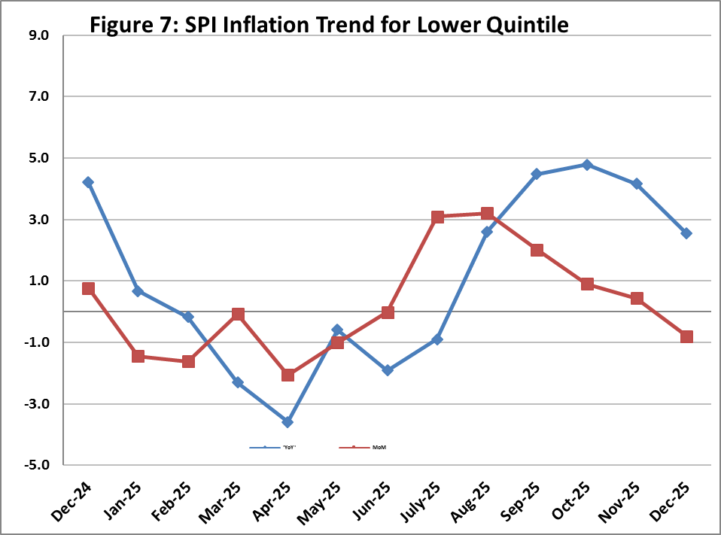

V. Wholesale Price Index
The Wholesale Price Index for December 2025 decreased by 0.86% over November 2025 and increased by 0.57% over the corresponding month of the last year i.e. December, 2024. YoY and MoM movements from December, 2024 to December, 2025 are also graphed below in Figure 8.

Table 5: Wholesale Price Index by Group of Commodities (Base 2015-16)
No | Group | Group  Weight  (%) | Indices |  |  | % Change  Dec 2025  Over |  | Impact  (In % points)  Dec 2025 Over
No | Group | Group  Weight  (%) | Dec 25 | Nov 25 | Dec 24 | Nov 25 | Dec 24 | Nov 25 | Dec 24
 | General | 100.00 | 313.72 | 316.44 | 311.95 | -0.86 | 0.57 | -0.86 | 0.57
1 | Agriculture Forestry & Fishery | 25.77 | 276.45 | 279.58 | 281.12 | -1.12 | -1.66 | -0.26 | -0.39
2 | Ores/Minerals, Elec., Gas & Water | 12.01 | 362.58 | 360.88 | 361.62 | 0.47 | 0.27 | 0.06 | 0.04
3 | Food, Beverages, Tobacco, Textiles & Leather Products | 31.11 | 293.01 | 293.48 | 276.70 | -0.16 | 5.89 | -0.05 | 1.63
 | i. Food Products, Beverages & Tobacco | 20.07 | 314.04 | 314.77 | 292.37 | -0.23 | 7.41 | -0.05 | 1.39
 | ii. Textiles & Apparels | 10.33 | 259.99 | 259.98 | 253.21 | 0.00 | 2.68 | 0.00 | 0.22
 | iii. Leather Products | 0.71 | 179.03 | 179.03 | 175.78 | 0.00 | 1.85 | 0.00 | 0.01
4 | Other Transportable Goods | 22.40 | 327.85 | 336.36 | 340.06 | -2.53 | -3.59 | -0.60 | -0.88
5 | Metal Product, Machinery & Equipment | 8.72 | 394.25 | 394.99 | 388.24 | -0.19 | 1.55 | -0.02 | 0.17

Main contributors to month-on-month and year-on-year percentage changes are given below and detail is given in Annexure-C.

MONTH-ON-MONTH: Top few commodities which varied from previous month are given below:
Increased: Dried Fruits & Nuts (8.47%), Spices (5.12%), Fuel Wood in Logs (4.67%), Wheat Flour (3.87%), Wheat (3.83%), Eggs (3.20%), Cement (2.82%), Fibre Crops (2.32%), Oil Cakes (2.19%), Motor Vehicles (1.83%), Maize (1.79%) and Bricks, Blocks & Tiles (1.63%).
Decreased: Edible Roots / Potatoes (25.72%), Vegetables (17.37%), Stimulant & Spice Crops (13.25%), Sugar Refined (11.54%), Furnace Oil (7.62%), Diesel Oil (4.31%), Cotton Seeds (3.06%), Other Glass Articles (2.8%), Other Cereal Flour (2.49%), Pulses (2.26%), Auto Tyres (2.22%) and Sugar Crops (2.09%).

YEAR-ON-YEAR: Top few commodities which varied from previous year are given below:
Increased: Other Food Products (52.77%), Engines & Motors (29.63%), Wheat (25.94%), Dyeing Material (22.99%), Sugar Crops (21.68%), Sugar Refined (21.64%), Sorghum / Jowar (21.62%), Wheat Flour (21.60%), Woven Fabrics (20.13%), Dried Fruits & Nuts (18.28%) and Maize (16.97%).
Decreased: Edible Roots / Potatoes (53.8%), Furnace Oil (28.94%), Other Cereal Flour (26.20%), Pulses (17.1%), Vegetables (13.23%), Cotton Seeds (10.29%), Fibre Crops (10.21%), Electrical Energy (8.06%), Stimulant & Spice Crops (6.47%) and Steel Bar & Sheets (5.82%).
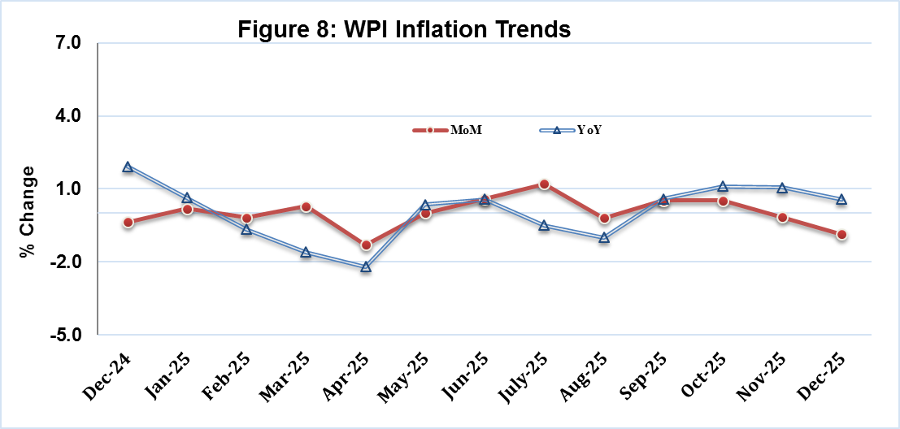

Annexure A:CPI (Urban) Index Numbers by Commodity Groups & Commodities (2015-16=100)
Item and Specification |  | Weight | Index Numbers  Dec 25 Nov 25 Dec 24 |  |  | % Change in Dec 2025 over  Nov 2025 Dec 2024
 | General | 100.0000 | 276.76 | 277.77 | 261.67 |  | - | 0.36 |  | + | 5.77
 | Food and non-alcoholic Beverages | 30.4215 | 288.12 | 294.42 | 279.90 |  | - | 2.14 |  | + | 2.94
01 | Wheat | 0.6120 | 301.23 | 291.10 | 240.47 |  | + | 3.48 |  | + | 25.27
02 | Wheat flour | 3.0075 | 279.63 | 274.13 | 237.45 |  | + | 2.01 |  | + | 17.76
03 | Wheat products | 0.0936 | 296.80 | 292.34 | 291.44 |  | + | 1.53 |  | + | 1.84
04 | Besan | 0.0830 | 231.51 | 237.80 | 312.98 |  | - | 2.65 |  | - | 26.03
05 | Rice | 1.1804 | 327.41 | 328.09 | 309.73 |  | - | 0.21 |  | + | 5.71
06 | Bakery and confectionary | 0.4770 | 273.15 | 272.88 | 264.44 |  | + | 0.10 |  | + | 3.29
07 | Nimco | 0.1224 | 302.13 | 302.13 | 295.40 |  | + | 0.00 |  | + | 2.28
08 | Meat | 2.0411 | 358.68 | 356.95 | 326.19 |  | + | 0.48 |  | + | 9.96
09 | Chicken | 1.3631 | 262.31 | 269.83 | 234.10 |  | - | 2.79 |  | + | 12.05
10 | Fish | 0.3855 | 230.17 | 225.91 | 217.77 |  | + | 1.89 |  | + | 5.69
11 | Milk fresh | 7.1070 | 268.65 | 268.47 | 259.98 |  | + | 0.07 |  | + | 3.33
12 | Milk products | 0.6407 | 272.44 | 271.89 | 265.64 |  | + | 0.20 |  | + | 2.56
13 | Milk powder | 0.3106 | 329.53 | 322.98 | 303.02 |  | + | 2.03 |  | + | 8.75
14 | Eggs | 0.5083 | 419.89 | 406.59 | 394.02 |  | + | 3.27 |  | + | 6.57
15 | Butter | 0.0932 | 492.40 | 492.40 | 396.71 |  | + | 0.00 |  | + | 24.12
16 | Mustard oil | 0.0120 | 311.83 | 314.38 | 319.64 |  | - | 0.81 |  | - | 2.44
17 | Cooking oil | 1.1016 | 342.56 | 333.09 | 319.87 |  | + | 2.84 |  | + | 7.09
18 | Vegetable ghee | 1.0324 | 359.59 | 352.81 | 343.79 |  | + | 1.92 |  | + | 4.60
19 | Dry fruits | 0.3299 | 315.53 | 305.47 | 297.52 |  | + | 3.29 |  | + | 6.05
20 | Fresh fruits | 1.4363 | 246.67 | 231.01 | 206.21 |  | + | 6.78 |  | + | 19.62
21 | Pulse masoor | 0.1624 | 196.36 | 197.83 | 206.94 |  | - | 0.74 |  | - | 5.11
22 | Pulse moong | 0.1697 | 232.42 | 232.69 | 236.31 |  | - | 0.12 |  | - | 1.65
23 | Pulse mash | 0.1152 | 181.89 | 184.05 | 214.47 |  | - | 1.17 |  | - | 15.19
24 | Pulse gram | 0.1660 | 222.79 | 228.28 | 302.73 |  | - | 2.40 |  | - | 26.41
25 | Gram whole | 0.0912 | 253.23 | 261.26 | 314.63 |  | - | 3.07 |  | - | 19.51
26 | Beans | 0.0408 | 352.87 | 350.67 | 386.38 |  | + | 0.63 |  | - | 8.67
27 | Potatoes | 0.4496 | 282.07 | 343.49 | 493.04 |  | - | 17.88 |  | - | 42.79
28 | Onions | 0.5928 | 243.04 | 362.71 | 341.58 |  | - | 32.99 |  | - | 28.85
29 | Tomatoes | 0.3459 | 164.69 | 300.55 | 347.16 |  | - | 45.20 |  | - | 52.56
30 | Fresh vegetables | 1.5306 | 230.34 | 292.67 | 288.32 |  | - | 21.30 |  | - | 20.11
31 | Sugar | 1.1130 | 275.32 | 295.93 | 217.31 |  | - | 6.96 |  | + | 26.69
32 | Gur | 0.0379 | 271.14 | 279.31 | 241.32 |  | - | 2.93 |  | + | 12.36
33 | Honey | 0.1017 | 222.62 | 222.62 | 214.16 |  | + | 0.00 |  | + | 3.95
34 | Sweetmeat | 0.3535 | 335.51 | 335.16 | 317.01 |  | + | 0.10 |  | + | 5.84
35 | Ice cream | 0.1044 | 199.68 | 199.68 | 199.45 |  | + | 0.00 |  | + | 0.12
36 | Condiments and Spices | 1.3340 | 376.23 | 374.08 | 334.36 |  | + | 0.57 |  | + | 12.52
37 | Dessert preparation | 0.0419 | 300.63 | 300.63 | 270.14 |  | + | 0.00 |  | + | 11.29
38 | Tea | 0.8427 | 273.67 | 273.67 | 332.73 |  | + | 0.00 |  | - | 17.75
39 | Beverages | 0.8906 | 262.00 | 260.74 | 254.77 |  | + | 0.48 |  | + | 2.84
 | Alcoholic Beverages, Tobacco | 0.8540 | 423.08 | 422.93 | 405.62 |  | + | 0.04 |  | + | 4.30
40 | Cigarettes | 0.7167 | 411.88 | 411.75 | 401.03 |  | + | 0.03 |  | + | 2.71
41 | Pan prepared | 0.1373 | 481.53 | 481.31 | 429.58 |  | + | 0.05 |  | + | 12.09
 | Clothing and footwear | 8.0096 | 259.13 | 258.42 | 245.42 |  | + | 0.27 |  | + | 5.59
42 | Cotton cloth | 2.2227 | 300.07 | 300.07 | 280.39 |  | + | 0.00 |  | + | 7.02
43 | Woollen cloth | 0.8361 | 254.35 | 253.81 | 235.97 |  | + | 0.21 |  | + | 7.79
44 | Readymade garments | 1.3196 | 224.78 | 224.08 | 209.07 |  | + | 0.31 |  | + | 7.51
45 | Woollen readymade garments | 0.4307 | 273.66 | 267.14 | 256.69 |  | + | 2.44 |  | + | 6.61
46 | Tailoring | 1.0741 | 243.85 | 242.64 | 229.09 |  | + | 0.50 |  | + | 6.44
47 | Hosiery | 0.4070 | 241.60 | 241.46 | 233.67 |  | + | 0.06 |  | + | 3.39
48 | Dupatta | 0.1713 | 206.53 | 206.28 | 199.76 |  | + | 0.12 |  | + | 3.39
49 | Cleaning and laundering | 0.0665 | 282.02 | 280.82 | 263.39 |  | + | 0.43 |  | + | 7.07
50 | Footwear | 1.4816 | 247.72 | 247.72 | 246.93 |  | + | 0.00 |  | + | 0.32
 | Housing, water, Elec., Gas and other Fuels | 27.0332 | 263.60 | 262.30 | 244.15 |  | + | 0.50 |  | + | 7.97
51 | House rent | 19.2558 | 175.49 | 175.49 | 165.69 |  | + | 0.00 |  | + | 5.91
52 | Construction input items | 0.3765 | 270.45 | 269.51 | 265.94 |  | + | 0.35 |  | + | 1.70
53 | Construction wage rates | 0.2025 | 231.89 | 231.80 | 221.36 |  | + | 0.04 |  | + | 4.76
54 | Water supply | 0.5269 | 231.40 | 231.40 | 228.99 |  | + | 0.00 |  | + | 1.05
55 | Garbage collection | 0.1064 | 266.16 | 266.16 | 261.28 |  | + | 0.00 |  | + | 1.87
56 | Electricity charges | 4.5562 | 263.13 | 261.74 | 272.45 |  | + | 0.53 |  | - | 3.42
57 | Gas charges | 1.0807 | 1817.96 | 1817.96 | 1479.08 |  | + | 0.00 |  | + | 22.91
58 | Liquefied Hydrocarbons | 0.5064 | 361.24 | 310.43 | 357.75 |  | + | 16.37 |  | + | 0.98
59 | Solid Fuel | 0.4218 | 240.06 | 233.62 | 225.71 |  | + | 2.76 |  | + | 6.36
 | Furnishing and household equipments | 4.0937 | 272.53 | 272.54 | 263.20 |  | + | 0.00 |  | + | 3.54
60 | Furniture and furnishing | 0.4750 | 264.74 | 264.29 | 254.91 |  | + | 0.17 |  | + | 3.86
61 | Carpets | 0.0308 | 157.04 | 157.00 | 150.75 |  | + | 0.03 |  | + | 4.17
62 | Household textiles | 0.3420 | 214.73 | 214.05 | 207.66 |  | + | 0.32 |  | + | 3.40
63 | Household equipments | 1.0032 | 277.49 | 277.04 | 263.75 |  | + | 0.16 |  | + | 5.21
64 | Plastic products | 0.0536 | 233.93 | 233.93 | 217.79 |  | + | 0.00 |  | + | 7.41
65 | Major tools & equipments | 0.0084 | 253.31 | 252.56 | 237.52 |  | + | 0.30 |  | + | 6.65
66 | Washing soap/detergents/match | 1.4112 | 323.36 | 325.12 | 318.22 |  | - | 0.54 |  | + | 1.62
67 | Household servant | 0.7695 | 210.89 | 208.87 | 199.33 |  | + | 0.97 |  | + | 5.80
 | Health | 2.3098 | 286.29 | 285.70 | 268.54 |  | + | 0.21 |  | + | 6.61
68 | Drugs and medicines | 1.0735 | 309.08 | 308.39 | 291.11 |  | + | 0.22 |  | + | 6.17
69 | Therapeutic Appliances and Equipments | 0.0054 | 156.75 | 156.75 | 154.64 |  | + | 0.00 |  | + | 1.36
70 | Doctor (MBBS) clinic fee | 0.4044 | 357.82 | 357.17 | 332.67 |  | + | 0.18 |  | + | 7.56
71 | Dental services | 0.0156 | 236.28 | 234.70 | 217.31 |  | + | 0.67 |  | + | 8.73
72 | Medical tests | 0.2367 | 222.55 | 222.04 | 201.50 |  | + | 0.23 |  | + | 10.45
73 | Hospitals services | 0.5742 | 222.17 | 221.79 | 211.27 |  | + | 0.17 |  | + | 5.16
 | Transport | 6.1368 | 315.14 | 315.13 | 300.02 |  | + | 0.00 |  | + | 5.04
74 | Motor vehicles | 0.8097 | 267.55 | 267.45 | 259.37 |  | + | 0.04 |  | + | 3.15
75 | Motor vehicle accessories | 0.1941 | 269.38 | 268.35 | 263.75 |  | + | 0.38 |  | + | 2.13
76 | Motor fuel | 2.9088 | 359.14 | 361.54 | 345.61 |  | - | 0.66 |  | + | 3.91
77 | Mechanical services | 0.4290 | 246.76 | 242.10 | 230.93 |  | + | 1.92 |  | + | 6.85
78 | Motor vehicle tax | 0.0482 | 399.23 | 399.23 | 399.23 |  | + | 0.00 |  | + | 0.00
79 | Transport services | 1.7470 | 283.48 | 280.78 | 261.21 |  | + | 0.96 |  | + | 8.53
 | Communication | 2.3536 | 139.07 | 139.02 | 138.40 |  | + | 0.04 |  | + | 0.48
80 | Postal services | 0.0190 | 243.55 | 243.55 | 220.45 |  | + | 0.00 |  | + | 10.48
81 | Communication apparatus | 0.4524 | 190.93 | 190.66 | 188.41 |  | + | 0.14 |  | + | 1.34
82 | Communication Services | 1.8822 | 125.55 | 125.55 | 125.55 |  | + | 0.00 |  | + | 0.00
 | Recreation and culture | 1.7301 | 249.17 | 248.81 | 260.51 |  | + | 0.14 |  | - | 4.35
83 | Recreation and culture | 0.6478 | 156.34 | 155.56 | 154.56 |  | + | 0.50 |  | + | 1.15
84 | Text books | 0.6655 | 297.49 | 297.49 | 332.81 |  | + | 0.00 |  | - | 10.61
85 | Newspapers | 0.0716 | 242.82 | 242.82 | 216.94 |  | + | 0.00 |  | + | 11.93
86 | stationery | 0.3452 | 331.52 | 331.18 | 329.01 |  | + | 0.10 |  | + | 0.76
 | Education | 4.8807 | 218.20 | 216.38 | 199.96 |  | + | 0.84 |  | + | 9.12
87 | Education | 4.8807 | 218.20 | 216.38 | 199.96 |  | + | 0.84 |  | + | 9.12
 | Restaurants and hotels | 7.4050 | 290.95 | 288.70 | 277.24 |  | + | 0.78 |  | + | 4.95
88 | Readymade food | 5.5235 | 297.44 | 296.13 | 285.08 |  | + | 0.44 |  | + | 4.34
89 | Marriage Hall Charges | 1.7514 | 278.57 | 273.21 | 260.50 |  | + | 1.96 |  | + | 6.94
90 | Accommodation Services | 0.1301 | 182.00 | 182.00 | 169.66 |  | + | 0.00 |  | + | 7.27
 | Misc. goods and services | 4.7720 | 347.83 | 343.10 | 292.40 |  | + | 1.38 |  | + | 18.96
91 | Personal Grooming Services | 0.8001 | 273.60 | 273.44 | 253.70 |  | + | 0.06 |  | + | 7.84
92 | Electrical Appliances for Per | 0.0465 | 191.75 | 191.56 | 177.15 |  | + | 0.10 |  | + | 8.24
93 | Appliances/Articles/Products | 2.9807 | 293.10 | 292.40 | 266.74 |  | + | 0.24 |  | + | 9.88
94 | Personal Effects n.e.c. | 0.9447 | 591.05 | 569.56 | 411.80 |  | + | 3.77 |  | + | 43.53

Annexure B:CPI (Rural) Index Numbers by Commodity Groups & Commodities (2015-16=100)
Item and Specification |  | Weight | Index Numbers  Dec 25 Nov 25 Dec 24 |  |  | % Change in Dec 2025 over  Nov 2025 Dec 2024
 | General | 100.0000 | 286.21 | 287.84 | 271.60 |  | - | 0.57 |  | + | 5.38
 | Food and non-alcoholic Beverages | 40.8668 | 295.24 | 301.81 | 285.04 |  | - | 2.18 |  | + | 3.58
01 | Wheat | 3.4736 | 311.84 | 297.16 | 242.36 |  | + | 4.94 |  | + | 28.67
02 | Wheat Flour | 3.4297 | 295.34 | 290.09 | 236.62 |  | + | 1.81 |  | + | 24.82
03 | Wheat Products | 0.1068 | 300.53 | 298.48 | 288.63 |  | + | 0.69 |  | + | 4.12
04 | Besan | 0.0728 | 255.38 | 261.76 | 328.88 |  | - | 2.44 |  | - | 22.35
05 | Rice | 1.5501 | 429.56 | 432.36 | 410.83 |  | - | 0.65 |  | + | 4.56
06 | Bakery and Confectionary | 0.3702 | 319.83 | 319.38 | 305.11 |  | + | 0.14 |  | + | 4.82
07 | Nimco | 0.0774 | 312.22 | 312.04 | 303.64 |  | + | 0.06 |  | + | 2.83
08 | Meat | 1.7146 | 376.96 | 376.96 | 338.96 |  | + | 0.00 |  | + | 11.21
09 | Chicken | 1.4641 | 268.00 | 279.52 | 245.85 |  | - | 4.12 |  | + | 9.01
10 | Fish | 0.2640 | 239.08 | 232.77 | 235.83 |  | + | 2.71 |  | + | 1.38
11 | Milk fresh | 10.3803 | 271.51 | 269.27 | 257.85 |  | + | 0.83 |  | + | 5.30
12 | Milk products | 0.9624 | 268.49 | 266.96 | 256.93 |  | + | 0.57 |  | + | 4.50
13 | Milk powder | 0.1062 | 300.08 | 297.29 | 275.91 |  | + | 0.94 |  | + | 8.76
14 | Eggs | 0.5665 | 402.66 | 393.36 | 388.48 |  | + | 2.36 |  | + | 3.65
15 | Butter | 0.3333 | 326.47 | 324.30 | 306.16 |  | + | 0.67 |  | + | 6.63
16 | Mustard oil | 0.0136 | 337.61 | 337.58 | 338.70 |  | + | 0.01 |  | - | 0.32
17 | Cooking oil | 0.6011 | 369.77 | 368.62 | 371.36 |  | + | 0.31 |  | - | 0.43
18 | Vegetable ghee | 2.3764 | 388.46 | 383.89 | 379.32 |  | + | 1.19 |  | + | 2.41
19 | Dry fruits | 0.2496 | 381.83 | 379.41 | 360.48 |  | + | 0.64 |  | + | 5.92
20 | Fresh fruits | 1.4505 | 254.85 | 242.44 | 207.00 |  | + | 5.12 |  | + | 23.12
21 | Pulse Masoor | 0.2076 | 220.48 | 223.35 | 230.41 |  | - | 1.28 |  | - | 4.31
22 | Pulse Moong | 0.2510 | 255.09 | 255.82 | 255.39 |  | - | 0.29 |  | - | 0.12
23 | Pulse Mash | 0.1465 | 191.30 | 192.94 | 233.18 |  | - | 0.85 |  | - | 17.96
24 | Pulse Gram | 0.2751 | 232.64 | 240.05 | 325.17 |  | - | 3.09 |  | - | 28.46
25 | Gram Whole | 0.1116 | 273.41 | 279.75 | 325.53 |  | - | 2.27 |  | - | 16.01
26 | Beans | 0.0896 | 399.17 | 395.89 | 408.24 |  | + | 0.83 |  | - | 2.22
27 | Potatoes | 0.7437 | 294.43 | 363.61 | 508.25 |  | - | 19.03 |  | - | 42.07
28 | Onions | 0.8965 | 245.80 | 364.82 | 334.68 |  | - | 32.62 |  | - | 26.56
29 | Tomatoes | 0.5069 | 171.34 | 257.66 | 297.04 |  | - | 33.50 |  | - | 42.32
30 | Fresh Vegetables | 2.0947 | 233.12 | 290.14 | 296.97 |  | - | 19.65 |  | - | 21.50
31 | Sugar | 2.0296 | 278.94 | 300.13 | 215.76 |  | - | 7.06 |  | + | 29.28
32 | Gur | 0.1522 | 261.92 | 266.88 | 239.19 |  | - | 1.86 |  | + | 9.50
33 | Honey | 0.0296 | 225.70 | 227.15 | 218.40 |  | - | 0.64 |  | + | 3.34
34 | Sweetmeat | 0.3967 | 301.89 | 298.70 | 285.20 |  | + | 1.07 |  | + | 5.85
35 | Ice Cream | 0.0568 | 198.80 | 198.80 | 199.34 |  | + | 0.00 |  | - | 0.27
36 | Condiments and Spices | 1.4919 | 292.16 | 299.96 | 299.10 |  | - | 2.60 |  | - | 2.32
37 | Dessert Preparation | 0.0133 | 296.76 | 295.83 | 268.52 |  | + | 0.31 |  | + | 10.52
38 | Tea | 1.2566 | 271.09 | 271.09 | 333.85 |  | + | 0.00 |  | - | 18.80
39 | Beverages | 0.5537 | 254.91 | 254.91 | 244.48 |  | + | 0.00 |  | + | 4.27
 | Alcoholic Beverages, Tobacco | 1.2786 | 376.15 | 376.21 | 363.54 |  | - | 0.02 |  | + | 3.47
40 | Cigarettes | 1.2364 | 376.05 | 376.11 | 364.02 |  | - | 0.02 |  | + | 3.30
41 | Pan Prepared | 0.0422 | 379.08 | 379.08 | 349.58 |  | + | 0.00 |  | + | 8.44
 | Clothing and footwear | 9.4826 | 282.26 | 281.31 | 263.86 |  | + | 0.34 |  | + | 6.97
42 | Cotton Cloth | 2.8381 | 306.42 | 306.41 | 291.70 |  | + | 0.00 |  | + | 5.05
43 | Woollen Cloth | 1.0959 | 274.38 | 273.35 | 256.06 |  | + | 0.38 |  | + | 7.15
44 | Readymade Garments | 1.1345 | 263.76 | 262.63 | 236.32 |  | + | 0.43 |  | + | 11.61
45 | Woollen Readymade Garments | 0.5401 | 330.52 | 324.59 | 298.80 |  | + | 1.83 |  | + | 10.62
46 | Tailoring | 1.2999 | 264.86 | 263.13 | 245.26 |  | + | 0.66 |  | + | 7.99
47 | Hosiery | 0.4322 | 357.07 | 356.33 | 340.20 |  | + | 0.21 |  | + | 4.96
48 | Dupatta | 0.2078 | 258.81 | 258.61 | 242.71 |  | + | 0.08 |  | + | 6.63
49 | Cleaning and Laundering | 0.0176 | 267.84 | 264.46 | 251.35 |  | + | 1.28 |  | + | 6.56
50 | Footwear | 1.9165 | 245.93 | 245.58 | 231.35 |  | + | 0.14 |  | + | 6.30
 | Housing, water, Elec., Gas and other Fuels | 18.4853 | 235.35 | 232.79 | 225.79 |  | + | 1.10 |  | + | 4.23
51 | House Rent | 8.6110 | 184.43 | 184.43 | 172.58 |  | + | 0.00 |  | + | 6.87
52 | Construction Input Items | 0.6306 | 265.15 | 261.76 | 254.85 |  | + | 1.30 |  | + | 4.04
53 | Construction Wage Rates | 0.2526 | 249.14 | 249.08 | 238.26 |  | + | 0.02 |  | + | 4.57
54 | Water Supply | 0.0645 | 325.72 | 325.72 | 311.91 |  | + | 0.00 |  | + | 4.43
55 | Garbage Collection | 0.0080 | 204.36 | 204.36 | 199.62 |  | + | 0.00 |  | + | 2.37
56 | Electricity Charges | 3.4431 | 263.13 | 261.74 | 272.45 |  | + | 0.53 |  | - | 3.42
57 | Liquefied Hydrocarbons | 0.9994 | 321.18 | 297.00 | 319.27 |  | + | 8.14 |  | + | 0.60
58 | Solid Fuel | 4.4761 | 286.54 | 282.95 | 265.39 |  | + | 1.27 |  | + | 7.97
 | Furnishing and household equipments | 4.1031 | 298.95 | 298.32 | 289.68 |  | + | 0.21 |  | + | 3.20
59 | Furniture and Furnishing | 0.5786 | 297.27 | 297.27 | 283.25 |  | + | 0.00 |  | + | 4.95
60 | Household Textiles | 0.4382 | 255.97 | 254.67 | 239.72 |  | + | 0.51 |  | + | 6.78
61 | Household Equipments | 1.2774 | 299.36 | 298.70 | 285.36 |  | + | 0.22 |  | + | 4.91
62 | Plastic Products | 0.0776 | 312.43 | 312.43 | 291.12 |  | + | 0.00 |  | + | 7.32
63 | Major Tools and Equipments | 0.0324 | 250.69 | 250.69 | 236.51 |  | + | 0.00 |  | + | 6.00
64 | Washing Soaps, Detergents and | 1.6989 | 310.61 | 309.91 | 308.94 |  | + | 0.23 |  | + | 0.54
 | Health | 3.5141 | 284.75 | 283.16 | 261.49 |  | + | 0.56 |  | + | 8.90
65 | Drugs and Medicines | 1.5792 | 332.98 | 332.73 | 313.71 |  | + | 0.08 |  | + | 6.14
66 | Doctor Clinic Fee | 0.5128 | 340.65 | 335.19 | 288.55 |  | + | 1.63 |  | + | 18.06
67 | Dental Services | 0.0181 | 257.57 | 257.57 | 219.90 |  | + | 0.00 |  | + | 17.13
68 | Medical Tests | 0.3967 | 246.73 | 244.76 | 219.85 |  | + | 0.80 |  | + | 12.23
69 | Hospitals Services | 1.0073 | 196.14 | 194.55 | 182.98 |  | + | 0.82 |  | + | 7.19
 | Transport | 5.5580 | 328.23 | 328.76 | 313.24 |  | - | 0.16 |  | + | 4.79
70 | Motor Vehicles | 0.7305 | 194.78 | 194.77 | 193.13 |  | + | 0.01 |  | + | 0.85
71 | Motor Vehicles Accessories | 0.1572 | 274.53 | 274.33 | 269.12 |  | + | 0.07 |  | + | 2.01
72 | Motor Fuels | 2.4932 | 360.78 | 363.36 | 346.28 |  | - | 0.71 |  | + | 4.19
73 | Mechanical Services | 0.3645 | 234.23 | 232.83 | 229.81 |  | + | 0.60 |  | + | 1.92
74 | Motor Vehicle Tax | 0.0174 | 342.03 | 342.03 | 342.03 |  | + | 0.00 |  | + | 0.00
75 | Transport Services | 1.7952 | 360.97 | 359.34 | 336.74 |  | + | 0.45 |  | + | 7.20
 | Communication | 1.9940 | 129.75 | 129.74 | 128.64 |  | + | 0.01 |  | + | 0.86
76 | Postal Services | 0.0070 | 179.32 | 179.32 | 179.32 |  | + | 0.00 |  | + | 0.00
77 | Communication Apparatus | 0.3362 | 167.95 | 167.89 | 161.39 |  | + | 0.04 |  | + | 4.06
78 | Communication Services | 1.6508 | 121.76 | 121.76 | 121.76 |  | + | 0.00 |  | + | 0.00
 | Recreation and culture | 1.3764 | 294.68 | 294.40 | 307.45 |  | + | 0.10 |  | - | 4.15
79 | Recreation and Culture | 0.4763 | 261.67 | 260.88 | 247.20 |  | + | 0.30 |  | + | 5.85
80 | Text Books | 0.5047 | 305.32 | 305.32 | 360.47 |  | + | 0.00 |  | - | 15.30
81 | Newspapers | 0.0230 | 282.94 | 282.94 | 242.52 |  | + | 0.00 |  | + | 16.67
82 | Stationery | 0.3724 | 323.21 | 323.21 | 316.65 |  | + | 0.00 |  | + | 2.07
 | Education | 2.1342 | 251.05 | 248.58 | 223.51 |  | + | 0.99 |  | + | 12.32
83 | Education | 2.1342 | 251.05 | 248.58 | 223.51 |  | + | 0.99 |  | + | 12.32
 | Restaurants and hotels | 6.1895 | 306.16 | 305.53 | 287.08 |  | + | 0.21 |  | + | 6.65
84 | Readymade Food | 3.8001 | 332.19 | 331.17 | 312.79 |  | + | 0.31 |  | + | 6.20
85 | Marriage Hall Charges | 2.2525 | 273.96 | 273.96 | 254.26 |  | + | 0.00 |  | + | 7.75
86 | Accommodation Services | 0.1369 | 113.40 | 113.40 | 113.40 |  | + | 0.00 |  | + | 0.00
 | Misc. goods and services | 5.0174 | 378.90 | 371.89 | 316.64 |  | + | 1.88 |  | + | 19.66
87 | Personal Grooming Services | 1.5363 | 334.73 | 330.52 | 303.83 |  | + | 1.27 |  | + | 10.17
88 | Appliances/Articles/Products | 2.2746 | 270.04 | 269.46 | 258.84 |  | + | 0.22 |  | + | 4.33
89 | Personal Effects n.e.c. | 1.2065 | 640.38 | 617.69 | 441.92 |  | + | 3.67 |  | + | 44.91

Annexure C:Wholesale Price Indices by Major Groups & Commodities (2015-16=100)
Item and Specification |  | Weight | Index Numbers  Dec 25 Nov 25 Dec 24 |  |  | % Change in Dec 2025 over  Nov 2025 Dec 2024
 | General | 100.0000 | 313.72 | 316.44 | 311.95 |  | - | 0.86 |  | + | 0.57
 | Agriculture Forestry & Fishery | 25.7674 | 276.45 | 279.58 | 281.12 |  | - | 1.12 |  | - | 1.66
001 | Wheat | 0.6297 | 296.78 | 285.83 | 235.66 |  | + | 3.83 |  | + | 25.94
002 | Maize | 0.6764 | 330.16 | 324.34 | 282.26 |  | + | 1.79 |  | + | 16.97
003 | Rice | 2.4413 | 321.31 | 323.34 | 329.07 |  | - | 0.63 |  | - | 2.36
004 | Sorghum / Jowar | 0.0214 | 348.96 | 353.62 | 286.93 |  | - | 1.32 |  | + | 21.62
005 | Millet / Bajra | 0.0374 | 310.30 | 314.01 | 273.62 |  | - | 1.18 |  | + | 13.41
006 | Vegetables | 1.2441 | 304.92 | 369.03 | 351.42 |  | - | 17.37 |  | - | 13.23
007 | Fresh Fruits | 1.5144 | 248.47 | 246.57 | 229.66 |  | + | 0.77 |  | + | 8.19
008 | Dry Fruits | 0.2478 | 386.08 | 387.80 | 355.71 |  | - | 0.44 |  | + | 8.54
009 | Cotton Seeds | 1.1511 | 180.69 | 186.39 | 201.42 |  | - | 3.06 |  | - | 10.29
010 | Other Oil Seeds | 0.0722 | 297.67 | 295.30 | 292.20 |  | + | 0.80 |  | + | 1.87
011 | Edible Roots / Potatoes | 0.2540 | 311.47 | 419.32 | 674.25 |  | - | 25.72 |  | - | 53.80
012 | Stimulant & Spice Crops | 0.1634 | 334.16 | 385.20 | 357.29 |  | - | 13.25 |  | - | 6.47
013 | Pulses | 0.4901 | 244.02 | 249.66 | 294.34 |  | - | 2.26 |  | - | 17.10
014 | Sugar Crops | 1.0725 | 337.20 | 344.41 | 277.13 |  | - | 2.09 |  | + | 21.68
015 | Fibre Crops | 5.3169 | 296.01 | 289.30 | 329.68 |  | + | 2.32 |  | - | 10.21
016 | Unmanufactured Tobacco | 0.0742 | 557.51 | 559.79 | 570.07 |  | - | 0.41 |  | - | 2.20
017 | Poultry | 0.5633 | 262.11 | 264.99 | 224.16 |  | - | 1.09 |  | + | 16.93
018 | Raw Milk from Bovine Animals | 7.0279 | 255.85 | 255.85 | 246.78 |  | + | 0.00 |  | + | 3.68
019 | Eggs | 0.5034 | 425.73 | 412.51 | 389.80 |  | + | 3.20 |  | + | 9.22
020 | Raw Animal Materials / Wool | 0.0351 | 257.31 | 257.31 | 251.59 |  | + | 0.00 |  | + | 2.27
021 | Hides, Skins & Fur Skins, Raw | 0.4834 | 58.64 | 58.64 | 57.17 |  | + | 0.00 |  | + | 2.57
022 | Fuel Wood in Logs | 0.0179 | 231.13 | 220.82 | 210.99 |  | + | 4.67 |  | + | 9.55
023 | Fish Live Fresh or Chilled | 1.7295 | 229.64 | 228.02 | 228.56 |  | + | 0.71 |  | + | 0.47
 | Ores/Minerals, Elec., Gas & Water | 12.0069 | 362.58 | 360.88 | 361.62 |  | + | 0.47 |  | + | 0.27
024 | Coal not Agglomerated | 0.7508 | 219.17 | 219.17 | 227.51 |  | + | 0.00 |  | - | 3.67
025 | Natural Gas Liquefied | 5.7065 | 448.34 | 444.82 | 420.77 |  | + | 0.79 |  | + | 6.55
026 | Salt & Pure Sodium Chloride | 0.0584 | 429.60 | 429.52 | 407.15 |  | + | 0.02 |  | + | 5.51
027 | Electrical Energy | 5.4912 | 292.36 | 292.29 | 318.00 |  | + | 0.02 |  | - | 8.06
 | Food,Beverages,Tobacco,Textile | 31.1122 | 293.01 | 293.48 | 276.70 |  | - | 0.16 |  | + | 5.89
 | Food Products, Beverages & | 20.0718 | 314.04 | 314.77 | 292.37 |  | - | 0.23 |  | + | 7.41
028 | Meat of Animals | 3.4559 | 355.21 | 354.46 | 317.69 |  | + | 0.21 |  | + | 11.81
029 | Vegetables & Fruit Juice | 0.0058 | 251.32 | 254.18 | 250.48 |  | - | 1.13 |  | + | 0.34
030 | Dried Fruits & Nuts | 0.1733 | 461.54 | 425.49 | 390.20 |  | + | 8.47 |  | + | 18.28
031 | Fruit Juices | 0.3880 | 285.57 | 283.66 | 270.91 |  | + | 0.67 |  | + | 5.41
032 | Vegetable Oils Refined | 1.9242 | 287.28 | 286.38 | 287.74 |  | + | 0.31 |  | - | 0.16
033 | Vegetable Ghee | 1.5632 | 371.15 | 369.60 | 365.49 |  | + | 0.42 |  | + | 1.55
034 | Oil Cakes | 0.9611 | 268.23 | 262.49 | 269.66 |  | + | 2.19 |  | - | 0.53
035 | Processed Liquid Milk | 4.4437 | 332.40 | 332.40 | 320.15 |  | + | 0.00 |  | + | 3.83
036 | Milk & Cream in Solid Form | 0.0316 | 308.22 | 306.43 | 289.09 |  | + | 0.58 |  | + | 6.62
037 | Ice Cream | 0.0047 | 200.56 | 200.56 | 200.56 |  | + | 0.00 |  | + | 0.00
038 | Dairy Products N.E.C | 0.0117 | 340.66 | 337.02 | 325.53 |  | + | 1.08 |  | + | 4.65
039 | Wheat Flour | 2.3034 | 289.33 | 278.55 | 237.93 |  | + | 3.87 |  | + | 21.60
040 | Other Cereal Flour | 0.0604 | 244.66 | 250.92 | 331.50 |  | - | 2.49 |  | - | 26.20
041 | Sugar Refined | 1.7975 | 265.92 | 300.62 | 218.62 |  | - | 11.54 |  | + | 21.64
042 | Chocolate | 0.0139 | 144.31 | 144.31 | 143.40 |  | + | 0.00 |  | + | 0.63
043 | Sugar Confectionary | 0.0738 | 315.42 | 315.42 | 310.37 |  | + | 0.00 |  | + | 1.63
044 | Coffee & Tea | 0.7303 | 269.69 | 269.69 | 280.87 |  | + | 0.00 |  | - | 3.98
045 | Spices | 0.1449 | 318.02 | 302.52 | 300.82 |  | + | 5.12 |  | + | 5.72
046 | Other Food Products | 0.0336 | 360.19 | 360.19 | 235.77 |  | + | 0.00 |  | + | 52.77
047 | Mineral Water | 0.0207 | 213.58 | 213.71 | 206.22 |  | - | 0.06 |  | + | 3.57
048 | Beverages | 0.6303 | 262.50 | 259.69 | 260.40 |  | + | 1.08 |  | + | 0.81
049 | Tobacco Products | 1.2998 | 301.20 | 301.20 | 280.52 |  | + | 0.00 |  | + | 7.37
 | Textiles & Apparels | 10.3289 | 259.99 | 259.98 | 253.21 |  | + | 0.00 |  | + | 2.68
050 | Cotton Yarn | 5.2491 | 239.61 | 239.61 | 239.61 |  | + | 0.00 |  | + | 0.00
051 | Nylon Yarn | 0.1719 | 95.24 | 95.24 | 95.24 |  | + | 0.00 |  | + | 0.00
052 | Blended Yarn | 0.1689 | 148.12 | 148.12 | 148.12 |  | + | 0.00 |  | + | 0.00
053 | Woven Fabrics | 0.0128 | 307.27 | 306.85 | 255.78 |  | + | 0.14 |  | + | 20.13
054 | Cotton Fabrics | 0.6343 | 376.67 | 376.67 | 338.00 |  | + | 0.00 |  | + | 11.44
055 | Other Fabrics | 1.1016 | 272.56 | 272.53 | 259.18 |  | + | 0.01 |  | + | 5.16
056 | Silk & Reyon Fabrics | 0.7350 | 403.36 | 403.32 | 397.67 |  | + | 0.01 |  | + | 1.43
057 | Towels | 0.1235 | 205.30 | 205.30 | 202.83 |  | + | 0.00 |  | + | 1.22
058 | Blankets | 0.0029 | 158.98 | 158.92 | 158.72 |  | + | 0.04 |  | + | 0.16
059 | Bed Sheets | 0.0913 | 222.66 | 222.66 | 203.39 |  | + | 0.00 |  | + | 9.47
060 | Quilts | 0.0019 | 243.57 | 243.21 | 243.00 |  | + | 0.15 |  | + | 0.23
061 | Woollen Carpets | 0.0383 | 180.61 | 180.61 | 177.15 |  | + | 0.00 |  | + | 1.95
062 | Synthetic Carpets | 0.0566 | 160.49 | 160.49 | 156.16 |  | + | 0.00 |  | + | 2.77
063 | Hosiery Products | 0.8832 | 214.39 | 214.39 | 204.65 |  | + | 0.00 |  | + | 4.76
064 | Readymade Garments | 1.0576 | 278.68 | 278.68 | 264.59 |  | + | 0.00 |  | + | 5.33
 | Leather Products | 0.7115 | 179.03 | 179.03 | 175.78 |  | + | 0.00 |  | + | 1.85
065 | Leather Without Hair | 0.2973 | 175.98 | 175.98 | 167.33 |  | + | 0.00 |  | + | 5.17
066 | Other Leather N.E.C | 0.2567 | 141.18 | 141.18 | 142.17 |  | + | 0.00 |  | - | 0.70
067 | Footwears | 0.1575 | 246.48 | 246.48 | 246.48 |  | + | 0.00 |  | + | 0.00
 | Other Transportable Goods | 22.3979 | 327.85 | 336.36 | 340.06 |  | - | 2.53 |  | - | 3.59
068 | Timber | 0.0165 | 247.16 | 247.16 | 236.67 |  | + | 0.00 |  | + | 4.43
069 | Printing Paper | 0.4279 | 258.64 | 258.64 | 258.64 |  | + | 0.00 |  | + | 0.00
070 | Hard Board | 0.1579 | 261.62 | 261.62 | 261.62 |  | + | 0.00 |  | + | 0.00
071 | Motor Spirit | 1.6268 | 373.62 | 376.54 | 357.06 |  | - | 0.78 |  | + | 4.64
072 | Diesel Oil | 5.4849 | 341.06 | 356.44 | 323.77 |  | - | 4.31 |  | + | 5.34
073 | Kerosene Oil | 0.2151 | 366.15 | 372.03 | 323.55 |  | - | 1.58 |  | + | 13.17
074 | Furnace Oil | 3.2664 | 391.12 | 423.37 | 550.39 |  | - | 7.62 |  | - | 28.94
075 | Mobil Oil | 0.7114 | 251.76 | 251.76 | 251.76 |  | + | 0.00 |  | + | 0.00
076 | Chemicals | 1.7720 | 282.71 | 281.62 | 264.76 |  | + | 0.39 |  | + | 6.78
077 | Dyeing Material | 0.1539 | 335.16 | 335.16 | 272.52 |  | + | 0.00 |  | + | 22.99
078 | Fertilizers | 2.8657 | 285.22 | 285.24 | 271.22 |  | - | 0.01 |  | + | 5.16
079 | Pesticides | 0.2763 | 237.67 | 239.92 | 234.35 |  | - | 0.94 |  | + | 1.42
080 | Insecticides | 0.1276 | 197.82 | 197.82 | 174.37 |  | + | 0.00 |  | + | 13.45
081 | Paints & Varnishes | 0.1916 | 277.95 | 277.95 | 278.01 |  | + | 0.00 |  | - | 0.02
082 | Medicines | 1.1428 | 392.02 | 398.39 | 370.51 |  | - | 1.60 |  | + | 5.81
083 | Soaps & Detergents | 0.8168 | 239.58 | 239.54 | 238.02 |  | + | 0.02 |  | + | 0.66
084 | Auto Tyres | 0.2703 | 273.61 | 279.81 | 261.90 |  | - | 2.22 |  | + | 4.47
085 | Plastic Products | 0.4550 | 215.63 | 217.46 | 204.95 |  | - | 0.84 |  | + | 5.21
086 | Glass sheets | 0.2089 | 380.21 | 379.84 | 377.72 |  | + | 0.10 |  | + | 0.66
087 | Other Glass Articles | 0.1635 | 241.73 | 248.70 | 215.81 |  | - | 2.80 |  | + | 12.01
088 | Ceramics & Sanitary Fixture | 0.0244 | 233.89 | 232.22 | 224.17 |  | + | 0.72 |  | + | 4.34
089 | Bricks, Blocks & Tiles | 0.1566 | 215.62 | 212.17 | 206.65 |  | + | 1.63 |  | + | 4.34
090 | Cement | 1.8145 | 284.10 | 276.32 | 290.29 |  | + | 2.82 |  | - | 2.13
091 | Bed Foam | 0.0006 | 329.14 | 329.14 | 335.53 |  | + | 0.00 |  | - | 1.90
092 | Matches | 0.0505 | 3351.94 | 3351.11 | 3329.35 |  | + | 0.02 |  | + | 0.68
 | Metal Product, Machinery & Equipments | 8.7156 | 394.25 | 394.99 | 388.24 |  | - | 0.19 |  | + | 1.55
093 | Steel Bar & Sheets | 1.4615 | 303.28 | 307.77 | 322.03 |  | - | 1.46 |  | - | 5.82
094 | Pipe Fittings | 0.0780 | 515.22 | 516.31 | 505.32 |  | - | 0.21 |  | + | 1.96
095 | Steel Products | 0.3879 | 285.30 | 285.30 | 275.75 |  | + | 0.00 |  | + | 3.46
096 | Engines & Motors | 0.0046 | 242.26 | 242.26 | 186.89 |  | + | 0.00 |  | + | 29.63
097 | Vacuum Pumps | 0.0155 | 107.56 | 107.56 | 107.56 |  | + | 0.00 |  | + | 0.00
098 | Air Conditioners | 0.0049 | 310.77 | 310.77 | 309.58 |  | + | 0.00 |  | + | 0.38
099 | Cultivators | 0.0551 | 361.67 | 361.67 | 351.39 |  | + | 0.00 |  | + | 2.93
100 | Chuff Cutter | 0.1293 | 519.00 | 519.00 | 504.72 |  | + | 0.00 |  | + | 2.83
101 | Tractors | 0.0028 | 344.29 | 344.29 | 320.14 |  | + | 0.00 |  | + | 7.54
102 | Lathe Machines | 0.0525 | 536.70 | 536.70 | 488.10 |  | + | 0.00 |  | + | 9.96
103 | Concrete Mixture | 0.0107 | 445.73 | 445.73 | 426.37 |  | + | 0.00 |  | + | 4.54
104 | Fridge,WashM,SewM,Fans,Iron | 1.1645 | 312.39 | 312.36 | 304.01 |  | + | 0.01 |  | + | 2.76
105 | Electric Wires | 0.0912 | 380.80 | 380.80 | 338.91 |  | + | 0.00 |  | + | 12.36
106 | Lighting Equipments | 1.4431 | 757.41 | 757.41 | 757.41 |  | + | 0.00 |  | + | 0.00
107 | Radio & Television | 0.1843 | 190.54 | 190.54 | 190.53 |  | + | 0.00 |  | + | 0.01
108 | Motor Vehicles | 0.0244 | 271.56 | 266.69 | 256.95 |  | + | 1.83 |  | + | 5.69
109 | Motorcycles | 0.2570 | 271.29 | 271.29 | 263.76 |  | + | 0.00 |  | + | 2.85
110 | Bicycles | 3.3483 | 332.64 | 332.64 | 316.55 |  | + | 0.00 |  | + | 5.08

***********************

