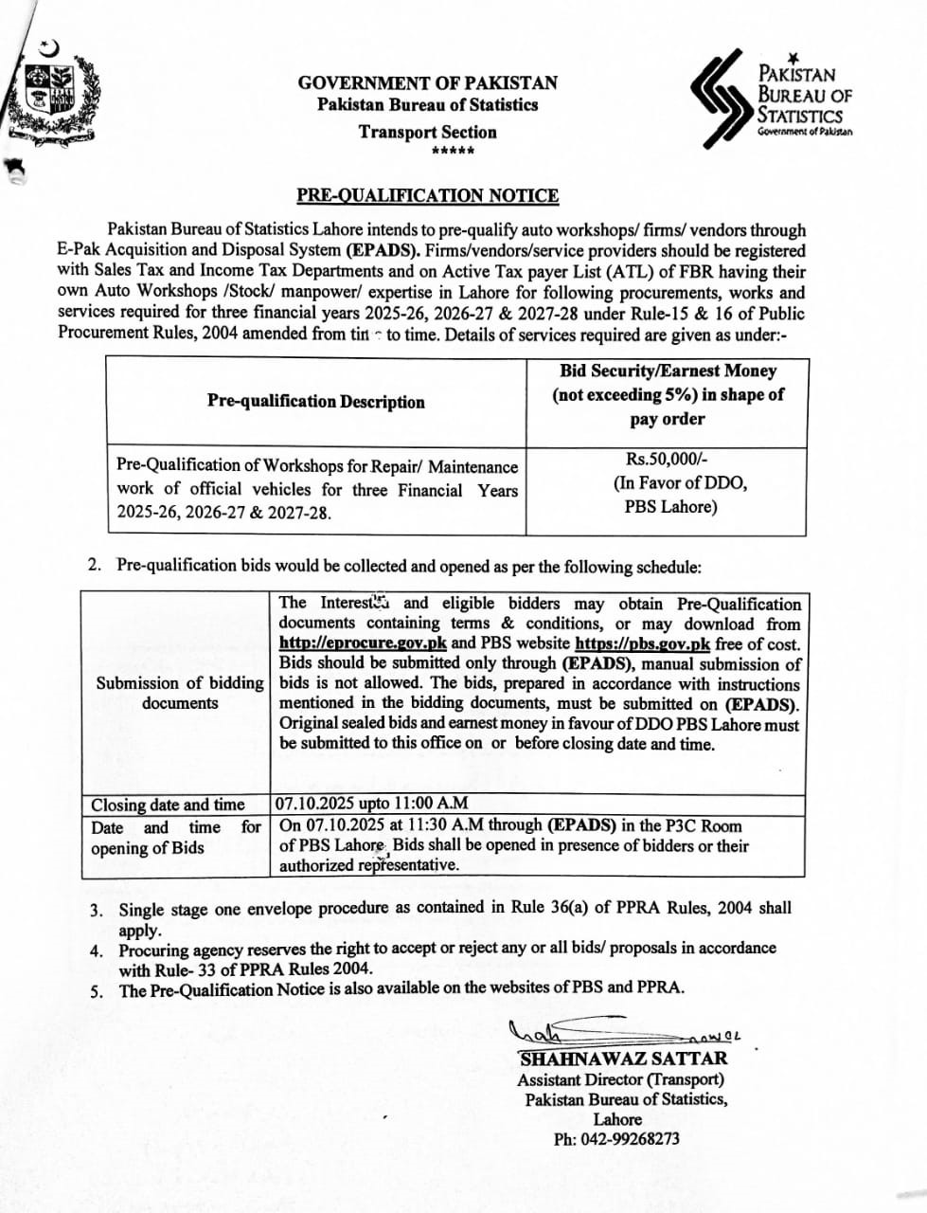

**Government of Pakistan**

**Pakistan Bureau of Statistics**

**Lahore**

**Pre-Qualification Documents**

Pre-Qualification of Workshops for Repair/ Maintenance work of official vehicles for Financial Year 2025-26, 2026-27 & 2027-28.

**Government of Pakistan**

**Pakistan Bureau of Statistics**

**Lahore**

**Invitation to bids**

Sealed proposals are invited from experienced and tax registered Auto workshops for regular repair and maintenance of official vehicles of this Bureau.

1. **Instruction to bidder**s

The selection of workshops will base on Prequalification process under Rules – 15 & 16 of PPRA, 2004. PBS Lahore will adopt single stage one envelope bidding procedure as laid down in rule 36 of Public Procurement Rules-2004. The bid shall be a single envelope, containing prequalification proposal. Bids should be submitted only through **(EPADS)**, manual submission of bids is not allowed. Original sealed bids and earnest money in favour of DDO PBS Lahore must be submitted marked as **“Prequalification Proposal”.** This office engaging in prequalification is announcing, in the prequalification documents, all information required for prequalification including instructions for preparation and submission of the prequalification documents, evaluation criteria, list of documentary evidence required by contractors to demonstrate their respective qualifications and any other information that this office deems necessary for prequalification. PBS Lahore is providing a set of pre-qualification documents to contractors downloaded free of cost from EPADS website **(**[**http://eprocure.gov.pk**](http://eprocure.gov.pk/)**)** and PBS website **(**[**https://pbs.gov.pk**](https://pbs.gov.pk)**).** PBS Lahore shall evaluate the proposal in the manner prescribed given in the document. During the evaluation no amendments in the prequalification proposal shall be permitted. After prequalification, only the prequalified contractors shall be entitled to participate in the subsequent procurement proceedings. PBS Lahore, at any stage of the procurement proceedings, having credible reasons for, or prima facie evidence of, any defect in the capacity or otherwise of a contractor, whether or not prequalified, may require the contractor to provide such further information concerning the professional, technical, financial, legal or managerial competence as PBS Lahore may decide. This office shall disqualify a contractor on the ground that he had provided false, fabricated or materially incorrect information. Bidders those will get minimum 50 marks in technical evaluation will be short- listed for financial bids.

1. **Eligibility and Prequalification Criteria**

The bidders fulfilling the following eligibility criteria, will be declared eligible for Prequalification process which is provided as **Annexure-B.**

* 1. Affidavit on stamp paper, declaring that the company is not black listed by any Government agency / authority (Original required)
  2. Income Tax, and General Sales Tax (GST) registration (Copies required)
  3. Bidder must have its own auto workshop setup in Lahore (Details of workshop is required on company letter head/profile).

Kindly fill the **annexure–A & annexure-B** and attach the supporting documentary evidences as mentioned above and also in each annexure;

**Annex – A:** Organization Information

**Annex – B:** Prequalification Criteria (Auto Workshops)

And also sign the declaration form at the end of document and attach with your other documents.

1. **Scope of job**
2. PBS Lahore will offer a prequalification letter for three years to qualified bidders for regular repair and maintenance including spare parts of its official vehicles in accordance with Rule-15 & 16 of Public Procurement Rules, 2004 amended from time to time
3. The qualified contractor will share the quotations of required vehicle services / other repairs as and when required by this office.
4. The contractor will provide financial proposal for repair and maintenance including spare parts.
5. The contractor with lowest offered bid will be awarded work order for the said repair and maintenance of vehicle.
6. The contractor will provide quality spare parts to this office within agreed timelines of purchase order during the contract period.
7. **Terms of Reference**

To provide uninterrupted service of repair and maintenance, contractor will agree on following terms of references:

1. The contractor will be bound to provide required service within agreed timelines starting from issuance of Work order. Hard copy of work order will be provided.
2. Income tax and GST (if applicable) will be deducted in accordance with the provisions of Government Rules amended from time to time.
3. In case of any dispute regarding quantity, quality of service and specification arises, the decision of the GRC, PBS shall be final & binding.
4. The payment for the services will be made through AGPR cross cheque / AGPR, Micro Payment Gateway (MPG) on the successful completion of service and receipt of invoice as per rules.
5. **General Guidelines:**
6. Only short-listed applicants will be considered for financial proposals/quotations. The financial proposal will be called separately from qualified bidders.
7. All documents and information received by PBS Lahore from applicants will be treated in strictly confidential.
8. Documents submitted to PBS Lahore will not be returned.
9. All expenses related to participation in this prequalification document shall be borne by the applicants.
10. Documents should be submitted through **EPADS.** Original Bids and Call Deposit in sealed envelope marked as “Pre-Qualification Proposal” shall be received on the postal address given below.
11. PBS Lahore reserves the right to request submission of additional information from applicants in order to clarify/further understand aspects of technical proposal, if required.
12. PBS Lahore reserves the right to verify any information provided by the applicants.
13. In case of any dispute regarding quantity, quality of service and specification arises, the decision of the Grievances Redressal Committee(GRC), Pakistan Bureau of Statistics shall be final & binding.
14. The workshop will be bound to return back all the replaced/old spare parts to this office.

**Postal Address:**

Assistant Director (Transport),

Pakistan Bureau of Statistics

Room No.8

US-AID Building, Gurumangat Road,

Gulberg-III, Lahore

Telephone: +92-42-9268273

1. **Declaration**

Kindly provide the declaration as per format provided below at the end of proposal.

I, hereby declare that:

* All the information provided in the technical proposal is correct in all manners and respects
* And I am duly authorized by the Governing body/Board/Management to submit this proposal on behalf of

**Name**

**Designation**

**Signature**

**Date and Place**

1. **Submission of Prequalification Proposal**

Complete proposal containing technical details; all required information and documentary evidences may be submitted before 11:00 AM on 07.10.2025. The proposals will be opened on same day at 11:30 AM in the presence of bidders who wish to attend. The proposal should be submitted in sealed envelope clearly mentioned “Prequalification of Auto Workshops”.

**Cover Letter for the Submission of Prequalification / Technical Proposal**

[Firm letterhead] [Date]

**To**

Assistant Director (Transport) [Address mentioned in Data Sheet]

**Re: Technical Proposal in respect of [Insert title of assignment]**

Dear Sir,

We offer to provide the Services for [Insert title of assignment] in accordance with your Tender for Proposal dated [Insert Date of Tender advertised]. We, hereby submit our technical Proposal and financial proposals including the required documents in a sealed envelope.

We hereby declare that all the information and statements made in these proposals are true and accept that any misinterpretation contained therein may lead to our disqualification. Our proposal is binding upon us and subject to the modifications resulting from contract negotiations. We undertake that we will initiate the services as per the client’s request if our proposal is accepted. We understand that you are not bound to accept any or all proposals you receive.

Thank you.

**Yours sincerely,**

Signature

Name and title of signatory:

**Important Note:** The competent authority may reject all proposals at any time prior to the acceptance of a bid or proposal. PBS Lahore shall upon request communicate to any bidder, the grounds for its rejection of all bids or proposals, but shall not be required to justify those grounds.

**Annexures**

**Annex – A**

**Organization Information**

|  |  |  |  |  |
| --- | --- | --- | --- | --- |
| **Serial No.** | **Required information** | **Response with Documentary Proof** | | |
| **1** | Legal name of the Auto Workshop/ repair Shop |  | | |
| **2** | Year of Registration / Establishment of the  organization |  | | |
| **3** | National Tax Number with year of issuance |  | | |
| **4** | General Sales Tax Number and year of registration |  | | |
| **5** | What is the legal status of your organization? Tick  the relevant box (one box only). (Attach Copy/Copies of Registration Certificate/s) |  | Public Sector  Organization |  |
| Sole  proprietor |  |
| Private Limited  Company |  |
| Public limited  Company |  |
|  |  |
| **6** | Name and Designation of Head of organization |  | | |
| Mobile |  | | |
| Phone |  | | |
| Email(if any) |  | | |
| Address of Organization |  | | |
| **7** | Name and Designation of Contact Person |  | | |
| Mobile |  | | |
| Phone |  | | |
| Fax(if any) |  | | |
| Fax number |  | | |

**Annex – B**

**Applicant Organization’s Name: ------------------------------------------------------------------------**

**Pre-Qualification Criteria (Auto Workshops)**

|  |  |  |  |
| --- | --- | --- | --- |
| **S.No.** | **Description** | **Documents Required** | **Marks** |
| **1** | **Relevant Experience** | Copy of Work Order and NTN certificate with date of registration | **Maximum 20 Marks** |
| 1.1 | 1-3 years’ experience | **5** marks for 1-3 years exp. |
| 1.2 | 4-7 years’ experience | **10** marks for 4-7 years exp. |
| 1.3 | 7-10 years’ experience | **15** marks for 7-10 years exp. |
| 1.4 | More than 10 years’ experience | **20** marks for more than 10  years experience. |
| **2.** | **Financial Capability** | Copies of last year’s tax returns and Bank Statement | **Maximum 20 Marks** |
| 2.1 | Bank Statement worth if up to 1  lac rupee | **5** marks if worth up to 1 lac  rupee |
| 2.2 | if more than 1 lac & up to 2 lac  rupees | **10** marks if worth 1 lac up to  2 lac rupees |
| 2.3 | If more than 2 lac & up to 3 lac  Rupees | **15** marks if worth 2 lac up to  3 lac rupees |
| 2.4 | If more than 3 lac rupees | **20** marks if worth more than  3 lac rupees |
| **3.** | **Total Clients with Company** | List of clients of the organization on letter head. Signed by Organizational head. | **Maximum 20 Marks** |
| 3.1 | If 1-3 clients | **5** marks if 1-3 clients |
| 3.2 | If 4-7 clients | **10** marks if 4-7 clients |
| 3.3 | If 8-10 clients | **15** marks if 8-10 clients |
| 3.4 | If more than 10 clients | **20** marks if more than 10  clients |
| **4.** | **Auto Workshop** | Details of auto workshop on company letter head. The procurement committee shall visit the workshops before decision. | **Maximum 20 Marks** |
| 4.1 | Electrical (for Automobile  Workshop) | **5** marks for if only one  facility is available |
| 4.2 | Mechanical (for Automobile  Workshop) | **10** Marks if 2 facilities are  available |
| 4.3 | Denting/ painting (for  Automobile Workshop) | **15** marks if 3 facilities are  available |
| 4.4 | Parts shop/repair shop | **20** marks if all 4 facilities are  available |
| **5.** | **Working Staff** | List of employees of the organization on letter head | **Maximum 20 Marks** |
| 5.1 | If 1-3 staff members | **5** marks if 1-3 staff members |
| 5.2 | If 4-7 staff members | **10** marks if 4-7 staff  members |
| 5.3 | If 8-10 staff members | **15** marks if 8-10 staff  members |
| 5.4 | If more than 10 staff members | **20** marks if more than 10  staff members |

**Note:** Minimum qualification marks are 50. Absence of any required document will lead to zero marks in that specific area.