Summary of Provisional Quantum Index Numbers of Large Scale Manufacturing Industries (QIM) for August 2025

The provisional quantum indices of Large Scale Manufacturing Industries (LSMI) for August, 2025 with base year 2015-16 have been developed on the basis of latest data supplied by the source agencies. The indices for August 2025 and July- August 2025-26 along with growth are as follows: -
- QIM estimated for July-August, 2025-26 is 113.62
- Overall Large Scale Manufacturing Sector has shown a growth of 4.44% during July- August 2025-26 when compared with the same period of last year.
- QIM estimated for August, 2025 is 112.04.
- The LSMI output increased by 0.54% for August, 2025 when compared with August, 2024 and decreased by 2.75% when compared with July, 2025.
Monthly Indices and Growth |  |  |  |  | Jul-Aug 2025-26
Index for |  |  | Growth |  | Index for |  | Growth
August-25 | August-24 | July-25 | MOM | YOY | 2025-26 | 2024-25 | 2025-26
112.04 | 111.43 | 115.20 | -2.75 | 0.54 | 113.62 | 108.79 | 4.44

2. The growth of important items/group of items is as follows;
Manufacturing Sector | Weight | % Change
Manufacturing Sector | Weight | August -25 | Jul-Aug 2025-26
Cotton Yarn | 8.88 | 4.17 | 2.94
Cotton Cloth | 7.29 | 0.23 | 0.31
Garments | 6.08 | -10.65 | 4.92
Petroleum Products | 6.66 | -13.59 | -2.69
Fertilizers | 3.93 | 2.82 | 0.60
Cement | 4.65 | 18.55 | 18.65
Iron & Steel | 3.45 | -3.18 | -3.44
Automobile | 3.10 | 130.68 | 90.40

3. The main contributors towards overall growth of 4.44% are Food (1.02), Tobacco (0.17), Textile (-0.03) Garments (0.84), Paper & Board (0.21), Petroleum Products (-0.21), Chemicals (-0.13), Pharmaceuticals (-0.11), Cement (0.98), Iron & Steel Products (-0.16), Electrical Equipment (0.08), Machinery and Equipment (-0.11), Automobiles (1.83), Other transport Equipment (0.23), and Furniture (-0.17).
4. Month-wise trend of QIM from July, 2023 to August, 2025 is given in the following graph:
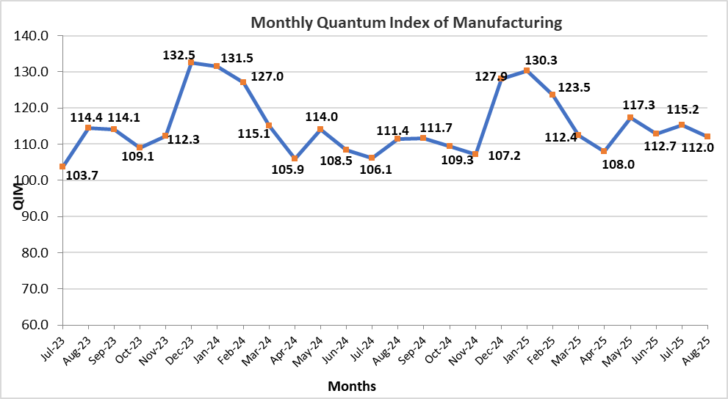

5. The sectors showing growth during July-August 2025-26 compared to July-August 2024-25 are given below: -

Manufacturing Sector | Weight | (%) Change  2024-25 |  | (%) Change  2025-26 |  | YOY Growth Impact 2025-26
Manufacturing Sector | Weight | August | Jul-Aug | August | Jul-Aug | Monthly | Cumulative
Food | 3.84 | 1.19 | 2.35 | 8.06 | 7.77 | 1.03 | 1.02
Tobacco | 2.07 | 0.72 | 34.02 | 23.37 | 11.06 | 0.33 | 0.17
Wearing Apparel | 6.08 | 18.69 | 14.51 | (10.65) | 4.92 | (1.99) | 0.84
Leather Products | 1.23 | (1.25) | 0.82 | 4.50 | 2.01 | 0.03 | 0.02
Paper & Board | 1.63 | 2.86 | 6.59 | 3.01 | 8.41 | 0.08 | 0.21
Rubber Products | 0.24 | 1.82 | (7.88) | 21.77 | 24.90 | 0.04 | 0.05
Non Metallic Mineral Products | 5.01 | (26.55) | (19.52) | 18.08 | 17.31 | 1.01 | 0.99
Computer, electronics and Optical products | 0.03 | (3.19) | (1.09) | 2.38 | 1.67 | 0.00 | 0.00
Electrical Equipment | 2.05 | (18.19) | (18.69) | 1.27 | 2.79 | 0.03 | 0.08
Automobiles | 3.10 | (10.00) | 21.40 | 130.68 | 90.40 | 2.31 | 1.83
Other transport Equipment | 0.69 | 28.75 | 22.86 | 40.87 | 44.47 | 0.23 | 0.23
Other Manufacturing (Football) | 0.32 | (4.13) | 2.33 | 6.47 | 19.35 | 0.03 | 0.09

6. The sectors showing Decline during July-August 2025-26 compared to July-August 2024-25 are given below: -
Manufacturing Sector | Weight | (%) Change  2024-25 |  | (%) Change  2025-26 |  | YOY Growth Impact 2025-26
Manufacturing Sector | Weight | August | Jul-Aug | August | Jul-Aug | Monthly | Cumulative
Beverages | 3.84 | (5.87) | (0.38) | 7.23 | (2.68) | 0.35 | (0.15)
Textile | 18.16 | (0.86) | 3.58 | (0.34) | (0.15) | (0.06) | (0.03)
Wood Products | 0.18 | 1.41 | 4.81 | (1.04) | (1.65) | (0.00) | (0.00)
Coke & Petroleum Products | 6.66 | 8.40 | 7.02 | (13.59) | (2.69) | (1.08) | (0.21)
Chemicals | 6.48 | 1.50 | 0.72 | (0.48) | (1.47) | (0.04) | (0.13)
Chemicals Products | 2.55 | (1.59) | (2.21) | (6.18) | (5.14) | (0.19) | (0.16)
Fertilizers | 3.93 | 3.37 | 2.45 | 2.82 | 0.60 | 0.15 | 0.03
Pharmaceuticals | 5.15 | 0.16 | (1.64) | (4.59) | (1.77) | (0.29) | (0.11)
Iron & Steel Products | 3.45 | (14.38) | (13.55) | (3.18) | (3.44) | (0.14) | (0.16)
Fabricated Metal | 0.42 | (26.11) | (21.02) | 3.40 | (0.19) | 0.01 | (0.00)
Machinery and Equipment | 0.39 | (35.21) | (24.71) | (45.39) | (33.84) | (0.15) | (0.11)
Furniture | 0.51 | (52.32) | (53.50) | (56.64) | (10.84) | (1.21) | (0.17)

7. The production in July-August 2025-26 as compared to July-August 2024-25 has increased in Food, Tobacco, wearing apparel, Non Metallic Mineral Products, Electrical Equipment, Automobiles and Other Transport Equipment while it Decreased in Beverages, Textile, Chemical Products, Iron & Steel Products, Machinery and Equipment, and Furniture.

