Summary of Provisional Quantum Index Numbers of Large Scale Manufacturing Industries (QIM) for June 2025

The provisional quantum indices of Large Scale Manufacturing Industries (LSMI) for June, 2025 with base year 2015-16 have been developed on the basis of latest data supplied by the source agencies. The indices for June 2025 and July-June 2024-25 along with growth are as follows: -
- QIM estimated for June, 2025 is 112.95
- The LSMI output increased by 4.14% for June 2025 when compared with June 2024 and decreased by -3.67% when compared with May 2025.
- QIM estimated for July-June, 2024-25 is 114.82
- Overall Large Scale Manufacturing Sector has shown a growth of -0.74% during July- June 2024-25 when compared with the same period of last year.
Jul-June 2024-25 |  |  | Monthly Indices and Growth
Index for |  | Growth | Index for |  |  | Growth
2024-25 | 2023-24 | 2024-25 | June-25 | June-24 | Apr-25 | MOM | YOY
114.82 | 115.67 | -0.74 | 112.95 | 108.46 | 117.25 | -3.67 | 4.14

2. The growth of important items/group of items is as follows;
Manufacturing Sector | Weight | % Change
Manufacturing Sector | Weight | June -25 | Jul-June 2024-25
Cotton Yarn | 8.88 | 1.11 | 7.59
Cotton Cloth | 7.29 | 0.22 | 0.68
Garments | 6.08 | 11.16 | 5.70
Petroleum Products | 6.66 | 11.92 | 5.33
Fertilizers | 3.93 | 10.02 | 1.69
Cement | 4.65 | -7.23 | -4.52
Iron & Steel | 3.45 | -1.45 | -8.71
Automobile | 3.10 | 65.53 | 46.15

3. The main contributors towards overall growth of -0.74% are Tobacco (0.10), Textile (0.41) Garments (0.88), Petroleum Products (0.37), Pharmaceuticals (0.16), Automobiles (0.85), Other transport Equipment (0.17), Food (-0.32), Chemicals (-0.28) Non Metallic Mineral Products (-0.51), Cement (-0.26), Iron & Steel Products (-0.40), Electrical Equipment (-0.34), Machinery and Equipment (-0.18) and Furniture (-1.59).

4. Month-wise trend of QIM from May 2023 to June 2025 is given in the following graph:
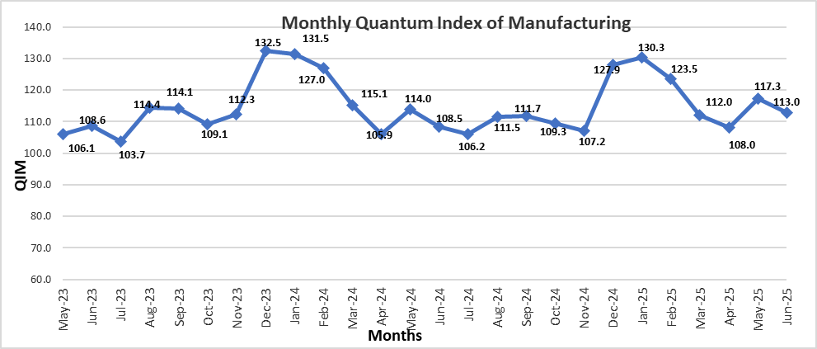
5. The sectors showing growth during July-June 2024-25 compared to July-June 2023-24 are given below: -

Manufacturing Sector | Weight | (%) Change  2023-24 |  | (%) Change  2024-25 |  | YOY Growth Impact 2024-25
Manufacturing Sector | Weight | June | Jul-June | June | Jul-June | Monthly | Cumulative
Beverages | 3.84 | 12.76 | -3.17 | 1.16 | 1.29 | 0.07 | 0.06
Tobacco | 2.07 | -3.17 | -23.01 | -16.28 | 6.99 | -0.22 | 0.10
Textile | 18.16 | 4.22 | -5.65 | -0.85 | 2.49 | -0.15 | 0.41
Wearing Apparel | 6.08 | -2.46 | 8.24 | 11.16 | 5.70 | 1.85 | 0.88
Leather Products | 1.23 | 6.69 | 5.59 | -2.41 | 0.93 | -0.02 | 0.01
Wood Products | 0.18 | 9.02 | 11.79 | 2.20 | 1.25 | 0.00 | 0.00
Paper & Board | 1.63 | 8.86 | -0.64 | -3.15 | 0.39 | -0.07 | 0.01
Coke & Petroleum Products | 6.66 | 28.30 | 9.81 | 11.92 | 5.33 | 0.88 | 0.37
Pharmaceuticals | 5.15 | -1.01 | 15.73 | 2.97 | 2.74 | 0.19 | 0.16
Computer, electronics and Optical products | 0.03 | 1.98 | -12.44 | 0.69 | 2.60 | 0.00 | 0.00
Automobiles | 3.10 | 37.44 | -25.03 | 65.53 | 46.15 | 1.58 | 0.85
Other transport Equipment | 0.69 | 9.28 | -4.02 | 61.72 | 36.60 | 0.28 | 0.17

6. The sectors showing Decline during July-June 2024-25 compared to July-June 2023-24 are given below: -
Manufacturing Sector | Weight | (%) Change  2023-24 |  | (%) Change  2024-25 |  | YOY Growth Impact 2024-25
Manufacturing Sector | Weight | June | Jul-June | June | Jul-June | Monthly | Cumulative
Food | 10.69 | 2.83 | 1.75 | 3.97 | -1.83 | 0.54 | -0.32
Chemicals | 6.48 | -3.59 | 5.10 | 3.89 | -3.45 | 0.31 | -0.28
Chemicals Products | 2.55 | -10.55 | -3.80 | -5.93 | -11.64 | -0.18 | -0.37
Fertilizers | 3.93 | 1.34 | 11.58 | 10.02 | 1.69 | 0.49 | 0.08
Rubber Products | 0.24 | -14.75 | -1.52 | 8.12 | -1.27 | 0.02 | -0.00
Non Metallic Mineral Products | 5.01 | -14.48 | -5.31 | -7.86 | -7.88 | -0.49 | -0.51
Iron & Steel Products | 3.45 | -11.80 | -4.42 | -1.45 | -8.71 | -0.07 | -0.40
Fabricated Metal | 0.42 | -17.60 | -7.79 | 5.34 | -13.87 | 0.02 | -0.05
Electrical Equipment | 2.05 | -20.89 | -9.45 | 1.63 | -11.65 | 0.05 | -0.34
Machinery and Equipment | 0.39 | 28.66 | 45.52 | -36.19 | -35.46 | -0.16 | -0.18
Furniture | 0.51 | -42.10 | 14.96 | -21.51 | -56.26 | -0.39 | -1.59
Other Manufacturing (Football) | 0.32 | 10.92 | 7.60 | -8.35 | -15.95 | -0.04 | -0.08

7. The production in July-June 2024-25 as compared to July-June 2023-24 has increased in Tobacco, Textile, wearing apparel, Coke & Petroleum Products, Automobiles and Other Transport Equipment while it Decreased in Food, Chemical Products, Non Metallic Mineral Products, Iron & Steel Products, Electrical Equipment, Machinery and Equipment, and Furniture.

