Summary of Provisional Quantum Index Numbers of Large Scale Manufacturing Industries (QIM) for July, 2025

The provisional quantum indices of Large Scale Manufacturing Industries (LSMI) for July, 2025 with base year 2015-16 have been developed on the basis of latest data supplied by the source agencies. The indices for July, 2025 along with growth are as follows: -
- QIM estimated for July, 2025 is 115.68
- The LSMI output increased by 8.99% for July, 2025 when compared with July, 2024 and 2.60% when compared with June, 2025.

Monthly Indices and Growth
Index for |  |  | Growth
July-25 | July-24 | June-25 | MOM | YOY
115.68 | 106.14 | 112.75 | 2.60 | 8.99

2. The growth of important items/group of items is as follows;
Manufacturing Sector | Weight | % Change in July -25
Cotton Yarn | 8.88 | 1.70
Cotton Cloth | 7.29 | 0.40
Garments | 6.08 | 24.79
Petroleum Products | 6.66 | 13.18
Fertilizers | 3.93 | -1.60
Cement | 4.65 | 18.75
Iron & Steel | 3.45 | -3.69
Automobile | 3.10 | 57.80

3. The main contributors towards overall growth of 8.99% are Food (0.89), Beverages (-0.39) Garments (3.80), Paper & Board (0.36), Petroleum Products (1.01), Chemical (-0.24), Automobiles (1.33), Non Metallic Mineral Products (0.96) and Furniture (0.91).

4. Month-wise trend of QIM from June, 2023 to July 2025 is given in the following graph:

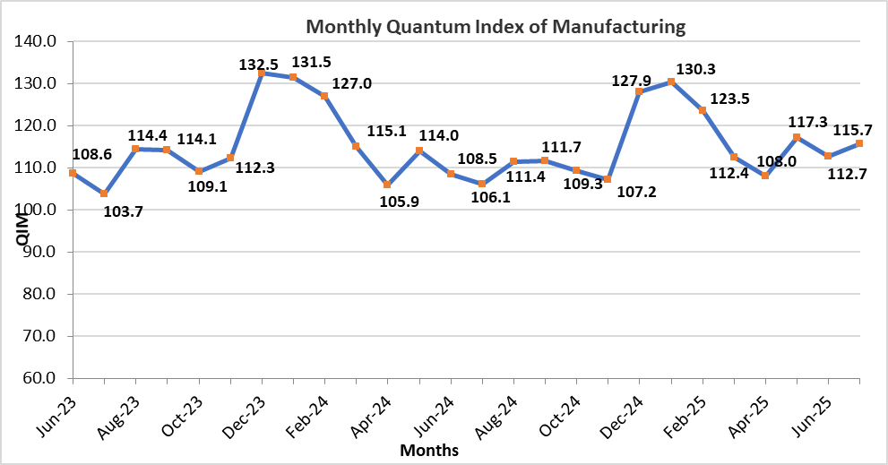
5. The sectors showing growth during July 2025-26 compared to July 2024-25 are given below: -

Manufacturing Sector | Weight | (%) Change  2024-25 | (%) Change  2025-26 | YOY Growth Impact 2025-26
Manufacturing Sector | Weight | July-24 | July-25 | Monthly
Food | 10.69 | 3.55 | 6.63 | 0.89
Tobacco | 2.07 | 90.15 | 0.07 | 0.00
Textile | 18.16 | 8.45 | 0.04 | 0.01
Wearing Apparel | 6.08 | 9.59 | 24.79 | 3.80
Leather Products | 1.23 | 2.89 | 0.29 | 0.00
Paper & Board | 1.63 | 11.10 | 15.01 | 0.36
Coke & Petroleum Products | 6.66 | 5.57 | 13.18 | 1.01
Pharmaceuticals | 5.15 | (3.40) | 1.09 | 0.07
Rubber Products | 0.24 | (16.02) | 17.29 | 0.04
Non Metallic Mineral Products | 5.01 | (10.91) | 16.52 | 0.96
Computer, electronics and Optical products | 0.03 | 1.09 | 0.96 | 0.00
Electrical Equipment | 2.05 | (19.18) | 4.39 | 0.12
Automobiles | 3.10 | 68.63 | 57.80 | 1.33
Other Transport Equipment | 0.69 | 16.29 | 45.80 | 0.21
Furniture | 0.51 | (55.83) | 86.79 | 0.91
Other Manufacturing (Football) | 0.32 | 10.67 | 33.73 | 0.15

6. The sectors showing Decline during July 2025-26 compared to July 2024-25 are given below: -
Manufacturing Sector | Weight | (%) Change  2024-25 | (%) Change  2025-26 | YOY Growth Impact 2025-26
Manufacturing Sector | Weight | July-24 | July-25 | Monthly
Beverages | 3.84 | 4.60 | (6.19) | (0.39)
Wood Products | 0.18 | 8.41 | (2.24) | (0.00)
Chemicals | 6.48 | (0.06) | (2.64) | (0.24)
Chemicals Products | 2.55 | (2.85) | (4.51) | (0.14)
Fertilizers | 3.93 | 1.55 | (1.60) | (0.09)
Iron & Steel Products | 3.45 | (12.70) | (3.69) | (0.17)
Fabricated Metal | 0.42 | (15.60) | (3.55) | (0.01)
Machinery and Equipment | 0.39 | (10.86) | (22.77) | (0.08)

7. The production in July 2025-26 as compared to July 2024-25 has increased in Food, Tobacco, Textile, wearing apparel, Leather Products, Paper & Board, Coke & Petroleum Products, Pharmaceuticals, Rubber products, Non Metallic Mineral products, Computer, electronics and Optical products, Automobiles, Other Transport Equipment, Furniture and Other Manufacturing (Football) while it Decreased in Beverages, Wood products, Chemicals, Iron & Steel Products, Fabricated Metal and Machinery and Equipment.

